Unit 3 Lesson 9: Fractional Lengths

1 Number Talk: Multiplication Strategies (Warm up)

Student Task Statement
Find the product mentally.
$19⋅14$

2 Info Gap: How Many Would It Take?

Student Task Statement
Your teacher will give you either a problem card or a data card. Do not show or read your card to your partner.
If your teacher gives you the problem card:
- Silently read your card and think about what information you need to be able to answer the question.
- Ask your partner for the specific information that you need.
- Explain how you are using the information to solve the problem.
- Continue to ask questions until you have enough information to solve the problem.
- Share the problem card and solve the problem independently.
- Read the data card and discuss your reasoning.
If your teacher gives you the data card:
- Silently read your card.
- Ask your partner “What specific information do you need?” and wait for them to ask for information.
- If your partner asks for information that is not on the card, do not do the calculations for them. Tell them you don’t have that information.
- Before sharing the information, ask “Why do you need that information?” Listen to your partner’s reasoning and ask clarifying questions.
- Read the problem card and solve the problem independently.
- Share the data card and discuss your reasoning.

3 How Many Times as Tall or as Far?

Student Task Statement
- A second-grade student is 4 feet tall. Her teacher is $5\frac{2}{3}$ feet tall.
  - How many times as tall as the student is the teacher?
  - What fraction of the teacher’s height is the student’s height?
- Find each quotient. Show your reasoning and check your answer.
  - $9÷\frac{3}{5}$
  - $1\frac{7}{8}÷\frac{3}{4}$
- Write a division equation that can help answer each of these questions. Then find the answer. If you get stuck, consider drawing a diagram.
  - A runner ran $1\frac{4}{5}$ miles on Monday and $6\frac{3}{10}$ miles on Tuesday. How many times her Monday’s distance was her Tuesday’s distance?
  - A cyclist planned to ride $9\frac{1}{2}$ miles but only managed to travel $3\frac{7}{8}$ miles. What fraction of his planned trip did he travel?

4 Comparing Paper Rolls (Optional)

Student Task Statement
The photo shows a situation that involves fractions.
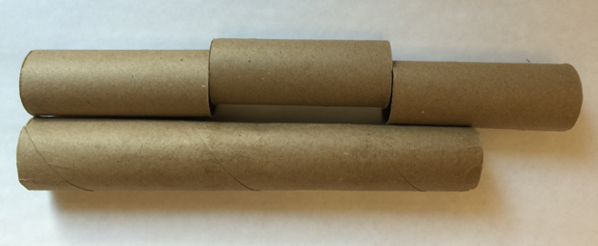
- Complete the sentences. Be prepared to explain your reasoning.
  - The length of the long tube is about ______ times the length of a short tube.
  - The length of a short tube is about ______ times the length of the long tube.
- If the length of the long paper roll is $11\frac{1}{4}$ inches, what is the length of each short paper roll?
© CC BY Open Up Resources. Adaptations CC BY IM.

