Unit 2 Lesson 15: Draw Groups of Things

WU How Many Do You See: Many Ways to Show 5 (Warm up)

Student Task Statement
How many do you see?
How do you see them?
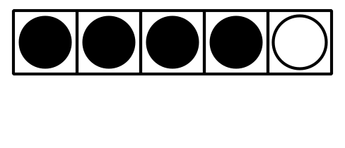

1 Number Posters with Drawings

Student Task Statement

Activity Synthesis
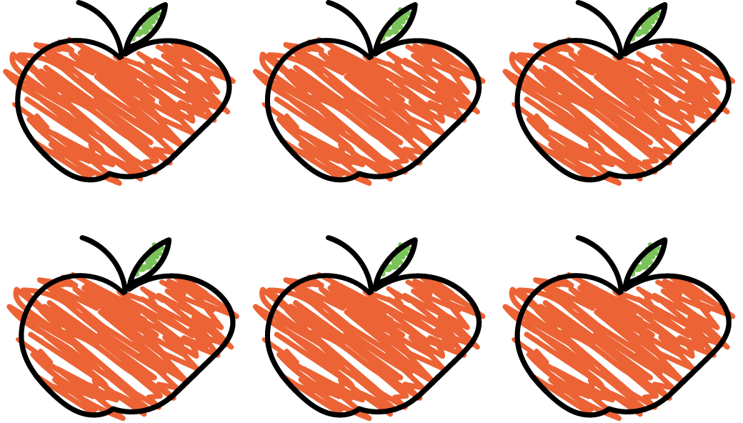
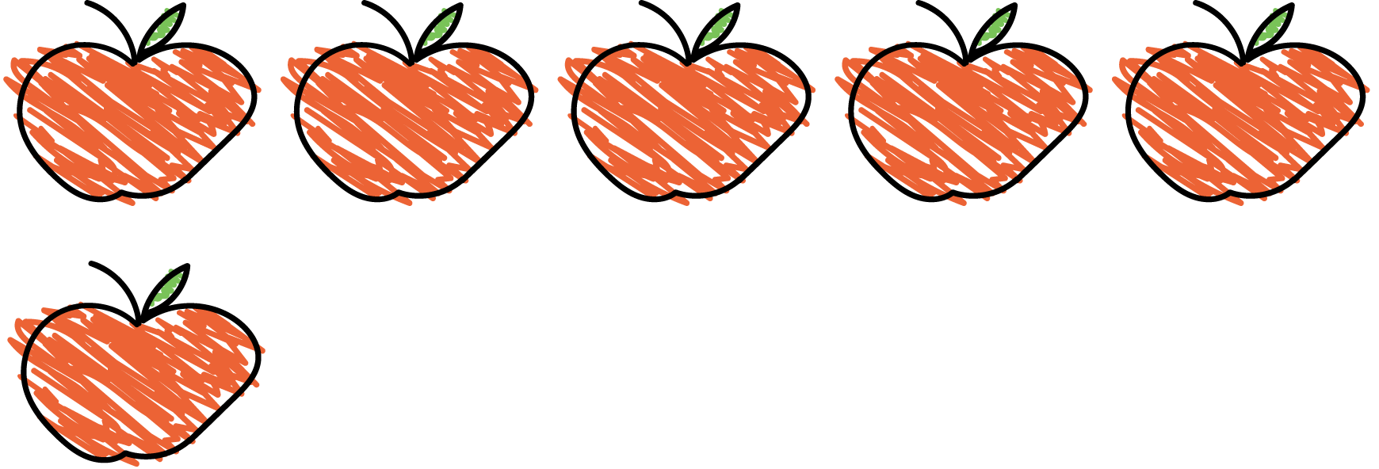

2 Introduce Math Libs, Draw 1–10

Student Task Statement

3 Centers: Choice Time

Student Task Statement
Choose a center.
Math Libs
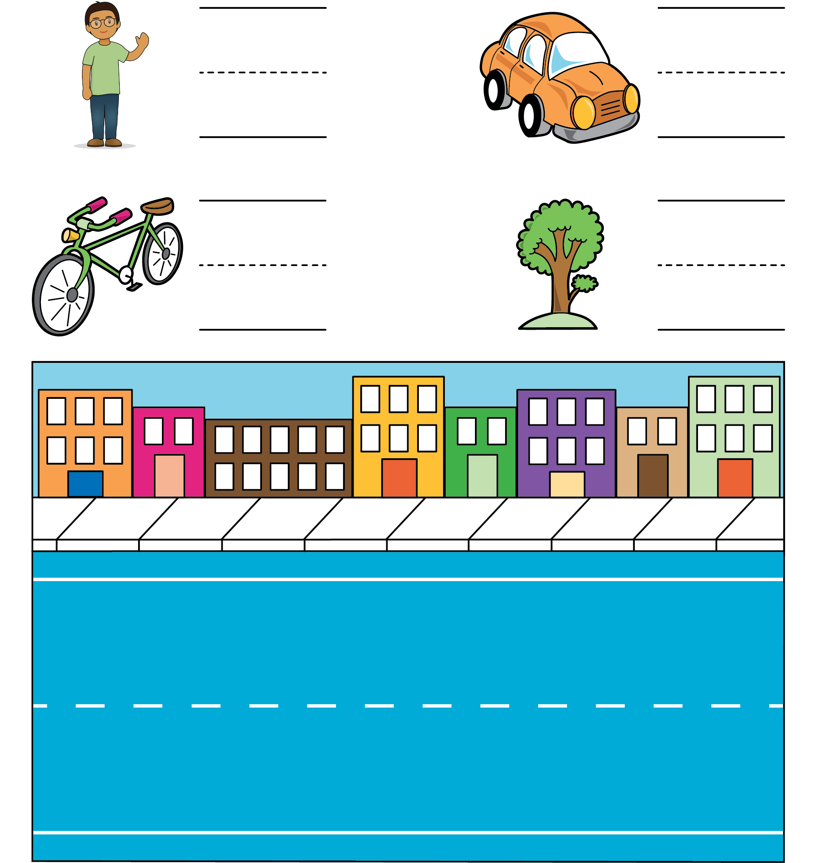
Bingo
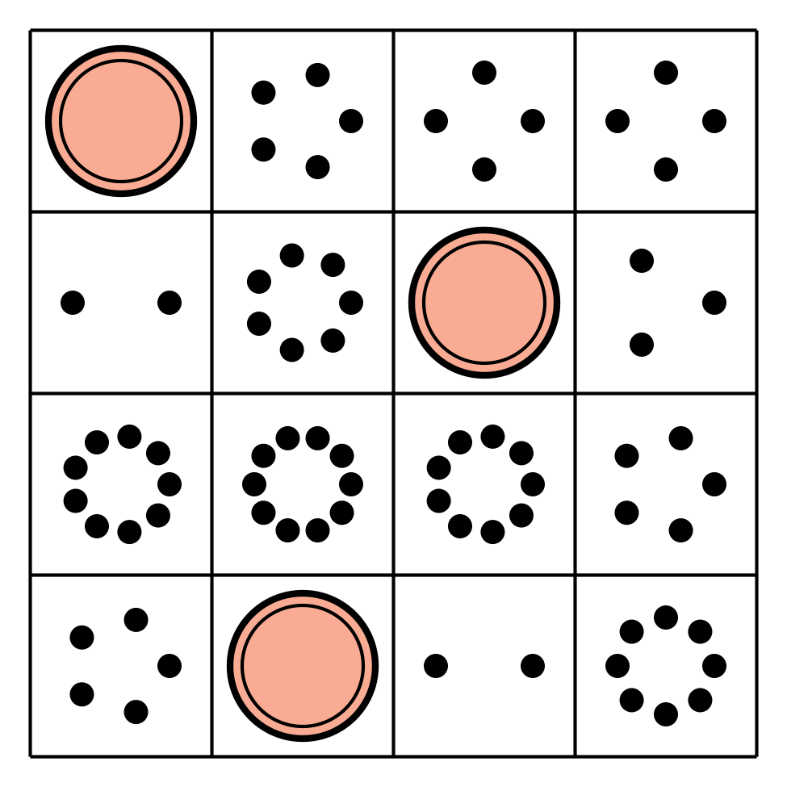
Number Race
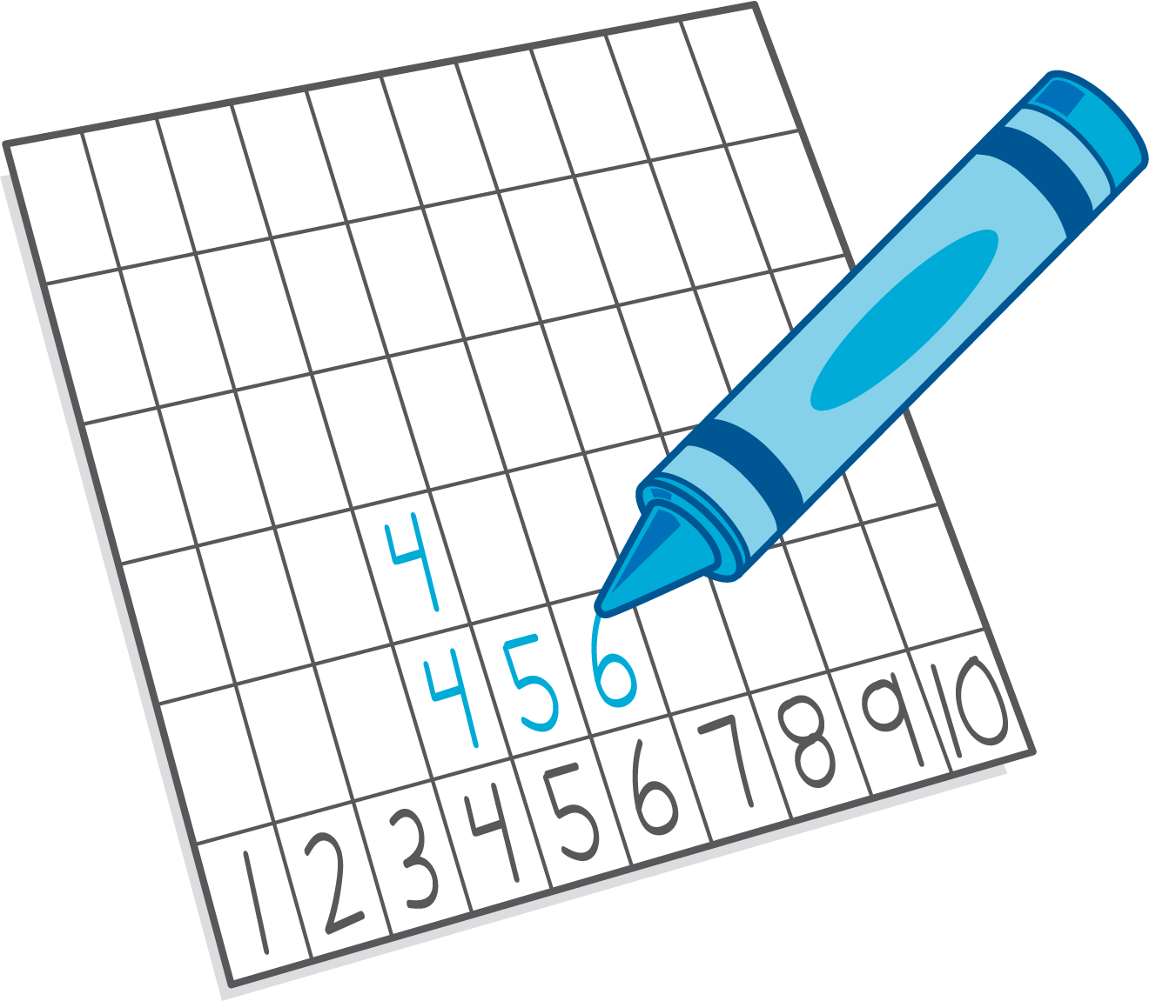
Geoblocks
Math Fingers
© CC BY 2021 Illustrative Mathematics®

