Lesson 8: Interpreting and Drawing Graphs for Situations
- Let’s make sense of graphs and scenarios.

8.1: Notice and Wonder: Crimes
What do you notice? What do you wonder?
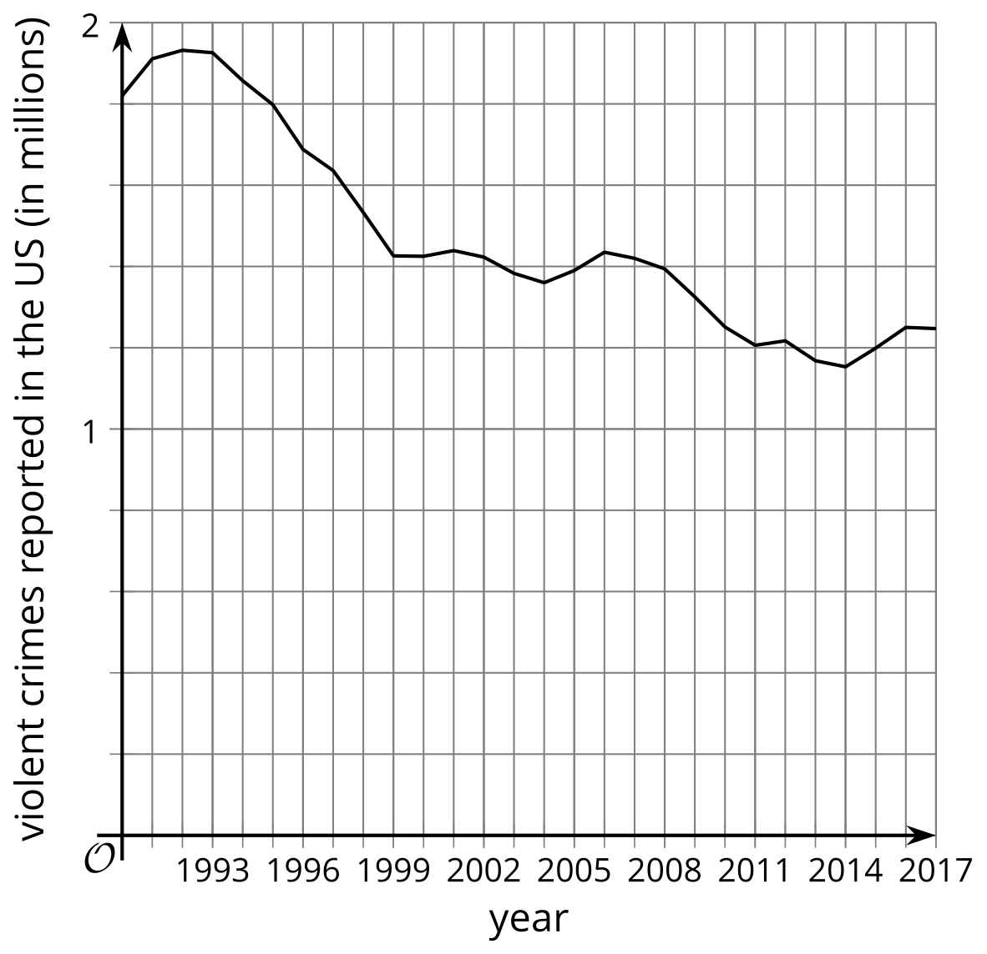

8.2: Dining Out
These graphs show how busy restaurants are at different times of the day.

restaurant A
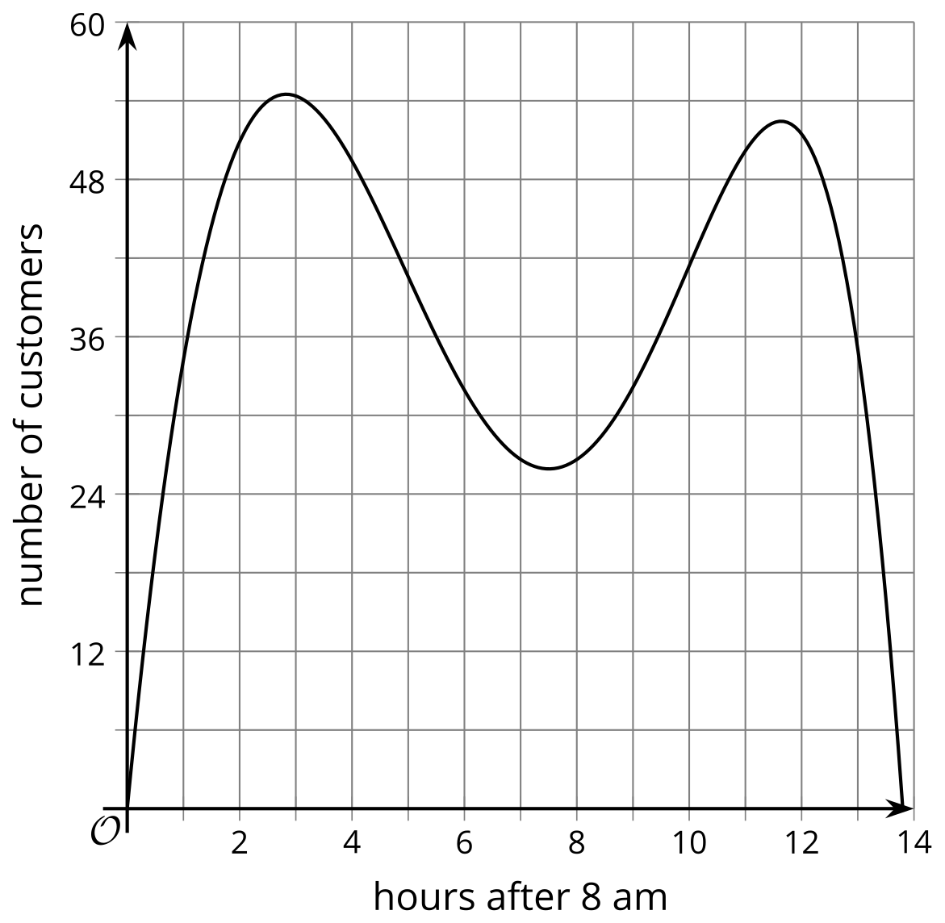

restaurant B
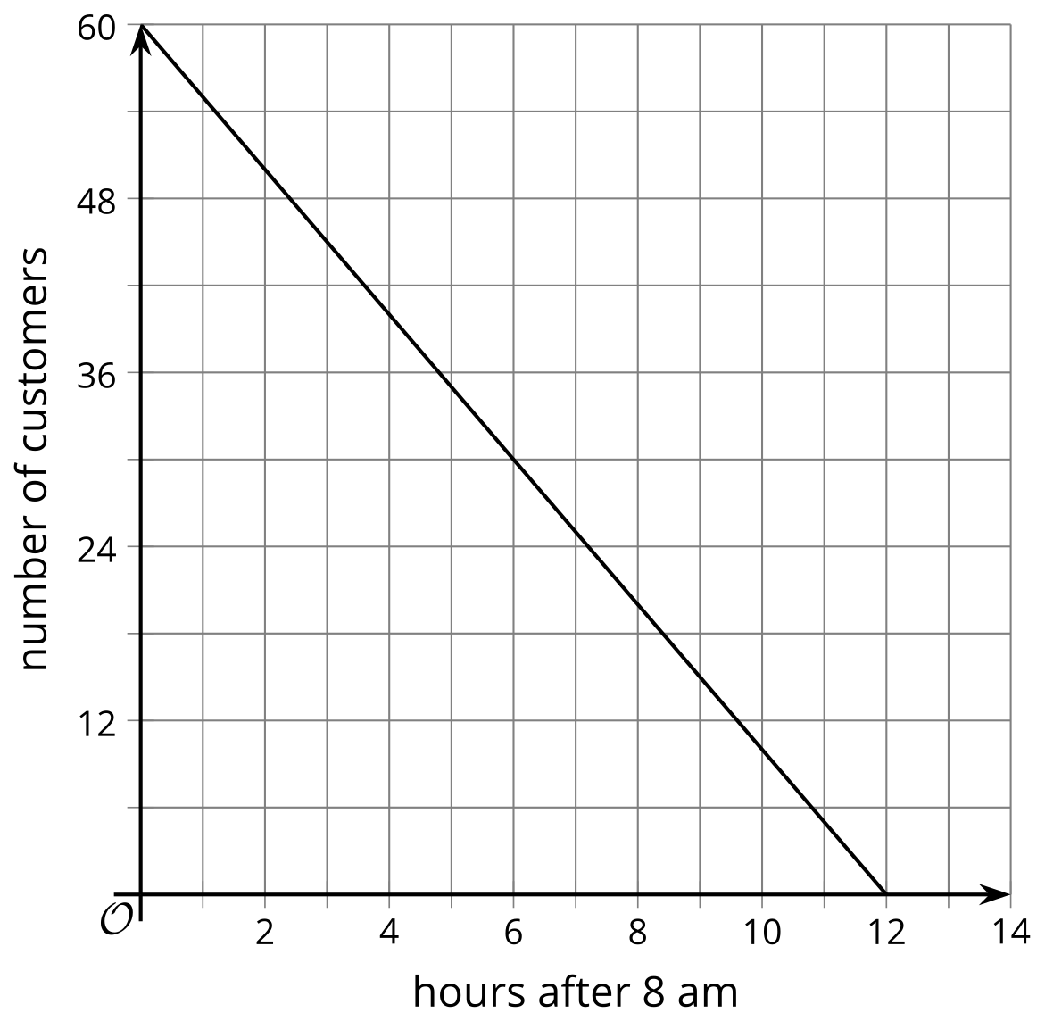

restaurant C
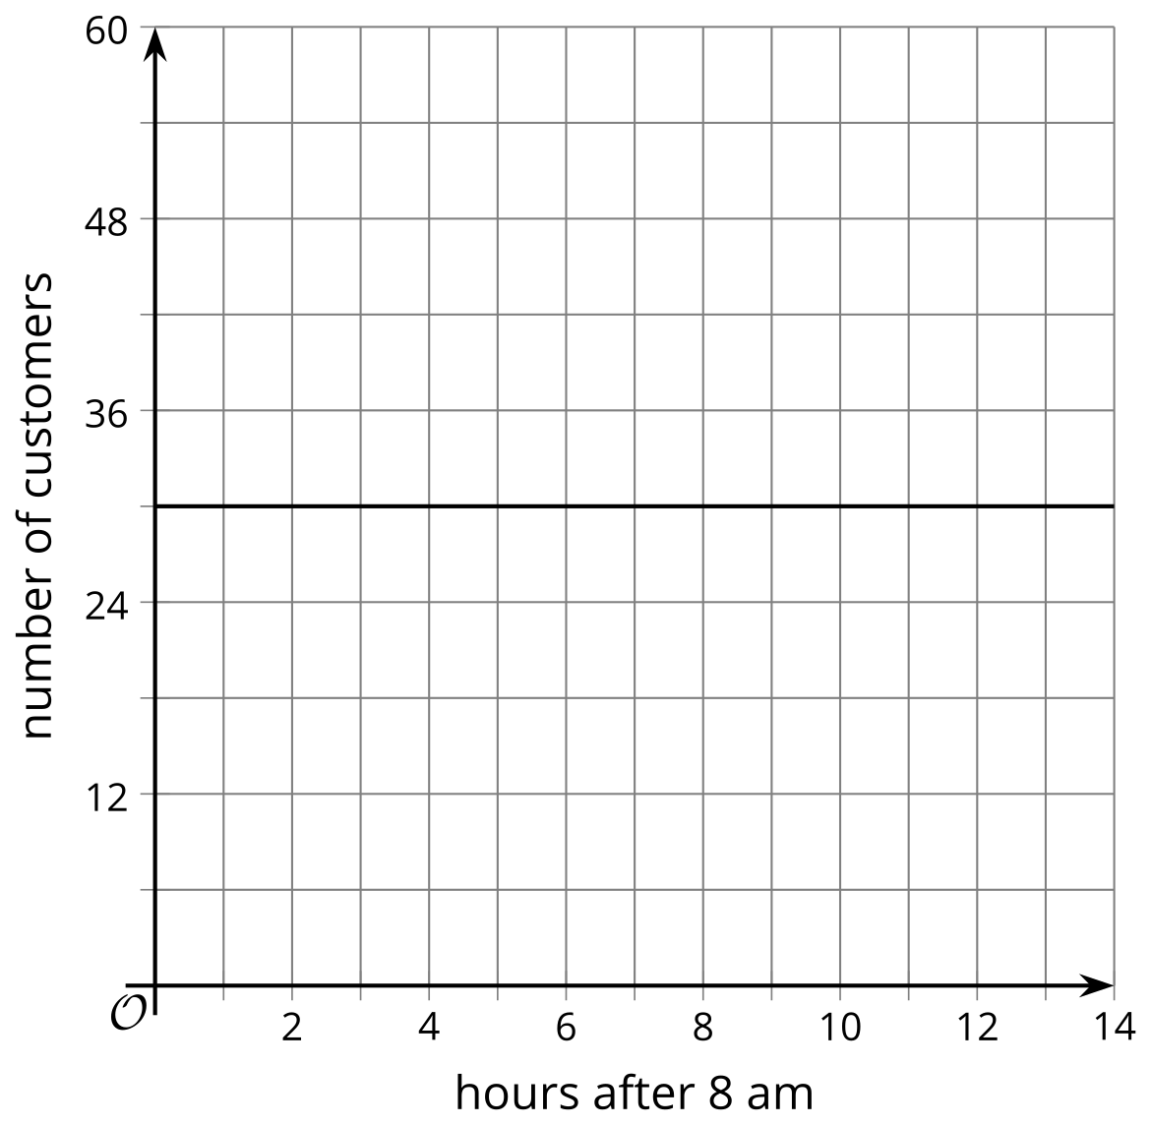

restaurant D
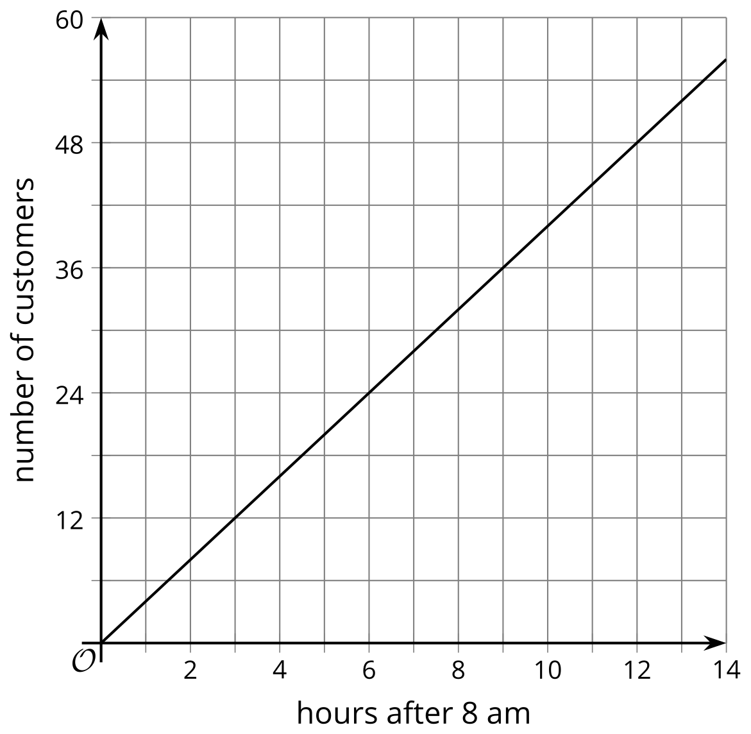
For each situation, select the best restaurant. Be prepared to explain your reasoning.
- Which restaurant is busy in the morning, then has fewer customers in the evening?
- If Lin’s mom wants to go to a popular dinner restaurant, which restaurant should Lin take her mom to eat?
- Noah’s dad prefers breakfast places with few customers so that he can start on work while eating. Which restaurant should Noah’s dad go to for breakfast?
- Which restaurant would you visit during a 30 minute lunch break? 1 hour lunch break?

8.3: Draw the Graphs
For each situation, draw a graph that could represent it.
- Diego starts at home and walks away from home at a steady rate of 3 miles per hour.
- 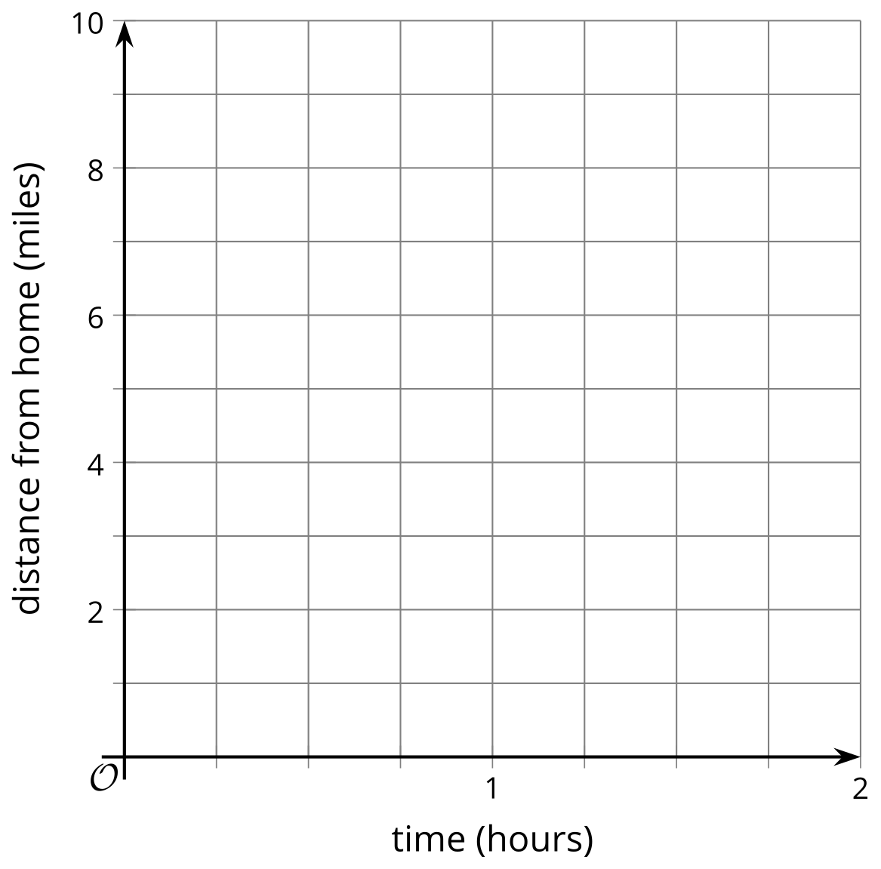
- Mai starts 5 miles from home and walks at a steady rate of 3 miles per hour toward her home until she gets there and stays.
- A soccer player kicks a ball that’s on the ground so that it goes up to a height of about 10 feet and then comes back down to hit the ground 1.55 seconds later.
- 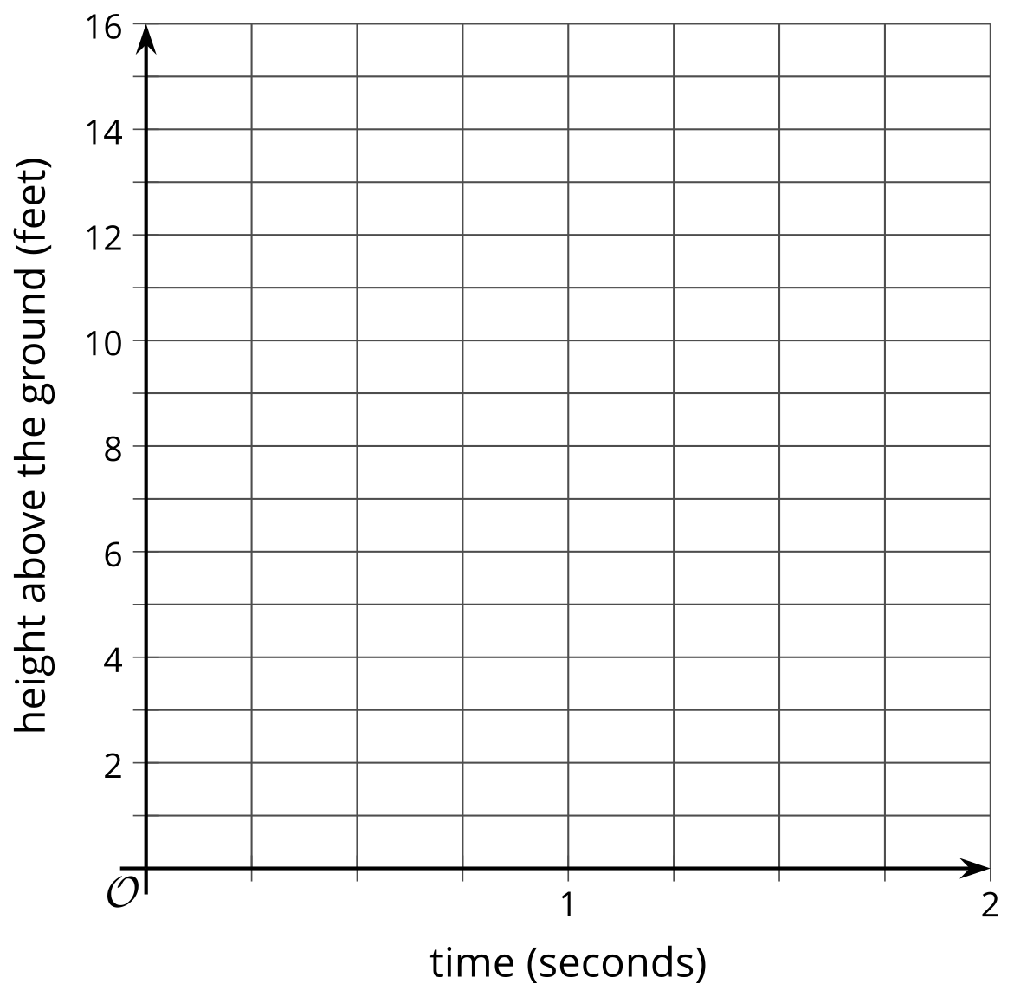
- The amount of charge left in a phone battery as a percentage is a function of time. Clare runs her phone until it is completely dead, then charges it all the way back up at a steady rate.
- 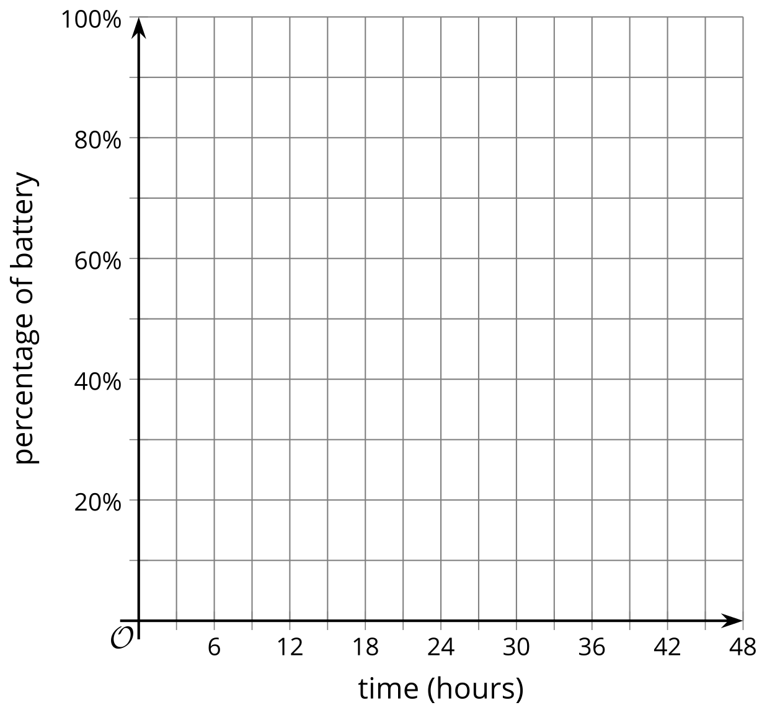
© CC BY 2019 by Illustrative Mathematics®

