Lesson 12: Represent Division of Unit Fractions by Whole Numbers

Standards Alignments
Addressing | 5.NF.B.7.a, 5.NF.B.7.b

Teacher-facing Learning Goals
- Make sense of diagrams that represent division of a unit fraction by a whole number.

Student-facing Learning Goals
- Let’s make sense of diagrams that represent division of a unit fraction by a whole number.

Lesson Purpose
The purpose of this lesson is for students to use diagrams and equations to represent division of a unit fraction by a whole number.
In the previous lesson, students solved problems about dividing a unit fraction by a whole number in a way that made sense to them. In this lesson, students use tape diagrams to represent division of a unit fraction by a whole number. The tape diagrams used to represent the problems are familiar to students from earlier grades. Here is a tape diagram showing $\frac{1}{4}$, one out of 4 pieces is shaded:
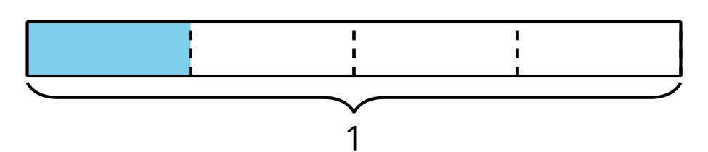
One way to show $\frac{1}{4}÷3$ is to divide the $\frac{1}{4}$ into 3 equal pieces.
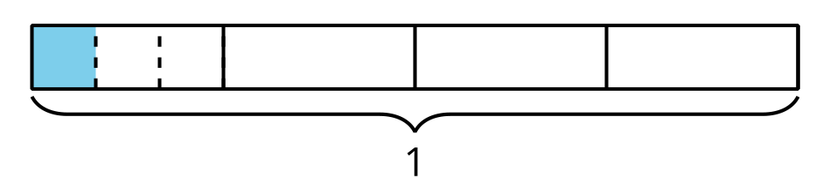
To see how much is shaded we can divide all of the $\frac{1}{4}$s and see that $\frac{1}{4}÷3=\frac{1}{12}$.
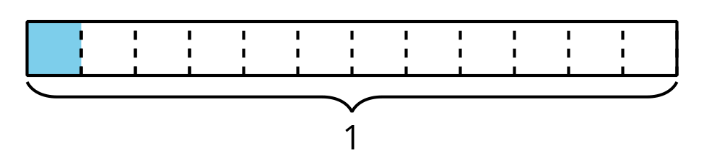
Students use these diagrams to understand this series of steps representing division of a unit fraction by a whole number throughout the lesson.

Access for:

Students with Disabilities
- Engagement (Activity 3)

Instructional Routines
Estimation Exploration (Warm-up), MLR3 Clarify, Critique, Correct (Activity 2)

Lesson Timeline
Warm-up | 10 min
Activity 1 | 10 min
Activity 2 | 10 min
Activity 3 | 15 min
Lesson Synthesis | 10 min
Cool-down | 5 min

Teacher Reflection Question
What did you say, do, or ask during the lesson synthesis that helped students be clear on the learning of the day? How did understanding the cool-down of the lesson before you started teaching today help you synthesize that learning?

Cool-down
(to be completed at the end of the lesson) 5min
Evaluate Division Expressions

Standards Alignments
Addressing | 5.NF.B.7.a

Student-facing Task Statement

- 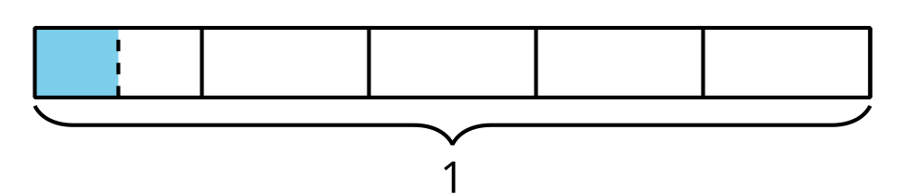
  - Write a division expression for the shaded region. Explain or show your reasoning.
  - What fraction does the shaded region represent? Explain or show your reasoning.

Student Responses
- $\frac{1}{5}÷2$ since the tape is divided into fifths and then the fifth is divided into 2 equal pieces
- $\frac{1}{10}$ because there are 10 of those pieces in the whole

