Lesson 10: What’s the Question?
- Let’s determine the question for story problems.

Warm-up: Notice and Wonder: A Day in the Park
In the park, there are 37 kids on the soccer field, 18 kids on the tennis courts, and 25 kids at the picnic tables.
What do you notice? What do you wonder?

10.1: Asked and Answered
Elena picked 29 apples. Elena picked 14 fewer apples than Han. Han picked 15 more apples than Diego.
- Write a question someone could answer based on this information.
- Answer your question. Show your thinking using diagrams, symbols, or other representations.

10.2: What is the Question?
Clare picked 51 apples. Lin picked 18 apples and Andre picked 19 apples.
Here is some student work showing the answer to a question about the apples.

- 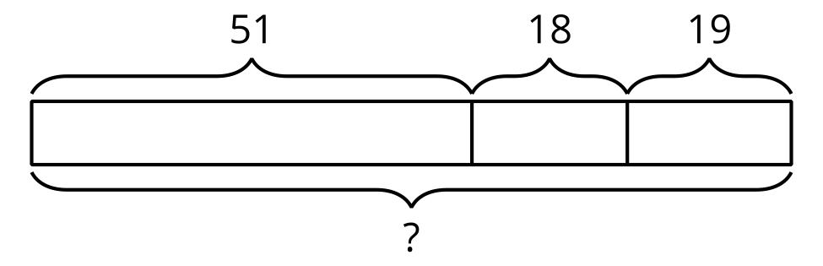
- $51+19=70$
- $70+18=88$
- What’s the question?
- Explain how you know.

- 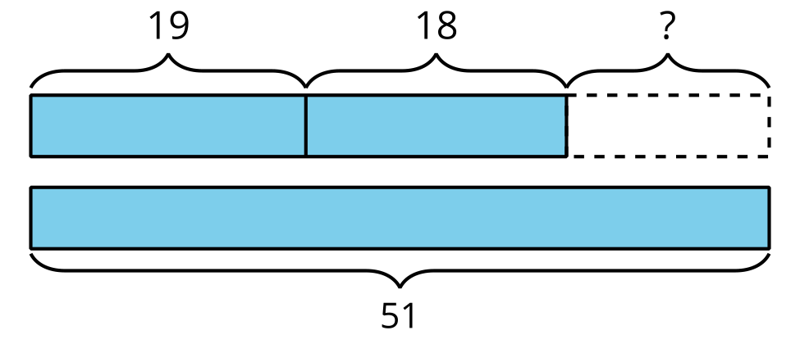
- $19+18=37$
- $51−37=14$
- What’s the question?
- Explain how you know.
© CC BY 2021 Illustrative Mathematics®

