Unit 6 Lesson 24: Assess the Reasonableness of Solutions

WU Notice and Wonder: Native American Languages (Warm up)

Student Task Statement
What do you notice and what do you wonder?
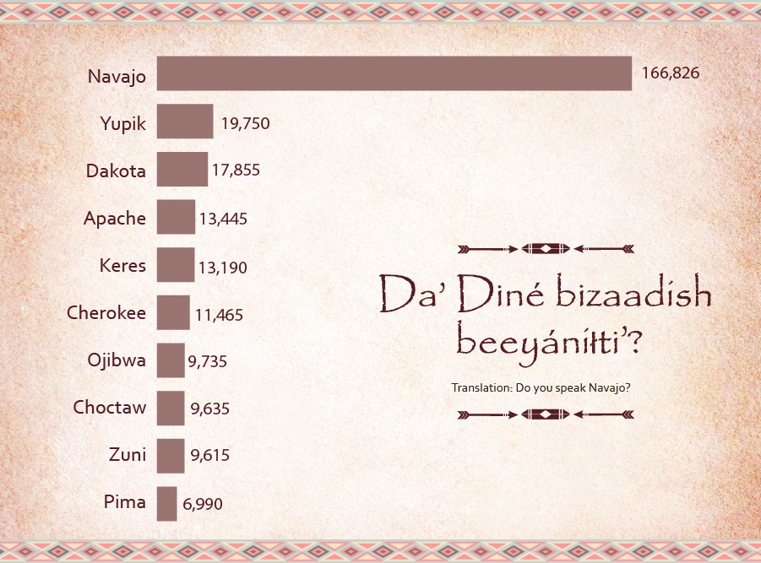

Activity Synthesis
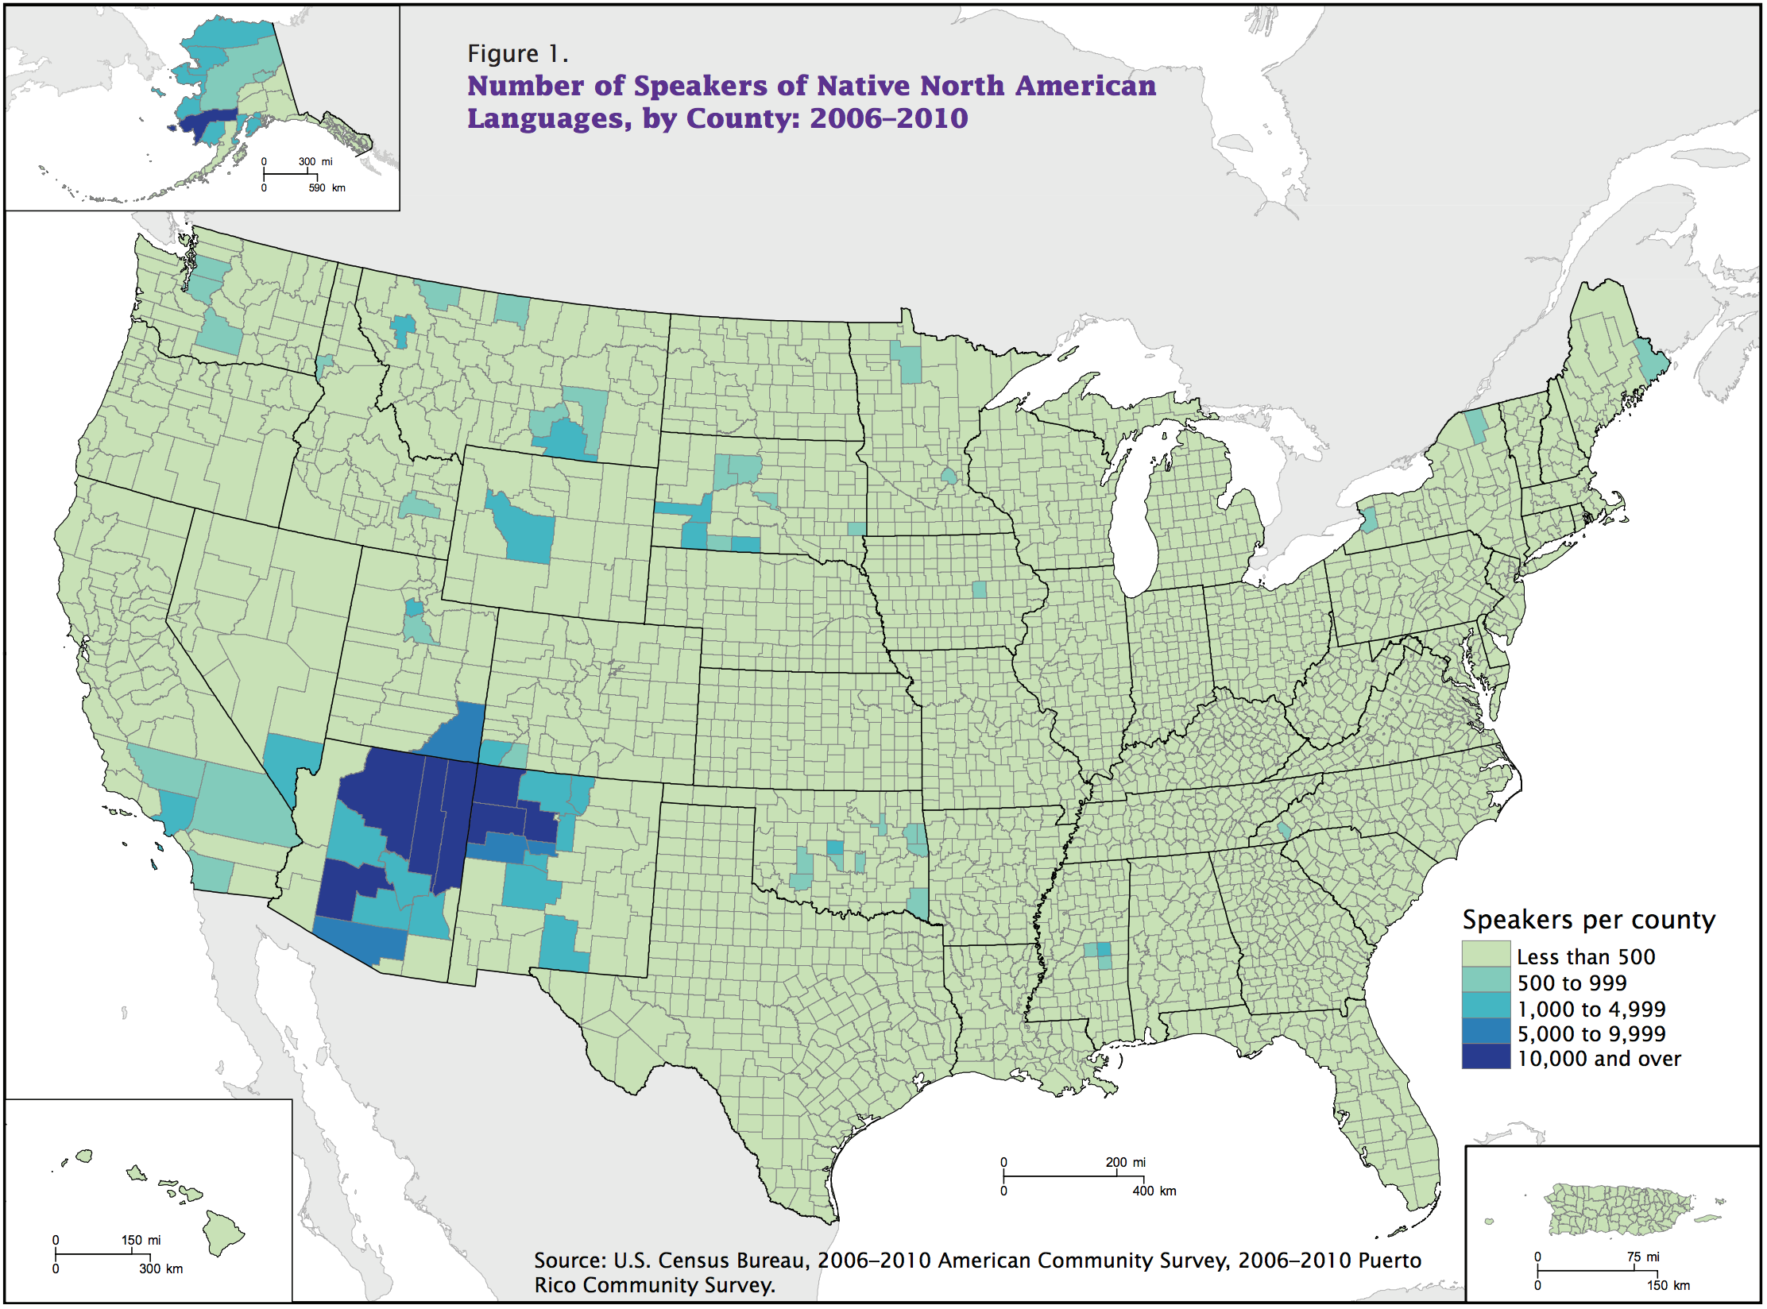

1 Do You Speak Navajo?

Student Task Statement
- In the list of the ten most widely spoken Native American languages in the U.S., Navajo and Yupik are the most widely spoken.
  - How many more Navajo speakers are there than Yupik speakers? Show your reasoning.
- language | - number of speakers
- Navajo | - 166,826
- Yupik | - 19,750
- Dakota | - 17,855
- Apache | - 13,445
- Keres | - 13,190
- Cherokee | - 11,465
- Ojibwa | - 9,735
- Choctaw | - 9,635
- Zuni | - 9,615
- Pima | - 6,990
  - About how many times as many Navajo speakers as there are Yupik speakers? Show your reasoning.
- Navajo, Apache, and Cherokee languages have been used during wartime to help the U.S. military keep its communications secure and incomprehensible to their enemies.
  - Based on the data here, how many people might have been able to understand the communications? Show your reasoning.
  - How do you know that your answer is reasonable?
- Are there more Navajo speakers than the speakers of all the other nine languages combined? Explain or show how you know.

2 Languages in Philadelphia and Chicago

Student Task Statement
Philadelphia, the birthplace of the United States, is a diverse city and home to people of different backgrounds.
The table shows 2017 data on some types of languages spoken in Philadelphia and the numbers of people who speak them.
language | number of speakers in Philadelphia
English only | 1,224,539
Spanish | 127,352
Other Indo-European | 6,750
Asian | 364
- Based on the data, are there more people in Philadelphia who only speak English or more people who speak a language other than English? Show how you know.
- What is the difference between the number of people who speak only English and those who speak another language? Show how you know.
- Chicago is a city with a similar population to Philadelphia.
- This table shows data on some types of languages spoken by people in Chicago.
- language | - number of speakers in Chicago
- English only | - 1,731,836
- Spanish | - 422,568
- Other Indo-European | - 25,777
- Asian | - 1,005
  - How many more speakers of Spanish and other Indo-European languages are in Chicago than in Philadelphia? Show your reasoning.
  - How do you know your answer is reasonable?
© CC BY 2021 Illustrative Mathematics®

