Unit 6 Lesson 15: Features of Trigonometric Graphs (Part 1)

1 Notice and Wonder: Musical Notes (Warm up)

Student Task Statement
Here are pictures of sound waves for two different musical notes:
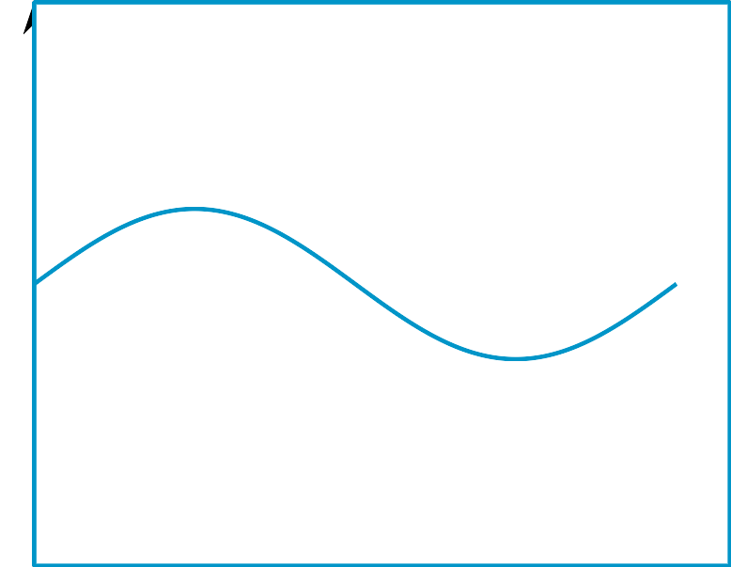
What do you notice? What do you wonder?

2 Equations and Graphs

Student Task Statement
Match each equation with its graph. More than 1 equation can match the same graph.
Equations:
- $y=\text{-}\text{cos}(θ)$
- $y=2\text{sin}(θ)−3$
- $y=\text{cos}\left(θ+\frac{π}{2}\right)$
- $y=3\text{sin}(θ)−2$
- $y=\text{sin}(θ−\frac{π}{2})$
- $y=\text{sin}(θ+π)$

A

B

C

D

3 Double the Sine

Student Task Statement
- Complete the table of values for the expression $\text{sin}(2θ)$
- $θ$ | - 0 | - $\frac{π}{12}$ | - $\frac{π}{6}$ | - $\frac{π}{4}$ | - $\frac{π}{2}$ | - $\frac{3π}{4}$ | - $π$ | - $\frac{5π}{4}$ | - $\frac{3π}{2}$ | - $\frac{7π}{4}$ | - $2π$
- $\text{sin}(2θ)$
- Plot the values and sketch a graph of the equation $y=\text{sin}(2θ)$. How does the graph of $y=\text{sin}(2θ)$ compare to the graph of $y=\text{sin}(θ)$?
- Predict what the graph of $y=\text{cos}(4θ)$ will look like and make a sketch. Explain your reasoning.

Activity Synthesis

Images for Activity Synthesis
© CC BY 2019 by Illustrative Mathematics®

