Unit 2 Lesson 12: Connect Quantities and Numbers

WU How Many Do You See: Image Flash (Warm up)

Student Task Statement
How many do you see?
How do you see them?
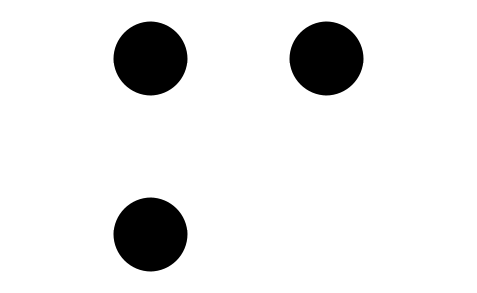
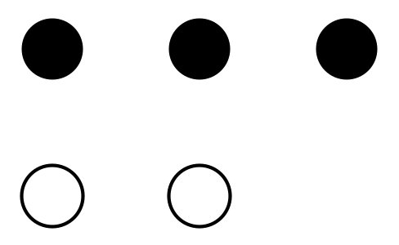

1 Which Bag?

Student Task Statement

2 Counting Stations

Student Task Statement
number of objects | bag name
1
2
3
4
5
6
7
8
9
10

3 Revisit Number Race, Numbers 1–10

Student Task Statement
Choose a center.
Number Race
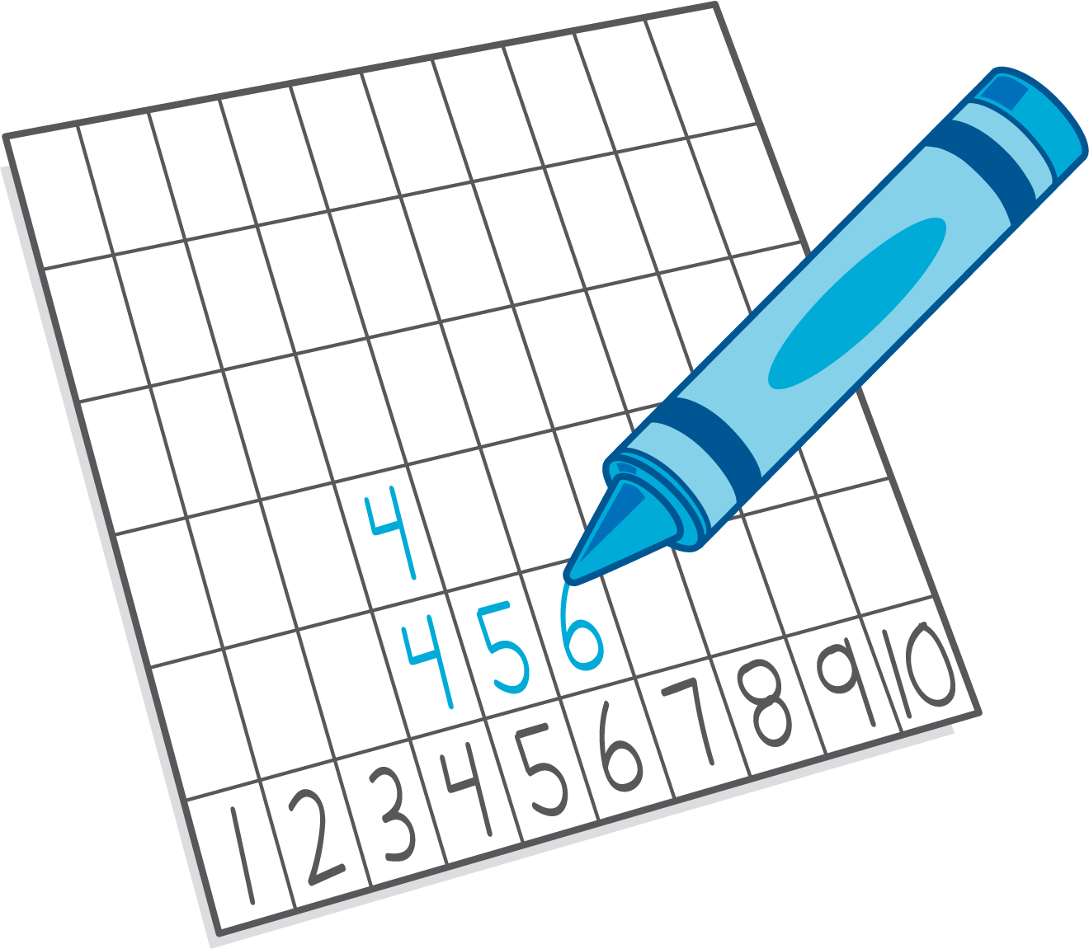
Geoblocks
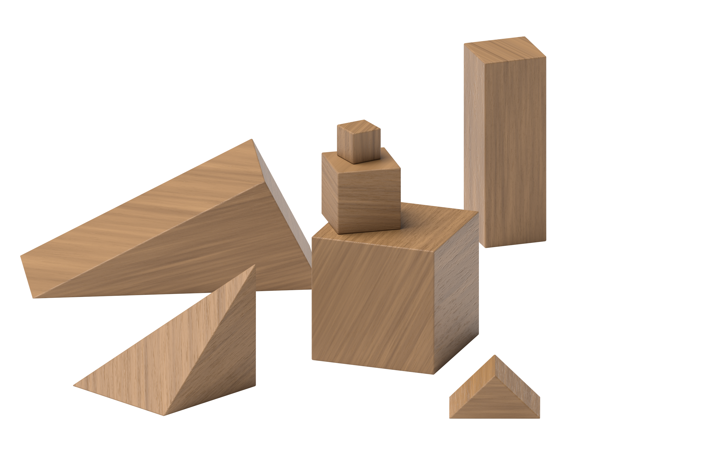
Math Fingers
© CC BY 2021 Illustrative Mathematics®

