Lesson 16: Distinguishing Between Surface Area and Volume

16.1: Attributes and Their Measures
For each quantity, choose one or more appropriate units of measurement.
For the last two, think of a quantity that could be appropriately measured with the given units.
Quantities
- Perimeter of a parking lot:
- Volume of a semi truck:
- Surface area of a refrigerator:
- Length of an eyelash:
- Area of a state:
- Volume of an ocean:
- ________________________: miles
- ________________________: cubic meters
Units
- millimeters (mm)
- feet (ft)
- meters (m)
- square inches (sq in)
- square feet (sq ft)
- square miles (sq mi)
- cubic kilometers (cu km)
- cubic yards (cu yd)

16.2: Building with 8 Cubes
Your teacher will give you 16 cubes. Build two different shapes using 8 cubes for each. For each shape:
- Give it a name or a label (e.g., Mai’s First Shape or Diego’s Steps).
- Determine the volume.
- Determine the surface area.
- Record the name, volume, and surface area on a sticky note.

16.3: Comparing Prisms Without Building Them
Three rectangular prisms each have a height of 1 cm.
- Prism A has a base that is 1 cm by 11 cm.
- Prism B has a base that is 2 cm by 7 cm.
- Prism C has a base that is 3 cm by 5 cm.
- Find the surface area and volume of each prism. Use the dot paper to draw the prisms, if needed.
- Analyze the volumes and surface areas of the prisms. What do you notice? Write 1 or 2 observations about them.

Are you ready for more?
Can you find more examples of prisms that have the same surface areas but different volumes? How many can you find?

Lesson 16 Summary
Length is a one-dimensional attribute of a geometric figure. We measure lengths using units like millimeters, centimeters, meters, kilometers, inches, feet, yards, and miles.
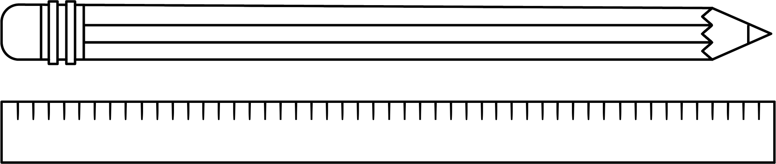
Area is a two-dimensional attribute. We measure area in square units. For example, a square that is 1 centimeter on each side has an area of 1 square centimeter.
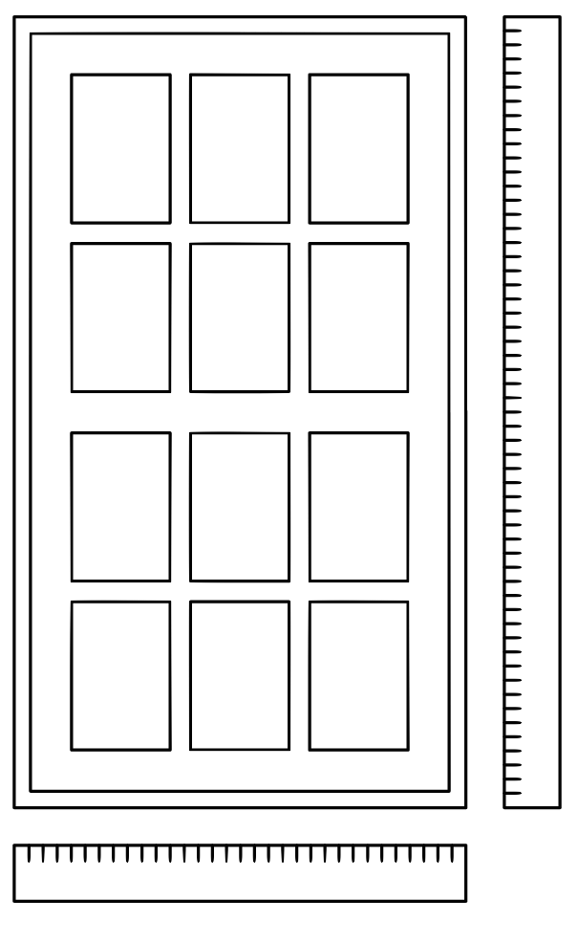
Volume is a three-dimensional attribute. We measure volume in cubic units. For example, a cube that is 1 kilometer on each side has a volume of 1 cubic kilometer.
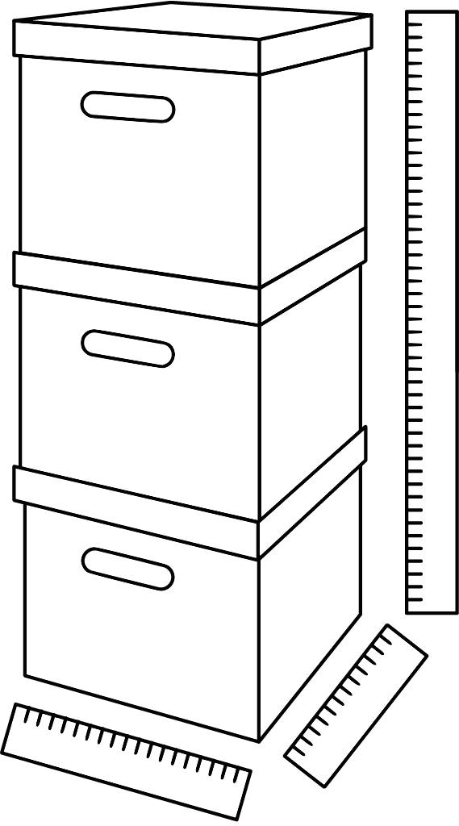
Surface area and volume are different attributes of three-dimensional figures. Surface area is a two-dimensional measure, while volume is a three-dimensional measure.
Two figures can have the same volume but different surface areas. For example:
- A rectangular prism with side lengths of 1 cm, 2 cm, and 2 cm has a volume of 4 cu cm and a surface area of 16 sq cm.
- A rectangular prism with side lengths of 1 cm, 1 cm, and 4 cm has the same volume but a surface area of 18 sq cm.
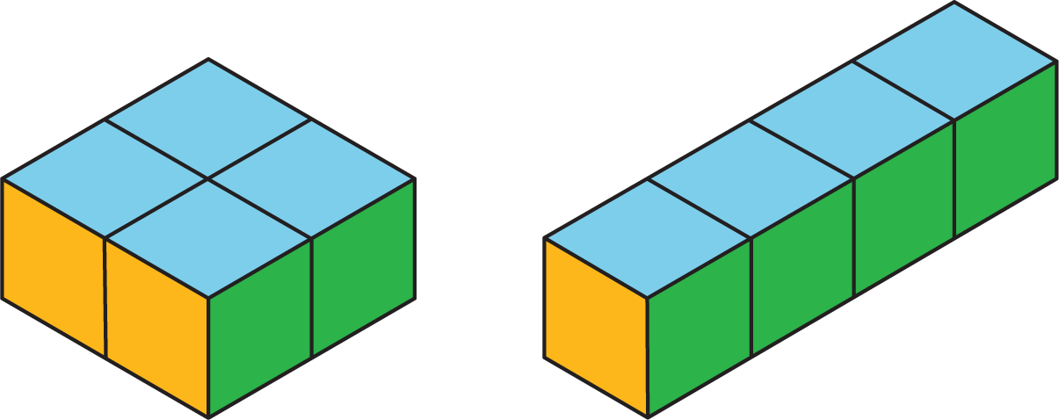
Similarly, two figures can have the same surface area but different volumes.
- A rectangular prism with side lengths of 1 cm, 1 cm, and 5 cm has a surface area of 22 sq cm and a volume of 5 cu cm.
- A rectangular prism with side lengths of 1 cm, 2 cm, and 3 cm has the same surface area but a volume of 6 cu cm.
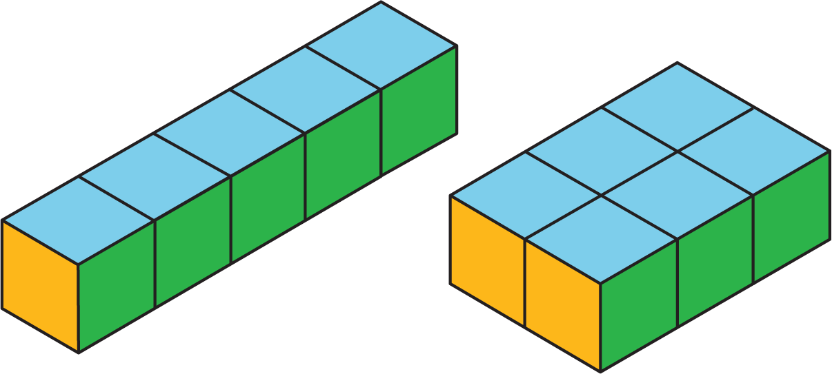
© CC BY Open Up Resources. Adaptations CC BY IM.

