Lesson 17 Practice Problems
- The 3 lines $x=3,y−2.5=\text{-}\frac{1}{5}(x−0.5),$ and $y−2.5=x−3.5$ intersect at point $P$. Find the coordinates of $P$. Verify algebraically that the lines all intersect at $P$.
- Triangle $ABC$ has vertices at $(0,0),(5,5),$ and $(10,1)$. Kiran calculates the point of intersection of the medians using the following steps:
  - Draw the triangle.
  - Calculate the midpoint of each side.
  - Draw the medians.
  - Write an equation for 2 of the medians.
  - Solve the system of equations.
- Use Kiran’s method to calculate the point of intersection of the medians.
- (From Unit 6, Lesson 16.)
- Triangle $ABC$ and its medians are shown. Write an equation for median $AE$.
- (From Unit 6, Lesson 16.)
- Given $A=(1,2)$ and $B=(7,14)$, find the point that partitions segment $AB$ in a $2:1$ ratio.
- (From Unit 6, Lesson 15.)
- A quadrilateral has vertices $A=(0,0),B=(4,6),C=(0,12),$ and $D=(\text{-}4,6)$. Mai thinks the quadrilateral is a rhombus and Elena thinks the quadrilateral is a square. Do you agree with either of them? Show or explain your reasoning.
- (From Unit 6, Lesson 14.)
- The image shows a graph of the parabola with focus $(\text{-}3,\text{-}2)$ and directrix $y=2$, and the line given by $y=\text{-}3$. Find and verify the points where the parabola and the line intersect.
- (From Unit 6, Lesson 13.)
- For each equation, is the graph of the equation parallel to the line shown, perpendicular to the line shown, or neither?
- 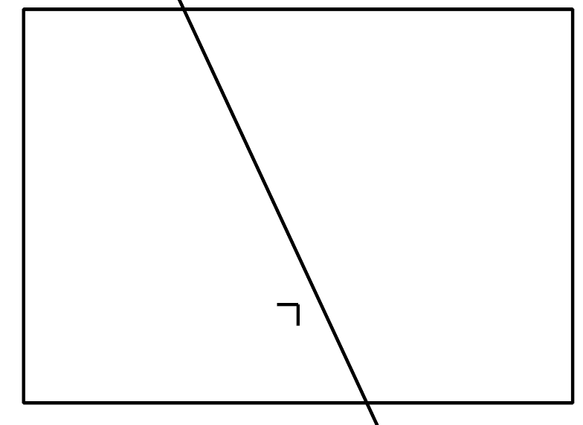
  - $y=0.25x$
  - $y=2x−4$
  - $y−2=\text{-}4(x−3)$
  - $2y+8x=7$
  - $x−4y=3$
- (From Unit 6, Lesson 12.)
- Write 2 equivalent equations for a line with $x$-intercept $(3,0)$ and $y$-intercept $(0,2)$.
- (From Unit 6, Lesson 9.)
- Parabola A and parabola B both have the line $y=\text{-}2$ as the directrix. Parabola A has its focus at $(3,4)$ and parabola B has its focus at $(5,0)$. Select all true statements.
  - Parabola A is wider than parabola B.
  - Parabola B is wider than parabola A.
  - The parabolas have the same line of symmetry.
  - The line of symmetry of parabola A is to the right of that of parabola B.
  - The line of symmetry of parabola B is to the right of that of parabola A.
- (From Unit 6, Lesson 7.)
© CC BY 2019 by Illustrative Mathematics®

