Unit 7 Lesson 4: Absolute Value of Numbers

1 Number Talk: Closer to Zero (Warm up)

Student Task Statement
For each pair of expressions, decide mentally which one has a value that is closer to 0.
$\frac{9}{11}$ or $\frac{15}{11}$
$\frac{1}{5}$ or $\frac{1}{9}$
$1.25$ or $\frac{5}{4}$
$0.01$ or $0.001$

2 Jumping Flea

Student Task Statement
- A flea is jumping around on a number line.
- 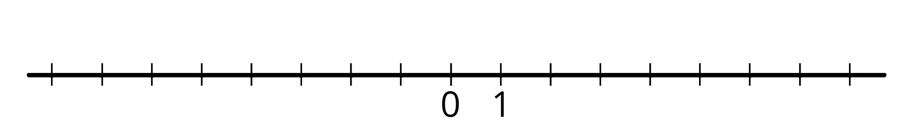
  - If the flea starts at 1 and jumps 4 units to the right, where does it end up? How far away from 0 is this?
  - If the flea starts at 1 and jumps 4 units to the left, where does it end up? How far away from 0 is this?
  - If the flea starts at 0 and jumps 3 units away, where might it land?
  - If the flea jumps 7 units and lands at 0, where could it have started?
  - The absolute value of a number is the distance it is from 0. The flea is currently to the left of 0 and the absolute value of its location is 4. Where on the number line is it?
  - If the flea is to the left of 0 and the absolute value of its location is 5, where on the number line is it?
  - If the flea is to the right of 0 and the absolute value of its location is 2.5, where on the number line is it?
- We use the notation $\left|\text{-}2\right|$ to say "the absolute value of -2," which means "the distance of -2 from 0 on the number line."
  - What does $\left|\text{-}7\right|$ mean and what is its value?
  - What does $\left|1.8\right|$ mean and what is its value?

3 Absolute Elevation and Temperature

Student Task Statement
- A part of the city of New Orleans is 6 feet below sea level. We can use “-6 feet” to describe its elevation, and “$\left|\text{-}6\right|$ feet” to describe its vertical distance from sea level. In the context of elevation, what would each of the following numbers describe?
  - 25 feet
  - $\left|25\right|$ feet
  - -8 feet
  - $\left|\text{-}8\right|$ feet
- The elevation of a city is different from sea level by 10 feet. Name the two elevations that the city could have.
- We write “$\text{-}5^{∘}\text{C}$” to describe a temperature that is 5 degrees Celsius below freezing point and “$5^{∘}\text{C}$” for a temperature that is 5 degrees above freezing. In this context, what do each of the following numbers describe?
  - $1^{∘}\text{C}$
  - $\text{-}4^{∘}\text{C}$
  - ${\left|12\right|}^{∘}\text{C}$
  - ${\left|\text{-}7\right|}^{∘}\text{C}$

  - Which temperature is colder: $\text{-}6^{∘}\text{C}$ or $3^{∘}\text{C}$?
  - Which temperature is closer to freezing temperature: $\text{-}6^{∘}\text{C}$ or $3^{∘}\text{C}$?
  - Which temperature has a smaller absolute value? Explain how you know.

Activity Synthesis
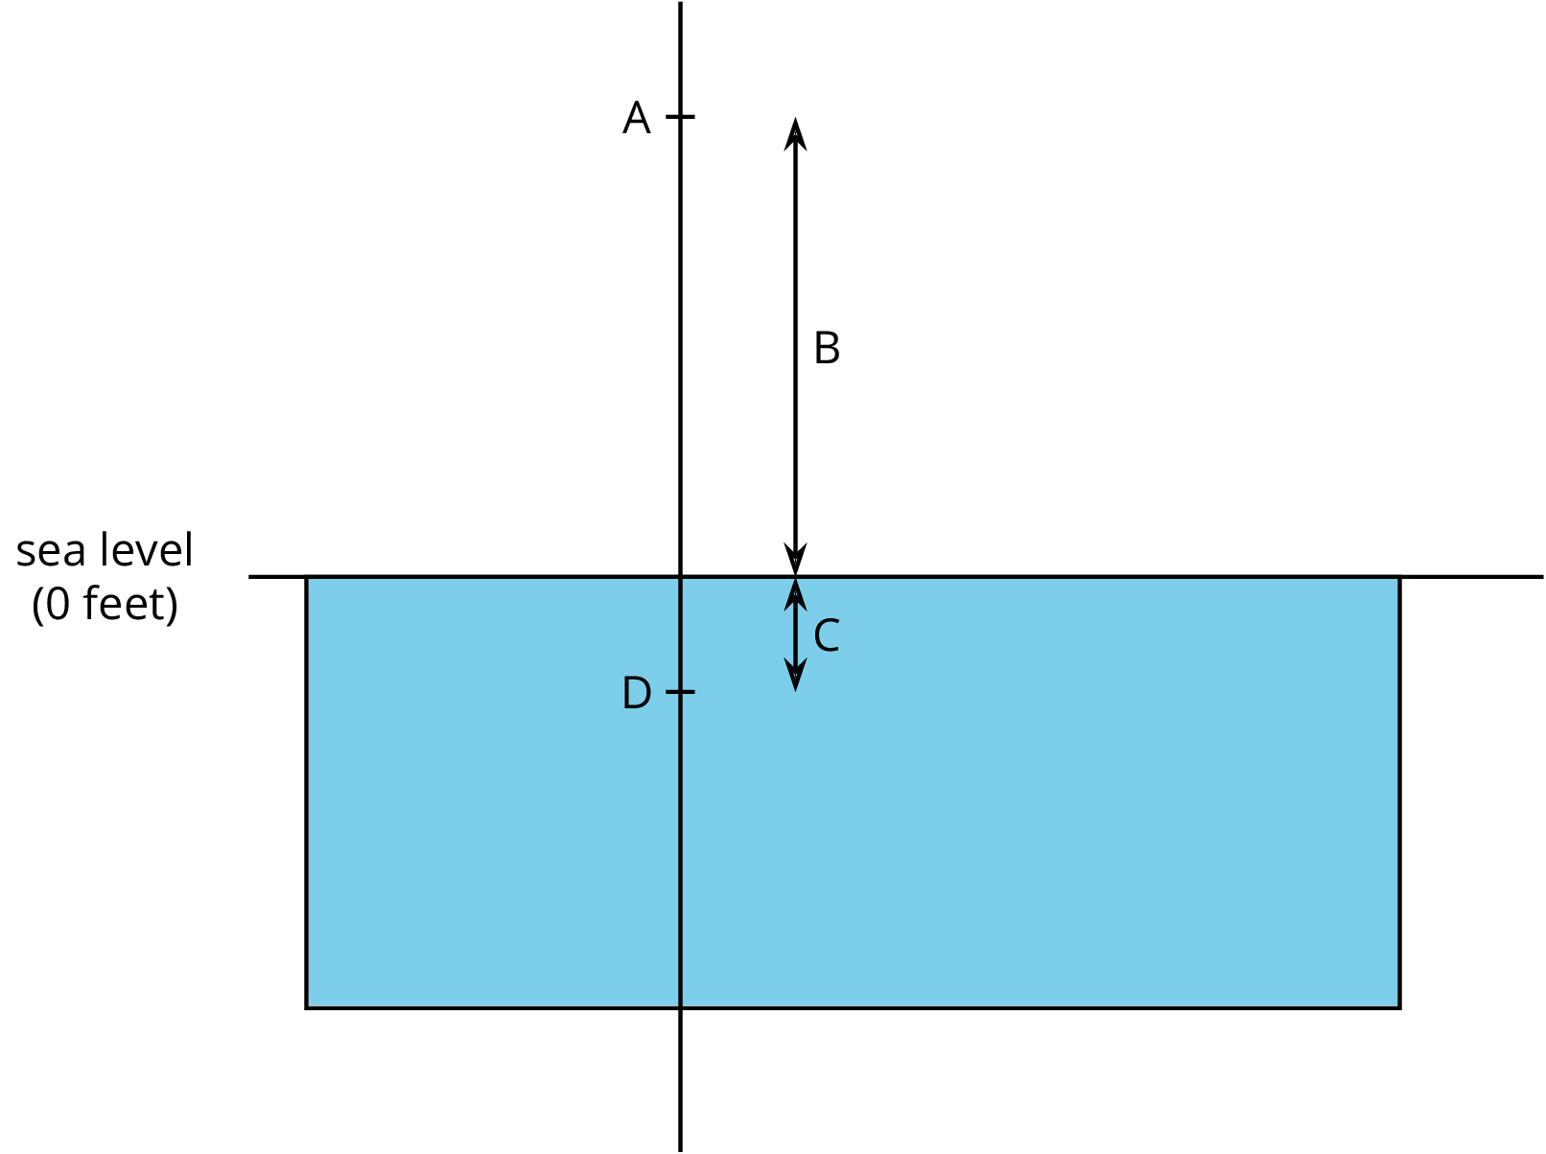
© CC BY Open Up Resources. Adaptations CC BY IM.

