Unit 2 Lesson 13: Numbers in Many Ways

WU How Many Do You See: Different Arrangements of 4 (Warm up)

Student Task Statement
How many do you see?
How do you see them?
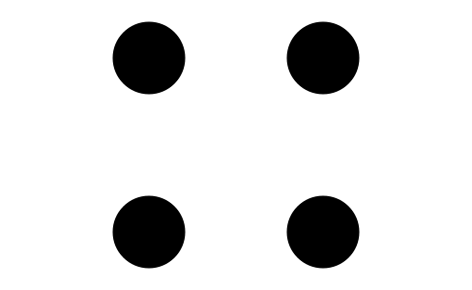
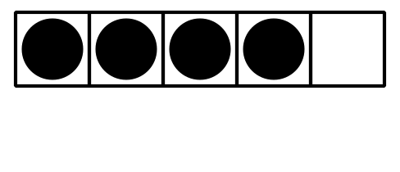

1 Matching Groups of Images and Numbers

Student Task Statement

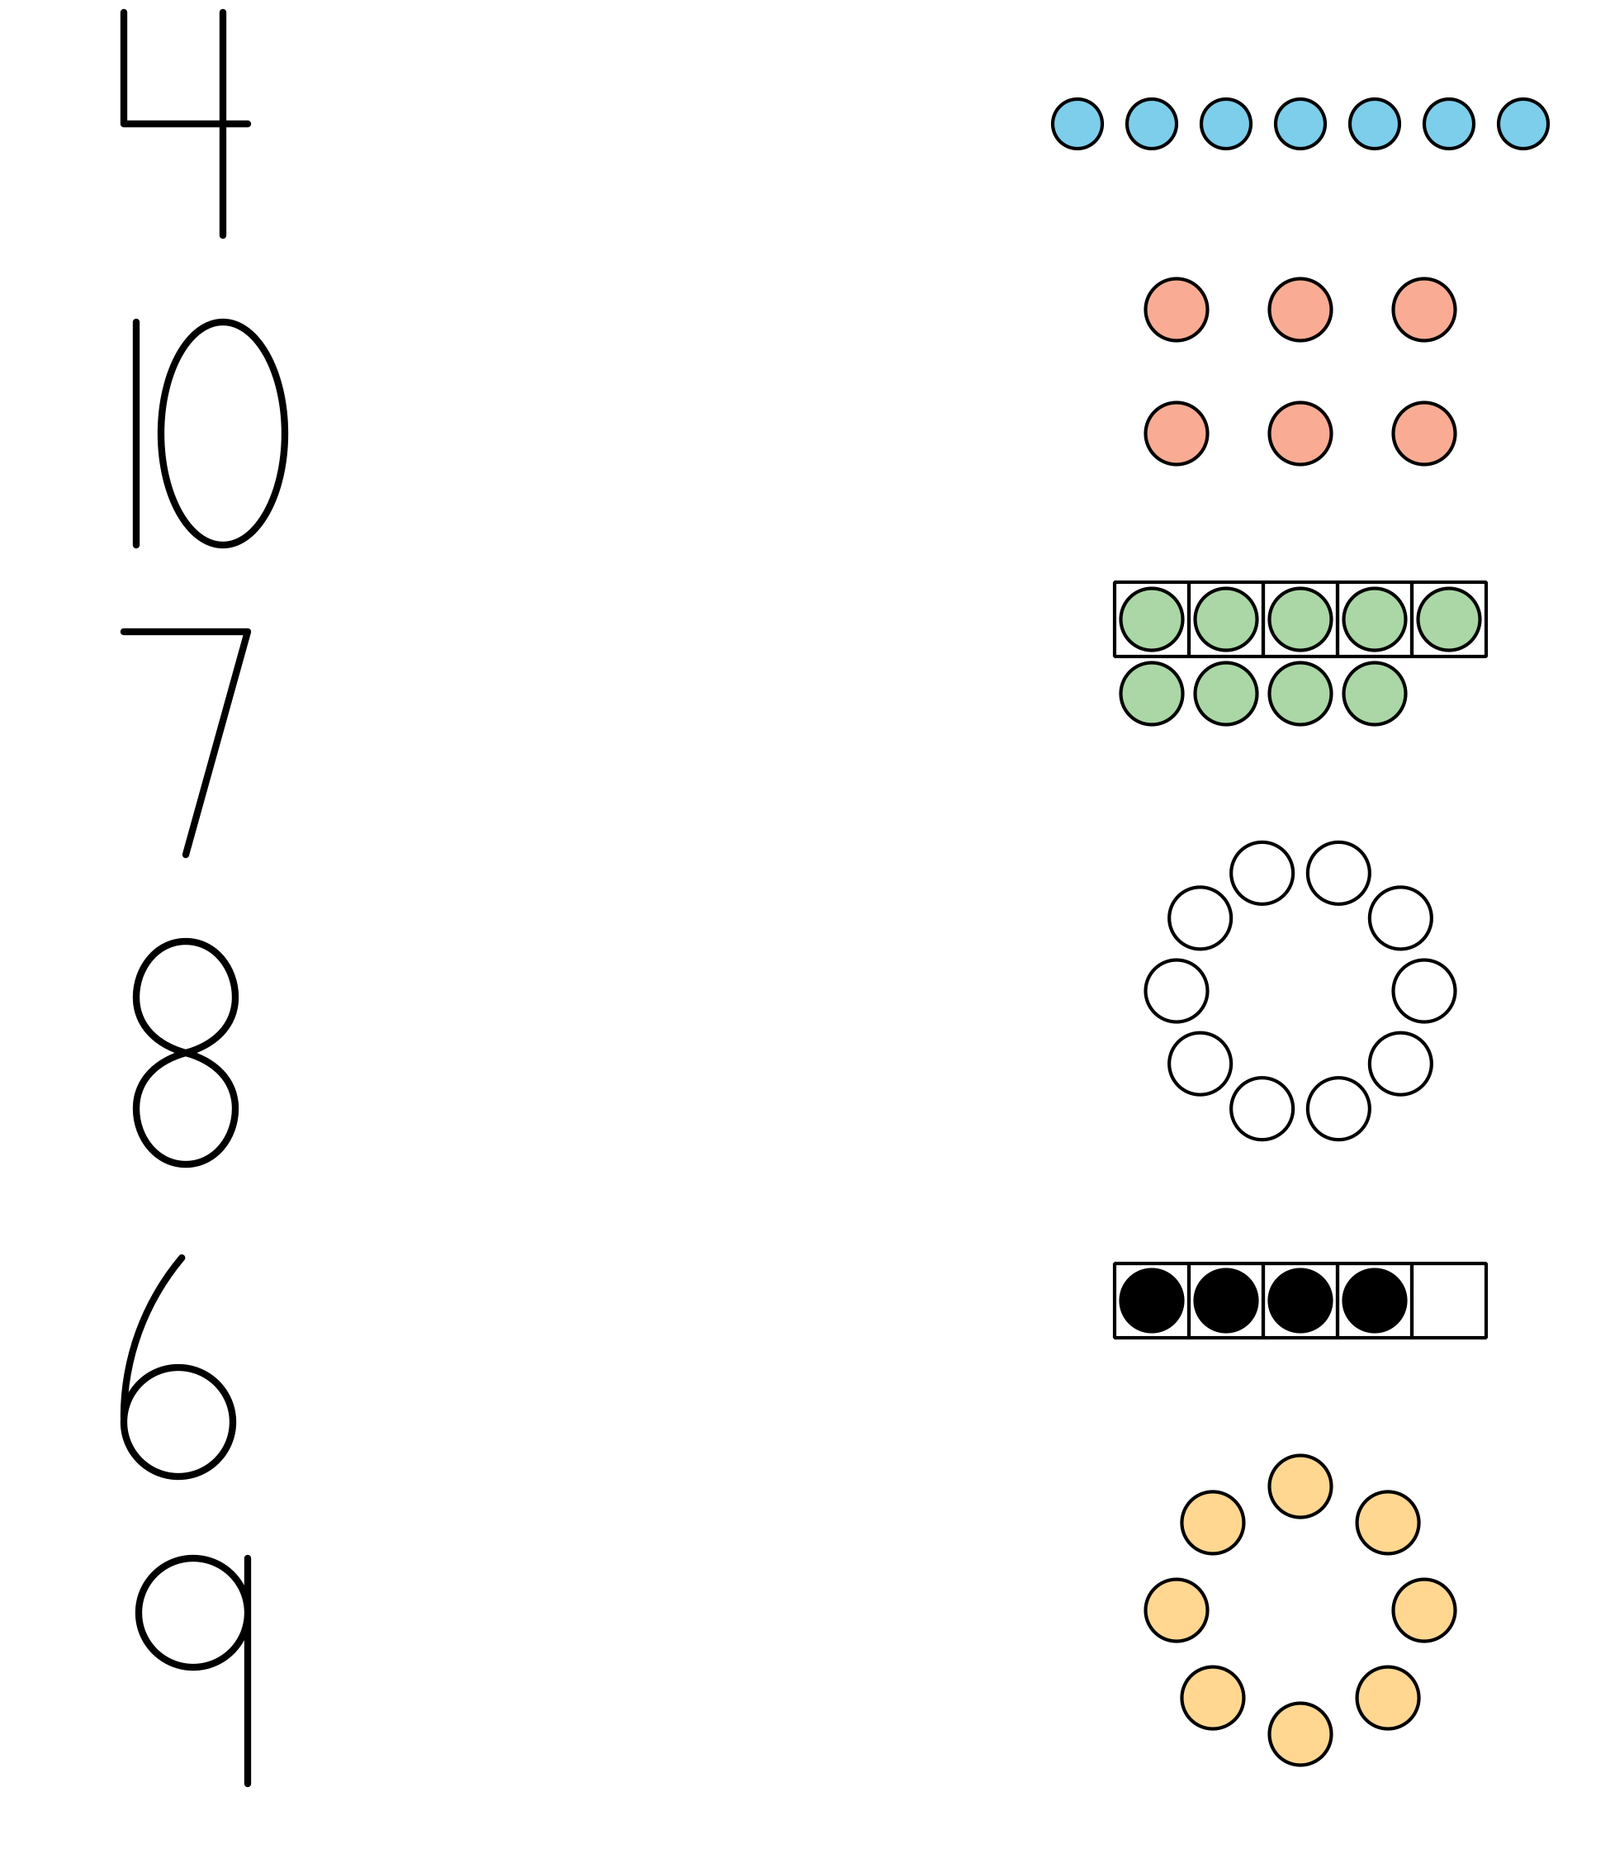

2 Different Arrangements, Same Number

Student Task Statement

3 Centers: Choice Time

Student Task Statement
Choose a center.
Number Race
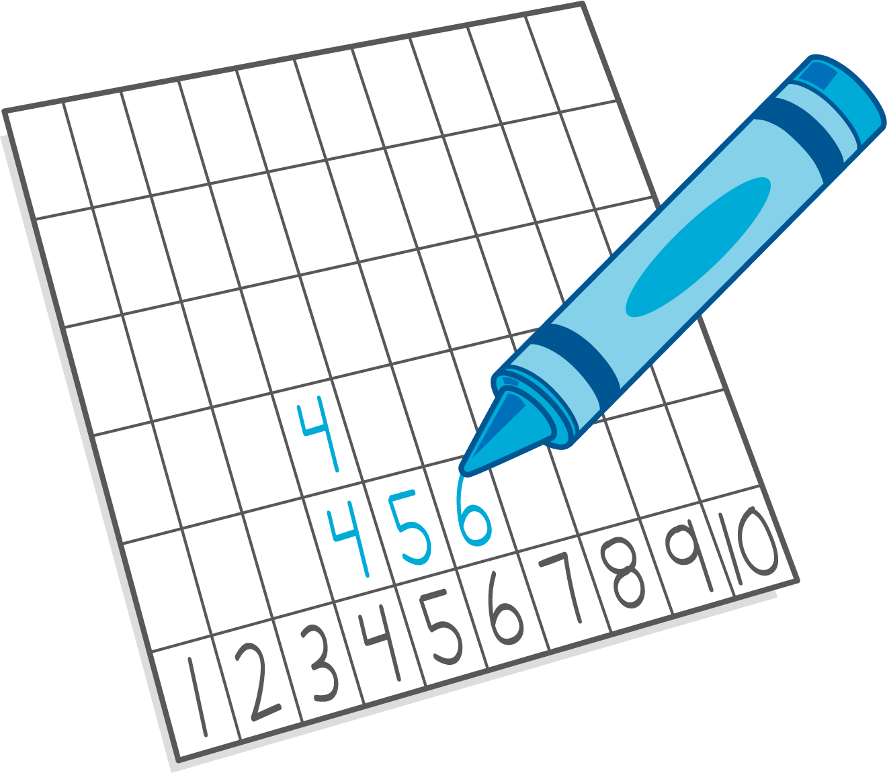
Geoblocks
Math Fingers

Images for Activity Synthesis
© CC BY 2021 Illustrative Mathematics®

