Lesson 2: Inscribed Angles
- Let’s analyze angles made from chords.

2.1: Notice and Wonder: A New Angle
What do you notice? What do you wonder?
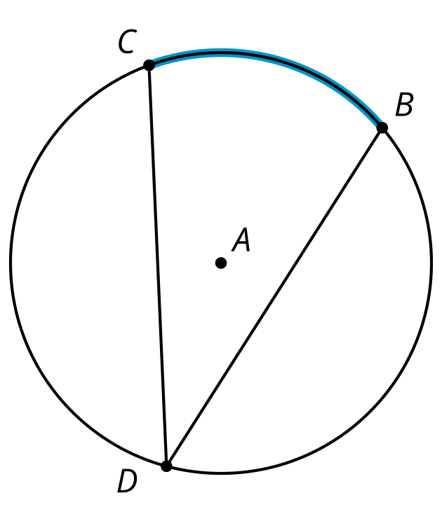

2.2: A Central Relationship
Here is a circle with central angle $QAC$.
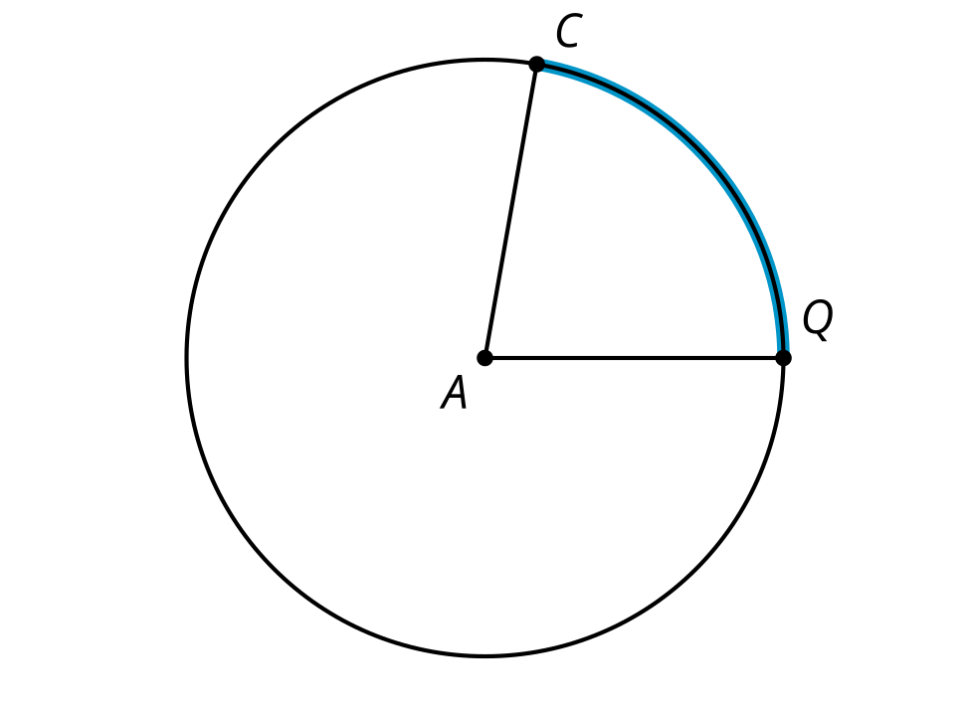
- Use a protractor to find the approximate degree measure of angle $QAC$.
- Mark a point $B$ on the circle that is not on the highlighted arc from $C$ to $Q$. Each member of your group should choose a different location for point $B$. Draw chords $BC$ and $BQ$. Use a protractor to find the approximate degree measure of angle $QBC$.
- Share your results with your group. What do you notice about your answers?
- Make a conjecture about the relationship between an inscribed angle and the central angle that defines the same arc.

Are you ready for more?
Here is a special case of an inscribed angle where one of the chords that defines the inscribed angle goes through the center. The central angle $DCF$ measures $θ$ degrees, and the inscribed angle $DEF$ measures $α$ degrees. Prove that $α=\frac{1}{2}θ$.
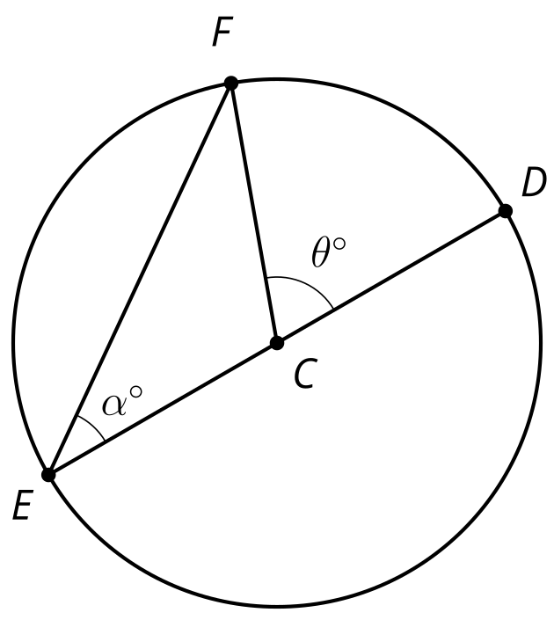

2.3: Similarity Returns
The image shows a circle with chords $CD,CB,ED,$ and $EB$. The highlighted arc from point $C$ to point $E$ measures 100 degrees. The highlighted arc from point $D$ to point $B$ measures 140 degrees.
Prove that triangles $CFD$ and $EFB$ are similar.
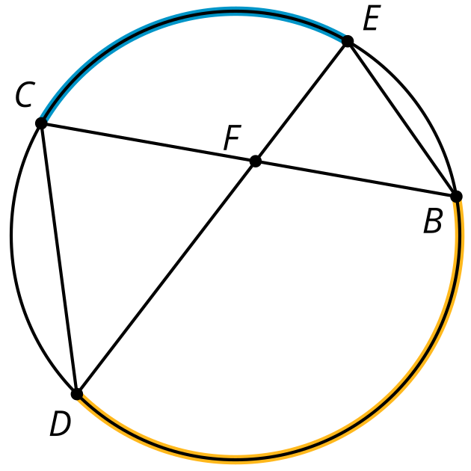

Lesson 2 Summary
We have discussed central angles such as angle $AOB$. Another kind of angle in a circle is an inscribed angle, or an angle formed by 2 chords that share an endpoint. In the image, angle $ACB$ is an inscribed angle.
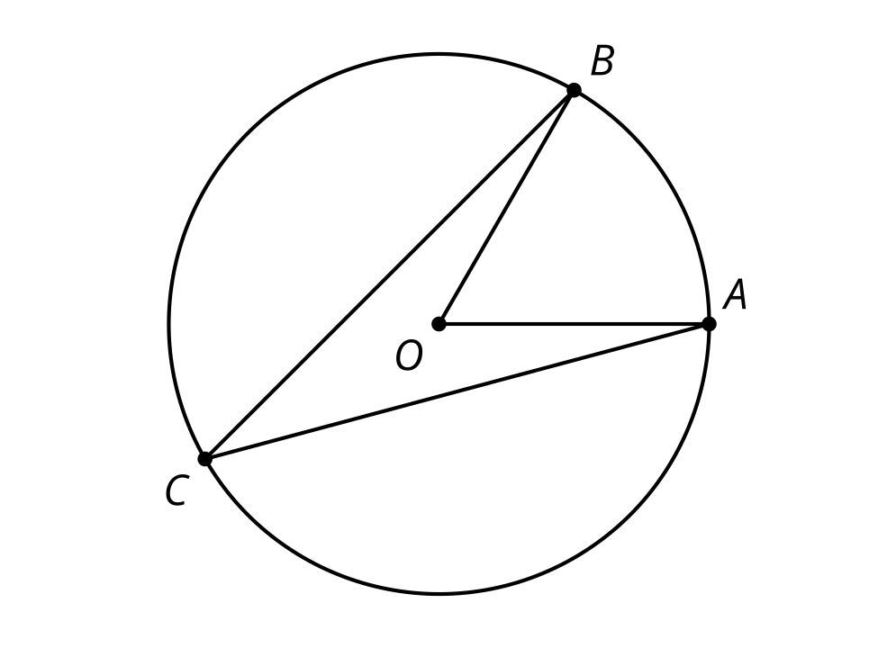
It looks as though the inscribed angle is smaller than the central angle that defines the same arc. In fact, the measure of an inscribed angle is always exactly half the measure of the associated central angle. For example, if the central angle $AOB$ measures 50 degrees, the inscribed angle $ACB$ must measure 25 degrees, even if we move point $C$ along the circumference (without going past $A$ or $B$). This also means that all inscribed angles that define the same arc are congruent.
© CC BY 2019 by Illustrative Mathematics®

