Lesson 14: Fractional Lengths in Triangles and Prisms
Let’s explore area and volume when fractions are involved.

14.1: Area of Triangle
Find the area of Triangle A in square centimeters. Show your reasoning.
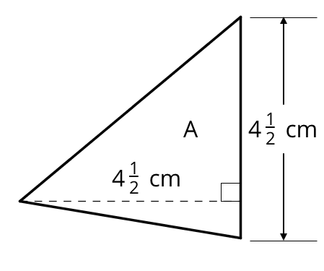

14.2: Bases and Heights of Triangles
- The area of Triangle B is 8 square units. Find the length of $b$. Show your reasoning.
- 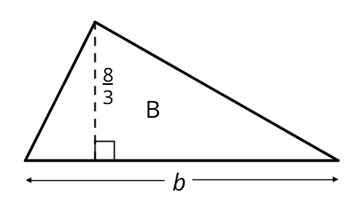
- The area of Triangle C is $\frac{54}{5}$ square units. What is the length of $h$? Show your reasoning.
- 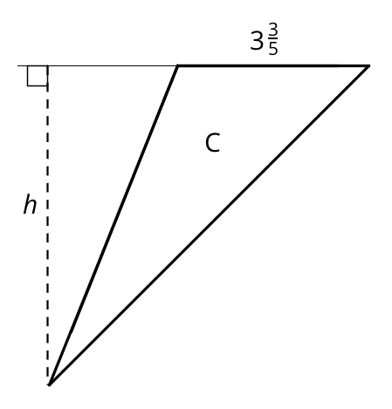

14.3: Volumes of Cubes and Prisms
Your teacher will give you cubes that have edge lengths of $\frac{1}{2}$ inch.
- Here is a drawing of a cube with edge lengths of 1 inch.
- 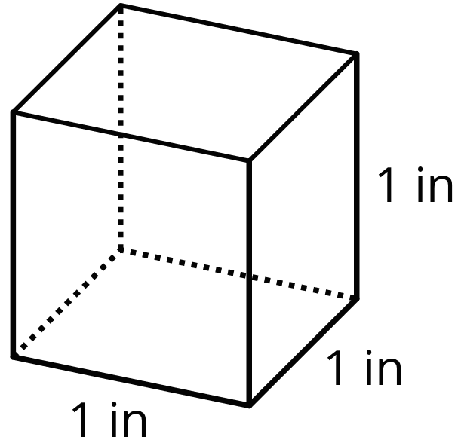
  - How many cubes with edge lengths of $\frac{1}{2}$ inch are needed to fill this cube?
  - What is the volume, in cubic inches, of a cube with edge lengths of $\frac{1}{2}$ inch? Explain or show your reasoning.
- Four cubes are piled in a single stack to make a prism. Each cube has an edge length of $\frac{1}{2}$ inch. Sketch the prism, and find its volume in cubic inches.
- Use cubes with an edge length of $\frac{1}{2}$ inch to build prisms with the lengths, widths, and heights shown in the table.
  - For each prism, record in the table how many $\frac{1}{2}$-inch cubes can be packed into the prism and the volume of the prism.
- prism  length (in) | - prism  width (in) | - prism  height (in) | - number of $\frac{1}{2}$-inch  cubes in prism | - volume of  prism (in³)
- $\frac{1}{2}$ | - $\frac{1}{2}$ | - $\frac{1}{2}$
- 1 | - 1 | - $\frac{1}{2}$
- 2 | - 1 | - $\frac{1}{2}$
- 2 | - 2 | - 1
- 4 | - 2 | - $\frac{3}{2}$
- 5 | - 4 | - 2
- 5 | - 4 | - $2\frac{1}{2}$
  - Examine the values in the table. What do you notice about the relationship between the edge lengths of each prism and its volume?
- What is the volume of a rectangular prism that is $1\frac{1}{2}$ inches by $2\frac{1}{4}$ inches by 4 inches? Show your reasoning.

Are you ready for more?
A unit fraction has a 1 in the numerator.
- These are unit fractions: $\frac{1}{3},\frac{1}{100},\frac{1}{1}$.
- These are not unit fractions: $\frac{2}{9},\frac{8}{1},2\frac{1}{5}$.
- Find three unit fractions whose sum is $\frac{1}{2}$. An example is: $\frac{1}{8}+\frac{1}{8}+\frac{1}{4}=\frac{1}{2}$ How many examples like this can you find?
- Find a box whose surface area in square units equals its volume in cubic units. How many like this can you find?

Lesson 14 Summary
If a rectangular prism has edge lengths of 2 units, 3 units, and 5 units, we can think of it as 2 layers of unit cubes, with each layer having $\left(3⋅5\right)$ unit cubes in it. So the volume, in cubic units, is: $2⋅3⋅5$
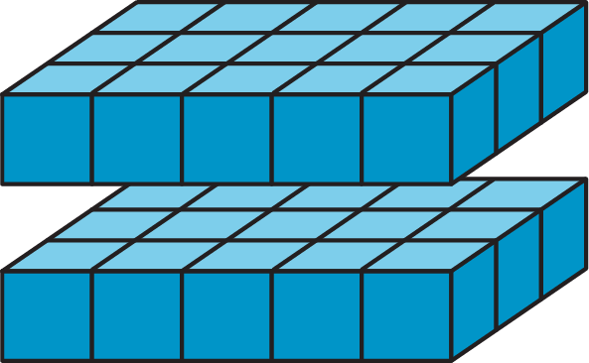
To find the volume of a rectangular prism with fractional edge lengths, we can think of it as being built of cubes that have a unit fraction for their edge length. For instance, if we build a prism that is $\frac{1}{2}$-inch tall, $\frac{3}{2}$-inch wide, and 4 inches long using cubes with a $\frac{1}{2}$-inch edge length, we would have:
- A height of 1 cube, because $1⋅\frac{1}{2}=\frac{1}{2}$.
- A width of 3 cubes, because $3⋅\frac{1}{2}=\frac{3}{2}$.
- A length of 8 cubes, because $8⋅\frac{1}{2}=4$.
The volume of the prism would be $1⋅3⋅8$, or 24 cubic units. How do we find its volume in cubic inches? We know that each cube with a $\frac{1}{2}$-inch edge length has a volume of $\frac{1}{8}$ cubic inch, because $\frac{1}{2}⋅\frac{1}{2}⋅\frac{1}{2}=\frac{1}{8}$. Since the prism is built using 24 of these cubes, its volume, in cubic inches, would then be $24⋅\frac{1}{8}$, or 3 cubic inches.
The volume of the prism, in cubic inches, can also be found by multiplying the fractional edge lengths in inches: ​​​​​​$\frac{1}{2}⋅\frac{3}{2}⋅4=3$
© CC BY Open Up Resources. Adaptations CC BY IM.

