Lesson 9: Subtraction Algorithms (Part 2)
- Let’s learn more about our first subtraction algorithm.

Warm-up: True or False: Does It Commute?
Decide if each statement is true or false. Be prepared to explain your reasoning.
- $4×5=5×4$
- $125+200=200+125$
- $300−100=100−300$

9.1: Revise Subtraction Work
Lin’s work for finding the value of $428−156$ is shown.
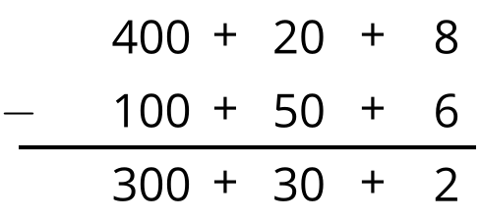
- What error do you see in Lin's work?
- What would you tell or show Lin so she can revise her work?

9.2: Try the Algorithm
Here is a subtraction algorithm you saw in an earlier lesson:
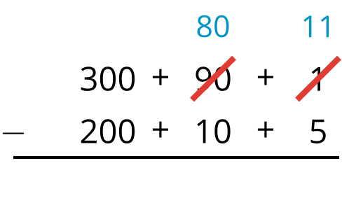
Try using this algorithm to find the value of each difference. Show your reasoning. Organize it so it can be followed by others.
- $283−159$
- $425−192$
- $639−465$
- $591−128$
- $832−575$
© CC BY 2021 Illustrative Mathematics®

