Unit 6 Lesson 13: Amplitude and Midline

1 Comparing Parabolas (Warm up)

Student Task Statement
Match each equation to its graph.
- $y=x^{2}$
- $y=3x^{2}$
- $y=3(x−1)^{2}$
- $y=3x^{2}−1$
- $y=x^{2}−1$

A
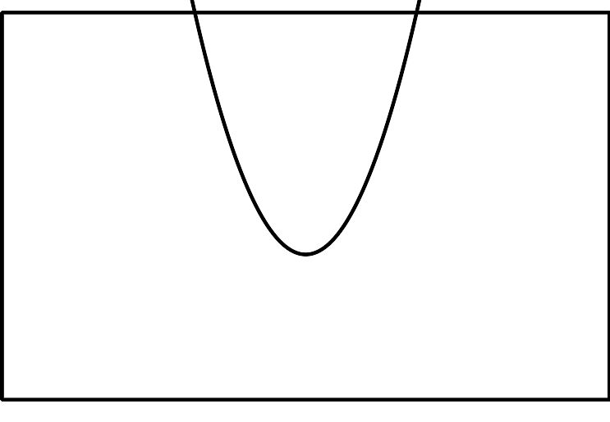

B
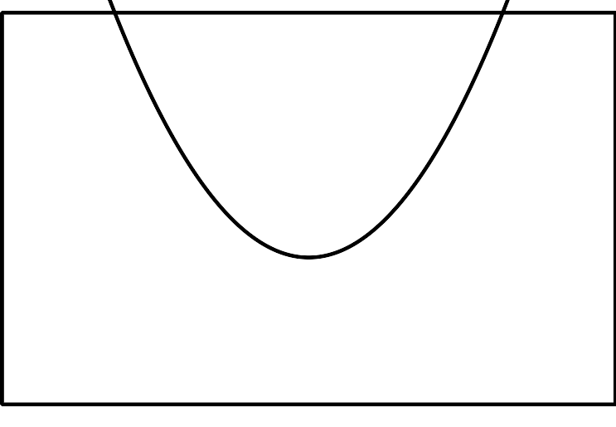

C
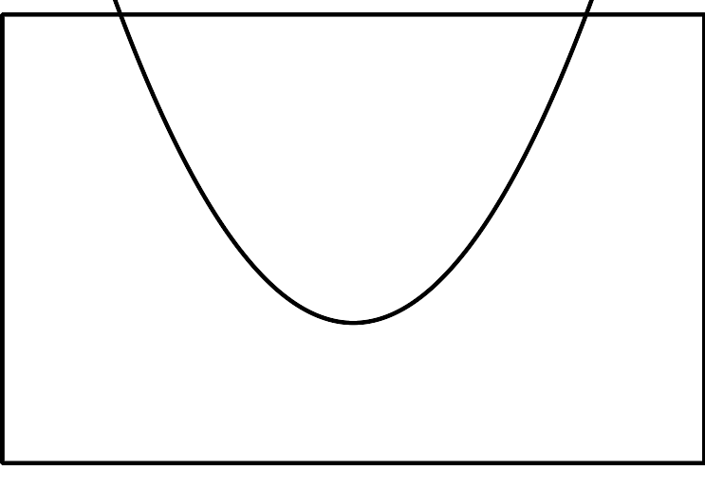

D
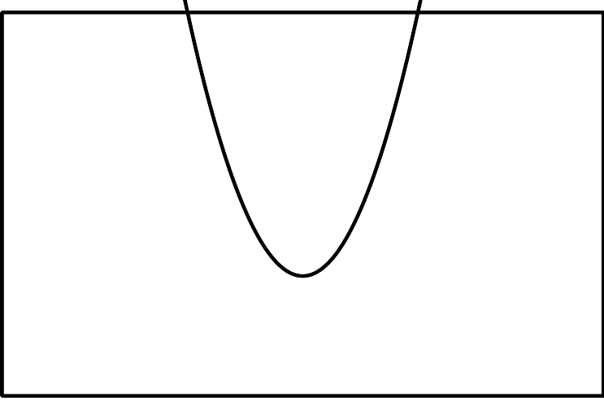

E
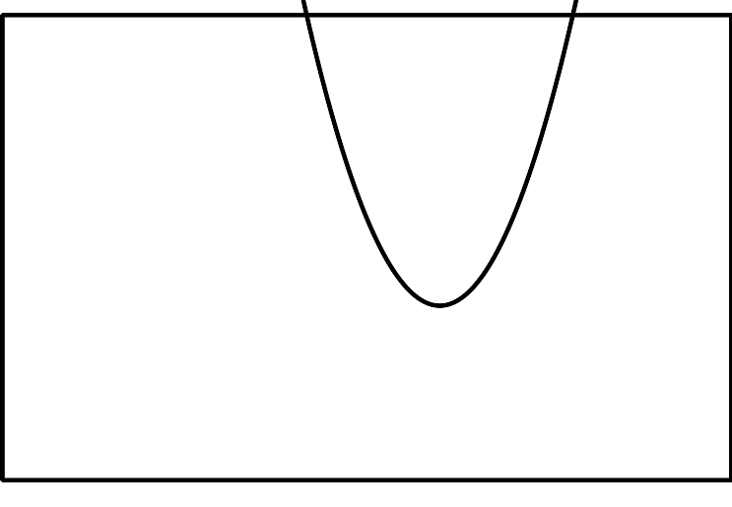
Be prepared to explain how you know which graph belongs with each equation.

2 Blowing in the Wind

Student Task Statement
Suppose a windmill has a radius of 1 meter and the center of the windmill is $(0,0)$ on a coordinate grid.
- Write a function describing the relationship between the height $h$ of $W$ and the angle of rotation $θ$. Explain your reasoning.
- Describe how your function and its graph would change if:
  - the windmill blade has length 3 meters.
  - The windmill blade has length 0.5 meter.
- Test your predictions using graphing technology.

Activity Synthesis

3 Up, Up, and Away

Student Task Statement
- A windmill has radius 1 meter and its center is 8 meters off the ground. The point $W$ starts at the tip of a blade in the position farthest to the right and rotates counterclockwise. Write a function describing the relationship between the height $h$ of $W$, in meters, and the angle $θ$ of rotation.
- Graph your function using technology. How does it compare to the graph where the center of windmill is at $(0,0)$?
- What would the graph look like if the center of the windmill were 11 meters off the ground? Explain how you know.

Images for Activity Synthesis
© CC BY 2019 by Illustrative Mathematics®

