Unit 7 Lesson 5: Comparing Numbers and Distance from Zero

1 Opposites (Warm up)

Student Task Statement
- $a$ is a rational number. Choose a value for $a$ and plot it on the number line.

  - Based on where you plotted $a$, plot $\text{-}a$ on the same number line.
  - What is the value of $\text{-}a$ that you plotted?
- Noah said, “If $a$ is a rational number, $\text{-}a$ will always be a negative number.” Do you agree with Noah? Explain your reasoning.

2 Submarine

Images for Launch
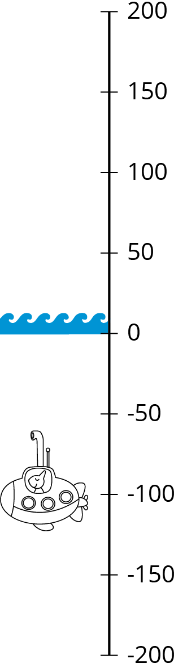

Student Task Statement
A submarine is at an elevation of -100 feet (100 feet below sea level). Let’s compare the elevations of these four people to that of the submarine:
- Clare’s elevation is greater than the elevation of the submarine. Clare is farther from sea level than the submarine.
- Andre’s elevation is less than the elevation of the submarine. Andre is farther away from sea level than the submarine.
- Han’s elevation is greater than the elevation of the submarine. Han is closer to sea level than is the submarine.
- Lin’s elevation is the same distance away from sea level as the submarine’s.
- Complete the table as follows.
  - Write a possible elevation for each person.
  - Use $<$, $>$, or $=$ to compare the elevation of that person to that of the submarine.
  - Use absolute value to tell how far away the person is from sea level (elevation 0).
- As an example, the first row has been filled with a possible elevation for Clare.
 | - possible  elevation | - compare to  submarine | - distance from  sea level
- Clare | - 150 feet | - $150>\text{-}100$ | - $\left|150\right|$ or 150 feet
- Andre
- Han
- Lin
- Priya says her elevation is less than the submarine’s and she is closer to sea level. Is this possible? Explain your reasoning.

3 Info Gap: Points on the Number Line (Optional)

Student Task Statement
Your teacher will give you either a problem card or a data card. Do not show or read your card to your partner.
If your teacher gives you the problem card:
- Silently read your card and think about what information you need to be able to answer the question.
- Ask your partner for the specific information that you need.
- Explain how you are using the information to solve the problem.
- Continue to ask questions until you have enough information to solve the problem.
- Share the problem card and solve the problem independently.
- Read the data card and discuss your reasoning.
If your teacher gives you the data card:
- Silently read your card.
- Ask your partner “What specific information do you need?” and wait for them to ask for information.
- If your partner asks for information that is not on the card, do not do the calculations for them. Tell them you don’t have that information.
- Before sharing the information, ask “Why do you need that information?” Listen to your partner’s reasoning and ask clarifying questions.
- Read the problem card and solve the problem independently.
- Share the data card and discuss your reasoning.

4 Inequality Mix and Match (Optional)

Student Task Statement
Here are some numbers and inequality symbols. Work with your partner to write true comparison statements.
-0.7
$\text{-}\frac{3}{5}$
1
4
$\left|\text{-}8\right|$
$<$
$\text{-}\frac{6}{3}$
-2.5
2.5
8
$\left|0.7\right|$
$=$
-4
0
$\frac{7}{2}$
$\left|3\right|$
$\left|\text{-}\frac{5}{2}\right|$
$>$
One partner should select two numbers and one comparison symbol and use them to write a true statement using symbols. The other partner should write a sentence in words with the same meaning, using the following phrases:
- is equal to
- is the absolute value of
- is greater than
- is less than
For example, one partner could write $4<8$ and the other would write, “4 is less than 8.” Switch roles until each partner has three true mathematical statements and three sentences written down.
© CC BY Open Up Resources. Adaptations CC BY IM.

