Lesson 12: Comparemos medidas

Standards Alignments
Addressing | 1.NBT.A.1, 1.OA.A.1, 1.OA.C.6

Teacher-facing Learning Goals
- Solve Compare story problems with unknowns in all positions.

Student-facing Learning Goals
- Resolvamos problemas-historia en los que comparamos longitudes.

Lesson Purpose
The purpose of this lesson is for students to solve Compare story problems about measurement.
In the previous lesson, students solved Compare, Difference Unknown story problems about length measurements. Students used connecting cubes, drawings, numbers, words, or equations to solve and represent these problems. They discussed how some problems can be solved using either addition or subtraction.
In this lesson, students solve two new problem types, Compare, Bigger Unknown and Compare, Smaller Unknown, through the context of measurement and consider how a representation can be used to solve different story problems. Due to language demands of these types of problems, students will focus on Bigger Unknown versions with “more” and Smaller Unknown versions with “fewer.” Students are reintroduced to a diagram that may be helpful for Compare problems and prepares them for working with tape diagrams in grade 2.

Access for:

Students with Disabilities
- Representation (Activity 1)

English Learners
- MLR8 (Activity 2)

Instructional Routines
MLR6 Three Reads (Activity 1), Notice and Wonder (Warm-up)

Materials to Gather
- Connecting cubes in towers of 10 and singles: Activity 1, Activity 2
- Dry erase markers: Activity 3
- Sheet protectors: Activity 3

Materials to Copy
- Write the Number Stage 3 Gameboard, Spanish (groups of 2): Activity 3

Required Preparation
- Create a poster for the Lesson Synthesis with the problems from Activity 1 and Activity 2 and this unlabeled diagram shown two times:
- 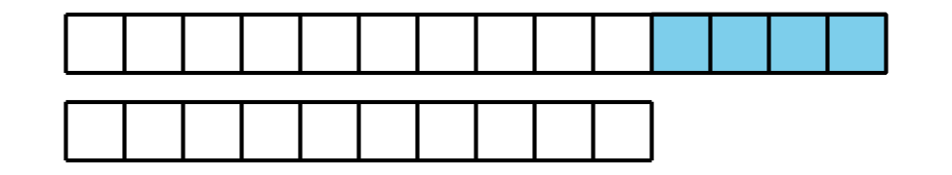

Lesson Timeline
Warm-up | 10 min
Activity 1 | 15 min
Activity 2 | 10 min
Activity 3 | 15 min
Lesson Synthesis | 10 min

Teacher Reflection Question
How did the Three Reads routine support your students in making sense of a story problem? What can you do to encourage students to use this method for themselves to make sense of a problem?

Cool-down
(to be completed at the end of the lesson) 0min
Unidad 6, punto de chequeo de la sección C

Standards Alignments
Addressing | 1.OA.A.1

Student-facing Task Statement
Lesson observations

Student Responses
- Retell the story.
- Represent the story with objects or drawings.
- Explain how their representation matches the story.

