Unit 1 Lesson 1: Build It

1 The Right Tool (Warm up)

Student Task Statement
- Copy this figure using only a pencil and no other tools.

- Familiarize yourself with your straightedge and compass by drawing a few circles of different sizes, a few line segments of different lengths, and extending some of those line segments in both directions.
- Complete these steps with a straightedge and compass:
  - Draw a point and label it $A$.
  - Draw a circle centered at point $A$ with a radius of length $PQ$.
  - Mark a point on the circle and label it $B$.
  - Draw another circle centered at point $B$ that goes through point $A$.
  - Draw a line segment between points $A$ and $B$.

2 Illegal Construction Moves

Student Task Statement
- Create a circle centered at $A$ with radius $AB$.
- Estimate the midpoint of segment $AB$ and label it $C$.
- Create a circle centered at $B$ with radius $BC$. This creates 2 intersection points. Label the one toward the top of the page as $D$ and the one toward the bottom as $E$.
- Use your straightedge to connect points $A$, $D$, and $E$ to make triangle $ADE$ and lightly shade it in with your pencil.

3 Can You Make a Perfect Copy?

Student Task Statement
Here is a hexagon with all congruent angles and all congruent sides (called a regular hexagon).
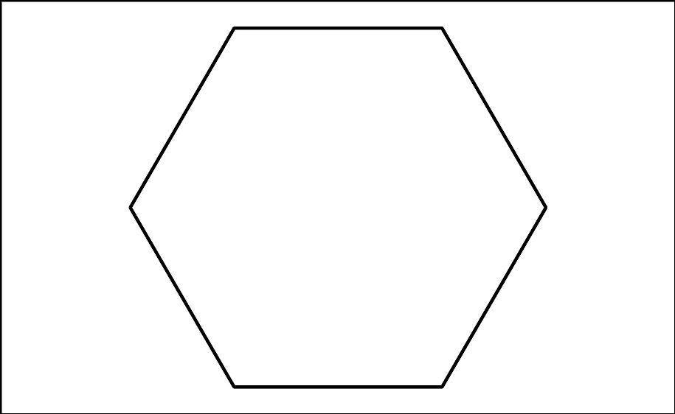

- Draw a copy of the regular hexagon using only your pencil and no other tools. Trace your copy onto tracing paper. Try to fold it in half. What happened?
- Here is a figure that shows the first few steps to constructing the regular hexagon. Use straightedge and compass moves to finish constructing the regular hexagon. Trace it onto tracing paper and confirm that when you fold it in half, the edges line up.
- How do you know each of the sides of the shape are the same length? Show or explain your reasoning.
© CC BY 2019 by Illustrative Mathematics®

