Unit 2 Lesson 14: Count Out Objects

WU How Many Do You See: 5-frames and Fingers (Warm up)

Student Task Statement
How many do you see?
How do you see them?
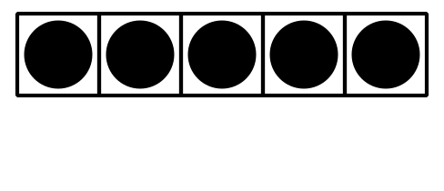
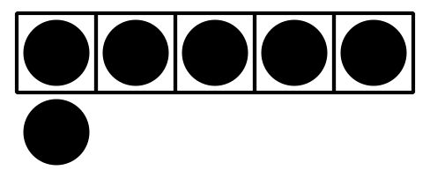

1 Toppings on Pizza

Student Task Statement

2 Number Posters with Objects

Student Task Statement

3 Introduce Bingo, Images and Numbers

Student Task Statement
Choose a center.
Bingo
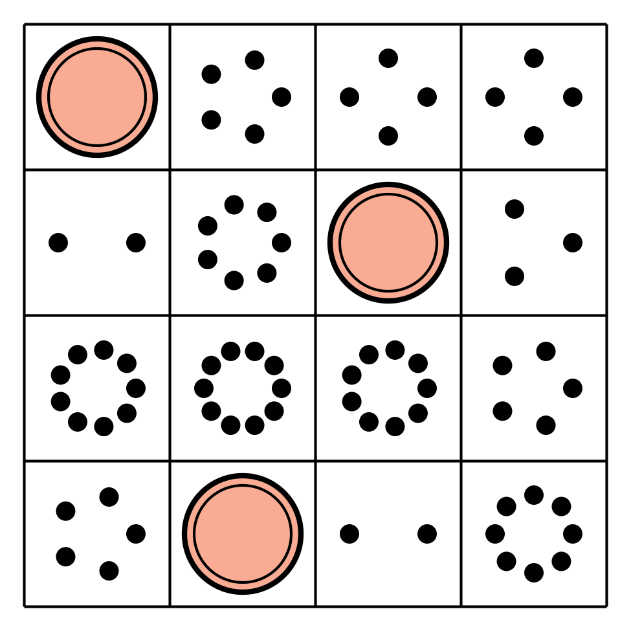
Number Race
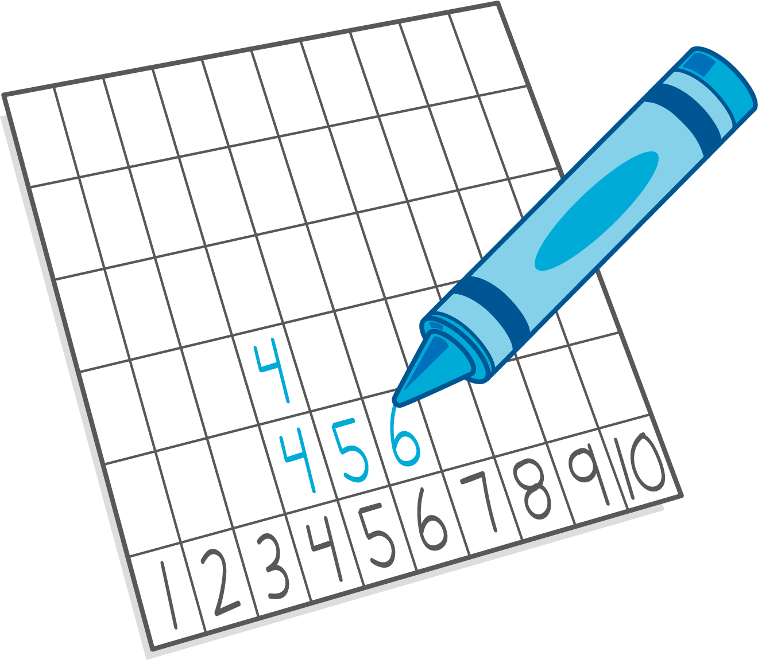
Geoblocks
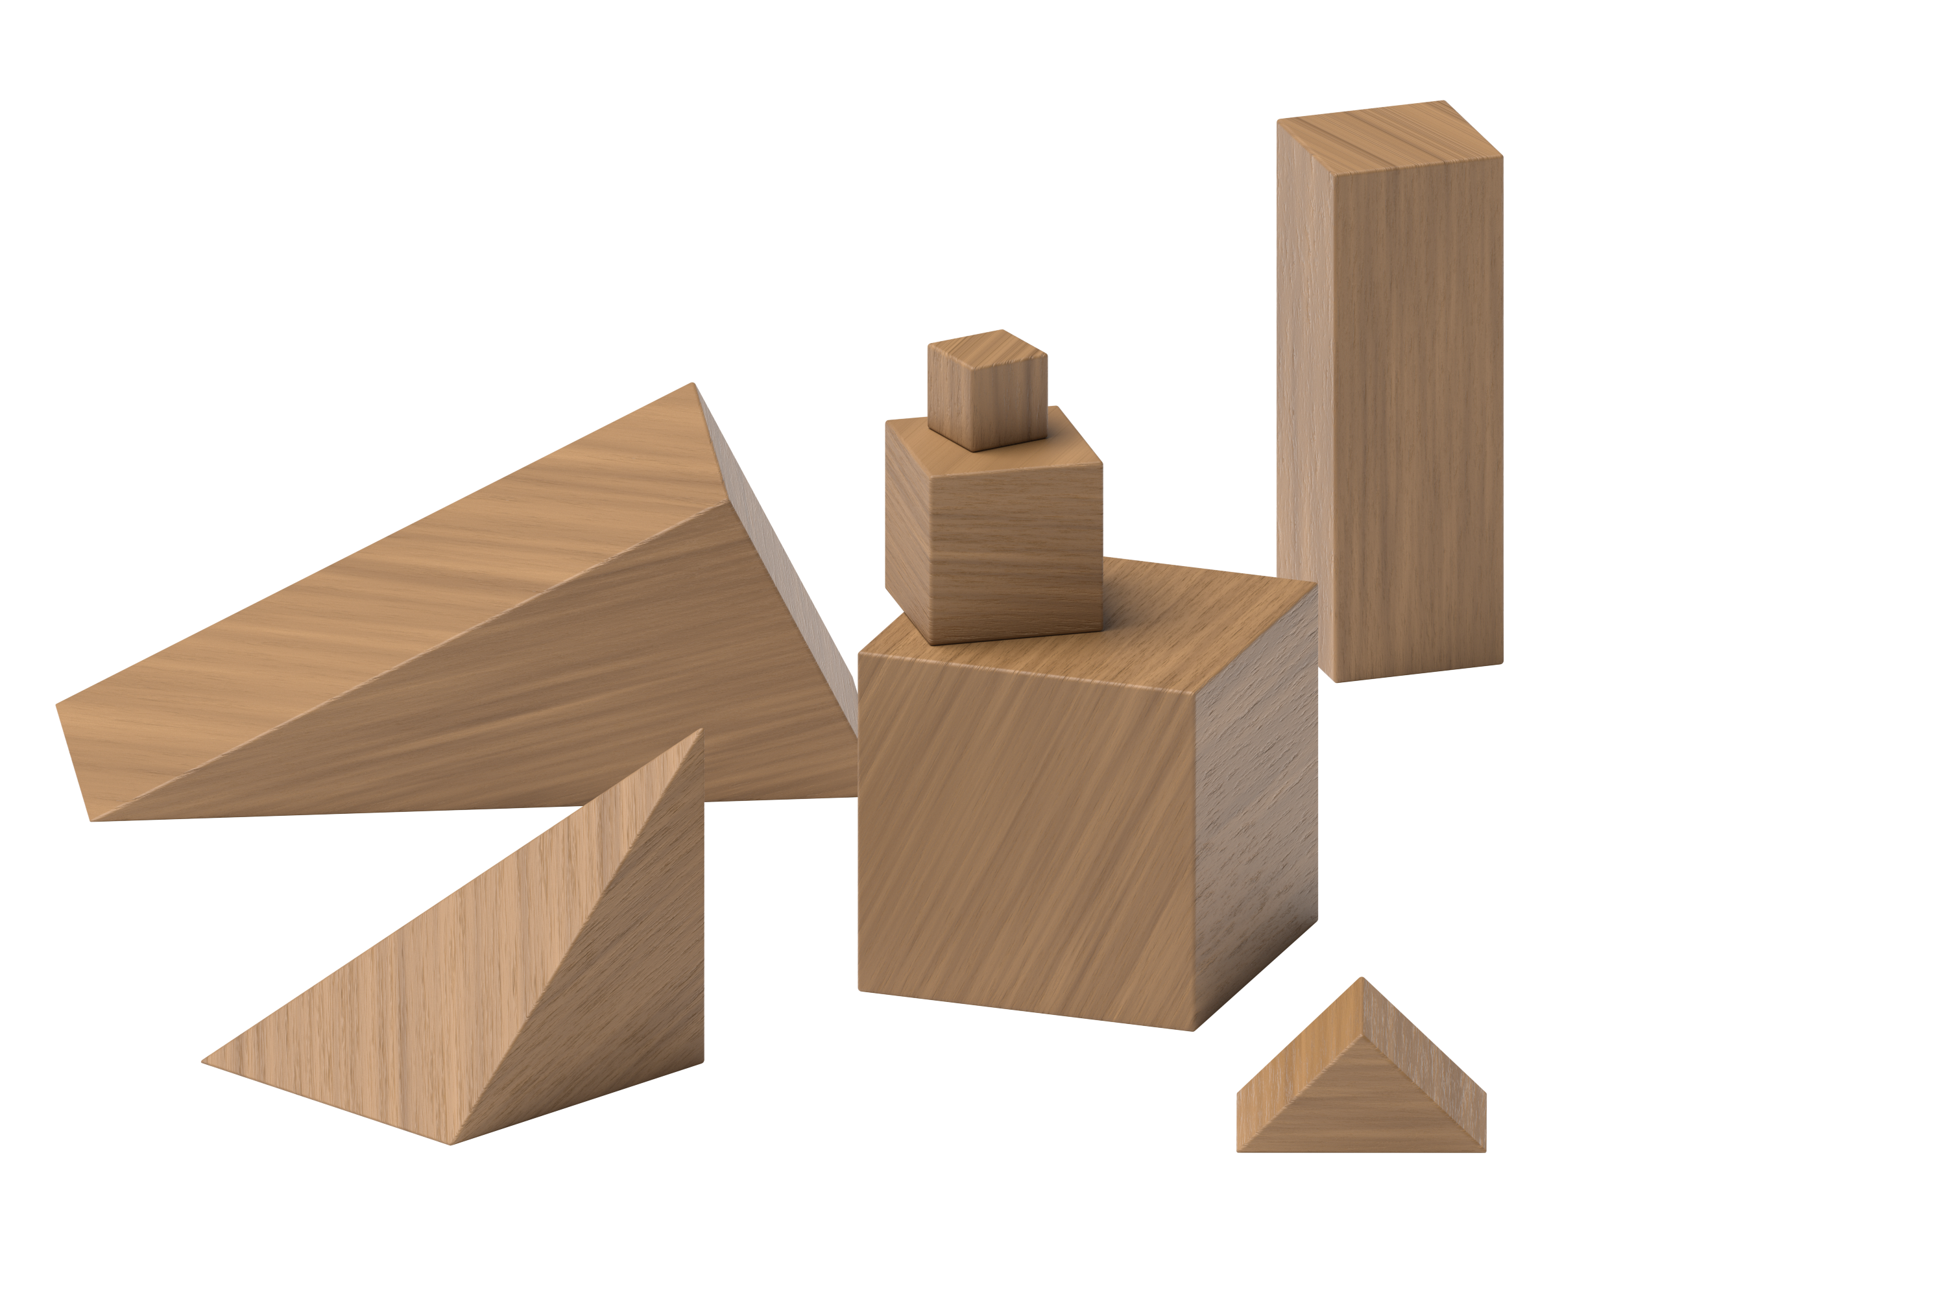
Math Fingers
© CC BY 2021 Illustrative Mathematics®

