Unit 5 Lesson 20: Evaluating Functions over Equal Intervals

1 Finding Slopes (Warm up)

Student Task Statement
- Find the slope of each line.
  - The line that passes through $\left(2,2\right)$ and $\left(3,6\right)$.
  - The graph of $f\left(x\right)=\text{-}2+\frac{1}{3}x$.
- Show on the graph where each slope can be seen.
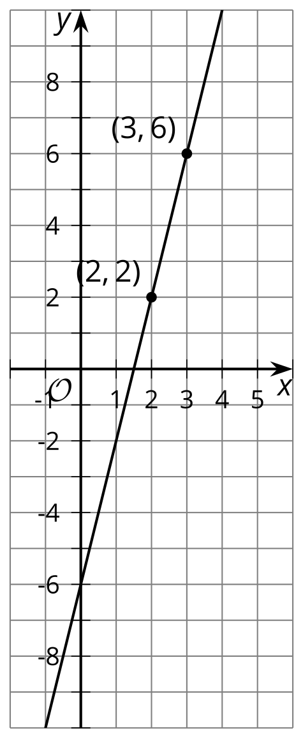
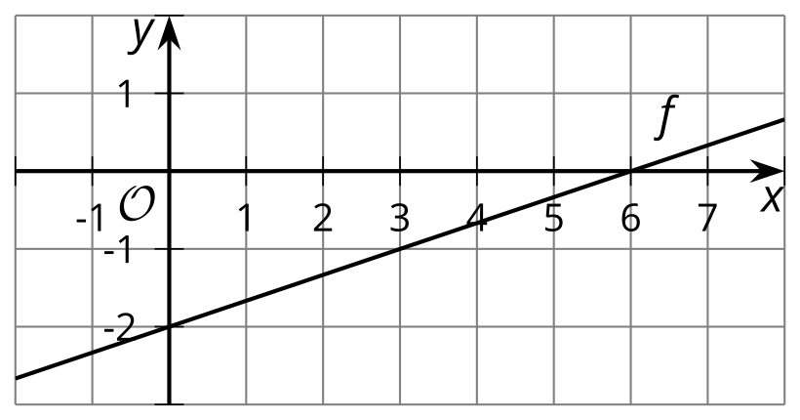

2 Incrementing by One

Student Task Statement
- For the function $f\left(x\right)=3x+4$, evaluate:
  - $f\left(0\right)$ and $f\left(1\right)$
  - $f\left(100\right)$ and $f\left(101\right)$
  - $f\left(\text{-}10\right)$ and $f\left(\text{-}9\right)$
  - $f\left(0.5\right)$ and $f\left(1.5\right)$
- What do all those pairs of numbers you found have in common?
- Write an expression for $f\left(w\right)$ and $f\left(w+1\right)$.
- What would you expect to be the result of subtracting $f\left(w\right)$ from $f\left(w+1\right)$?
- Subtract $f\left(w\right)$ from $f\left(w+1\right)$. If you don’t get the answer you predicted, work with a partner to check your algebra.
- For the function $g\left(x\right)=2^{x}$, evaluate:
  - $g\left(3\right)$ and $g\left(4\right)$
  - $g\left(0\right)$ and $g\left(1\right)$
  - $g\left(\text{-}1\right)$ and $g\left(\text{-}2\right)$
  - $g\left(10\right)$ and $g\left(11\right)$
- What do all those pairs of numbers you found have in common?
- Write an expression for $g\left(u\right)$ and $g\left(u+1\right)$.
- What would you expect to be the result of dividing $g\left(u+1\right)$ by $g\left(u\right)$?
- Divide $g\left(u+1\right)$ by $g\left(u\right)$. If you don’t get the answer you predicted, work with a partner to check your algebra.

3 Rewriting Expressions

Student Task Statement
- Evaluate:
  - $\frac{3^{5}}{3^{4}}$
  - $\frac{3^{1}}{3^{0}}$
  - $\frac{3^{\text{-}1}}{3^{\text{-}2}}$
  - $\frac{3^{100}}{3^{99}}$
  - $\frac{3^{x+1}}{3^{x}}$
- Solve for $m$:
  - $\frac{2^{m}}{2^{7}}=2$
  - $\frac{2^{100}}{2^{m}}=2$
  - $\frac{2^{m}}{2^{x}}=2$
- Write an equivalent expression using as few terms as possible:
  - $3\left(x+1\right)+4−\left(3x+4\right)$
  - $2\left(x+1\right)+5−\left(2x+5\right)$
  - $2\left(x+2\right)+5−\left(2\left(x+1\right)+5\right)$
  - $\text{-}5\left(x+1\right)+3−\left(\text{-}5x+3\right)$
  - $\frac{5^{x+1}}{5^{x}}$
  - $\frac{7^{x+4}}{7^{x}}$
© CC BY 2019 by Illustrative Mathematics®

