Lesson 3: Tangent Lines
- Let’s explore lines that intersect a circle in exactly 1 point.

3.1: Swim to Shore
Line $ℓ$ represents a straight part of the shoreline at a beach. Suppose you are in the ocean at point $C$ and you want to get to the shore as fast as possible. Assume there is no current. Segments $CJ$ and $CD$ represent 2 possible paths.
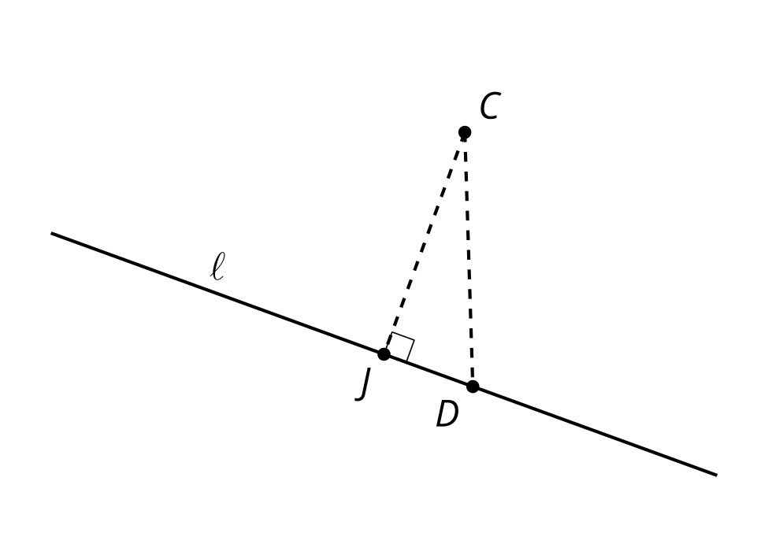
Diego says, “No matter where we put point $D$, the Pythagorean Theorem tells us that segment $CJ$ is shorter than segment $CD$. So, segment $CJ$ represents the shortest path to shore.”
Do you agree with Diego? Explain your reasoning.

3.2: A Particular Perpendicular
- Draw a radius in the circle. Mark the point where the radius intersects the circle and label it $A$.
- Construct a line perpendicular to the radius that goes through point $A$. Label this line $n$.
- Line $n$ intersects the circle in exactly 1 point, $A$. Why is it impossible for line $n$ to intersect the circle in more than 1 point?
- What kind of line, then, is $n$?

Are you ready for more?
Here is a circle centered at $O$ with radius 1 unit. Line $AB$ is tangent to the circle.
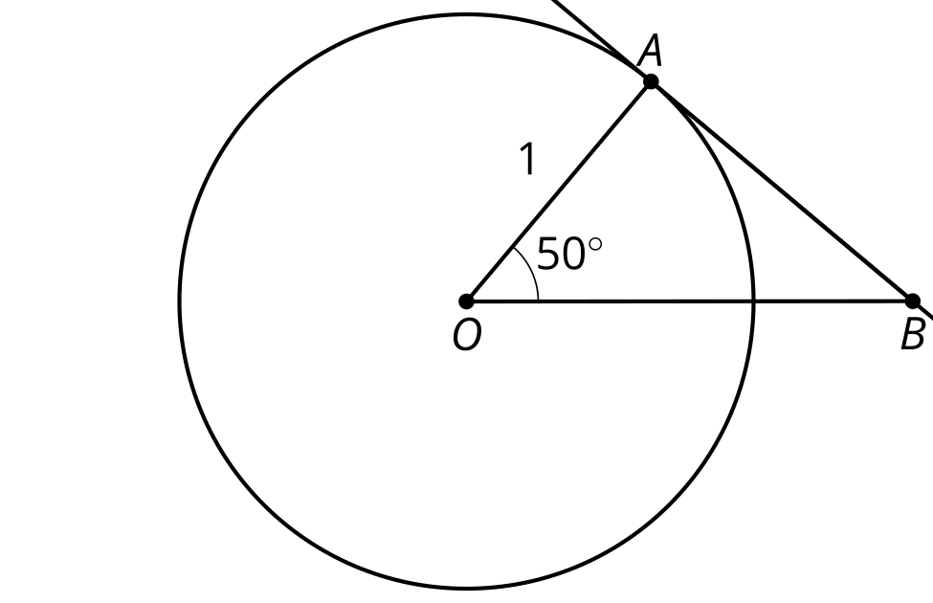
- Calculate the length of segment $AB$.
- How does the length of segment $AB$ relate to the tangent of 50 degrees? Why is this true?
- In right triangle trigonometry, “tangent” is defined in terms of side ratios. Write another definition of tangent (in the sense of a numerical value, not a line) in terms of a circle with radius 1 unit.

3.3: Another Angle
The image shows an angle whose rays are tangent to a circle.
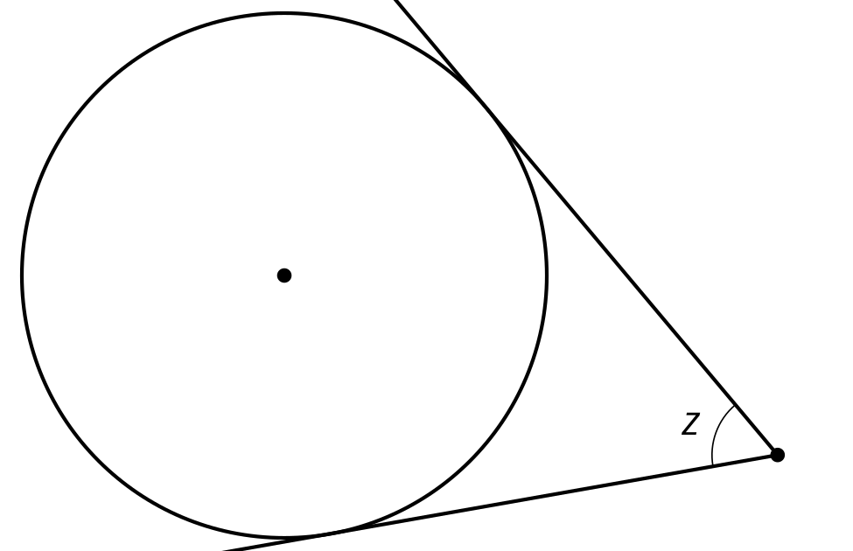
- Mark the approximate points of tangency.
- Draw the 2 radii that intersect these points of tangency. Label the measure of the central angle that is formed $w$.
- What is the value of $w+z$? Explain or show your reasoning.

Lesson 3 Summary
A line is said to be tangent to a circle if it intersects the circle in exactly 1 point. Suppose line $ℓ$ is tangent to a circle centered at $A$. Draw a radius from the center of the circle to the point of tangency, or the point where line $ℓ$ intersects the circle. Call this point $B$. It looks like radius $AB$ is perpendicular to line $ℓ$. Can we prove it?
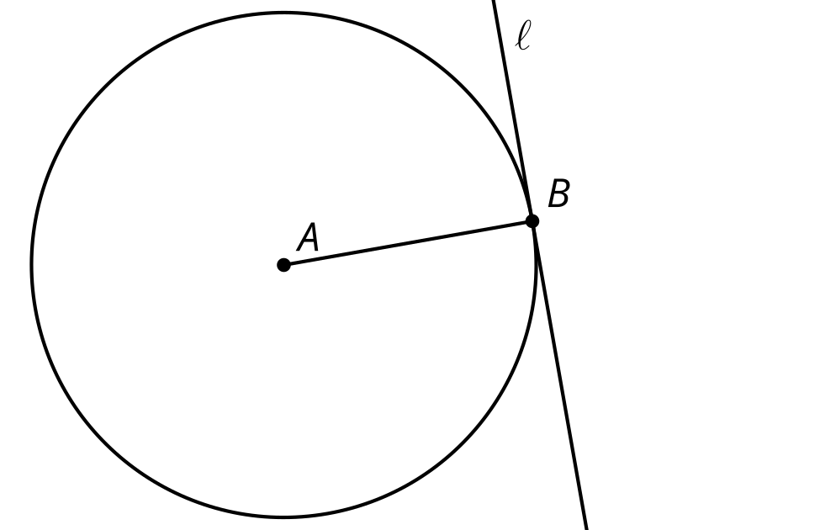
Every other point on the tangent line is outside the circle, so they must all be further away from the center than the point where the tangent intersects. This means the point $B$ where the tangent line intersects the circle is the closest point on the line to the center point $A$. The radius $AB$ must be perpendicular to the tangent line because the shortest distance from a point to a line is always along a perpendicular path.
© CC BY 2019 by Illustrative Mathematics®

