Lesson 1: Got Data?
Let's explore different kinds of data.

1.1: Dots of Data
Here is a dot plot for a data set.
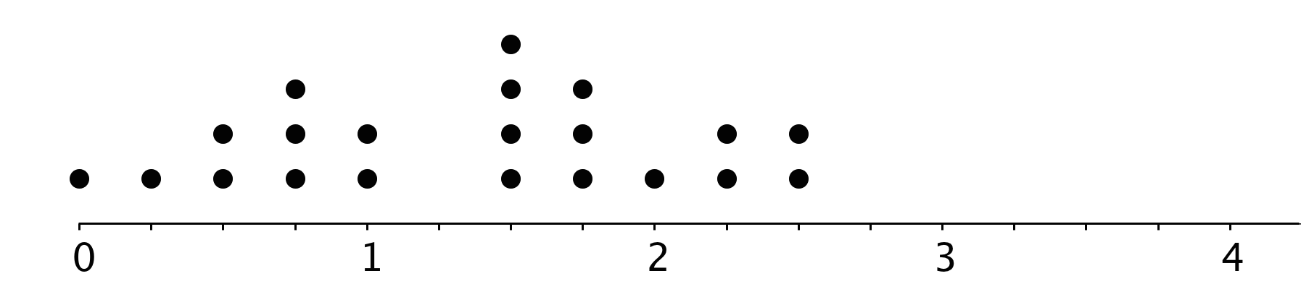

- Determine if each of the following would be an appropriate label to represent the data in the dot plot? Be prepared to explain your reasoning.
  - Number of children per class.
  - Distance between home and school, in miles.
  - Hours spent watching TV each day.
  - Weight of elephants, in pounds.
  - Points received on a homework assignment.
- Think of another label that can be used with the dot plot.
  - Write it below the scale of the dot plot. Be sure to include the unit of measurement.
  - In your scenario, what does one dot represent?
  - In your scenario, what would a data point of 0 mean? What would a data point of $3\frac{1}{4}$ mean?

1.2: Surveying the Class
Here are some survey questions. Your teacher will explain which questions can be used to learn more about the students in your class and how the responses will be collected. The data that your class collects will be used in upcoming activities.
- How long does it usually take you to travel to school? Answer to the nearest minute.
- How do you travel to school on most days? Choose one.
  - Walk
  - Bike
  - Scooter or skateboard
  - Car
  - School bus
  - Public transport
  - Other
- How tall are you without your shoes on? Answer to the nearest centimeter.
- What is the length of your right foot without your shoe on? Answer to the nearest centimeter.
- What is your arm span? Stretch your arms open, and measure the distance from the tip of your right hand’s middle finger to the tip of your left hand’s middle finger, across your back. Answer to the nearest centimeter.
- How important are the following issues to you? Rate each on a scale from 0 (not important) to 10 (very important).
  - Reducing pollution
  - Recycling
  - Conserving water
- Do you have any siblings? _____ Yes _____ No
- How many hours of sleep per night do you usually get when you have school the next day? Answer to the nearest half hour.
- How many hours of sleep per night do you usually get when you do not have school the next day? Answer to the nearest half hour.
- Other than traveling from school, what do you do right after school on most days?
  - Have a snack
  - Do homework
  - Read a book
  - Talk on the phone
  - Practice a sport
  - Do chores
  - Use the computer
  - Participate in an extracurricular activity
- If you could meet one of these celebrities, who would you choose?
  - A city or state leader
  - A champion athlete
  - A movie star
  - A musical artist
  - A best-selling author
- Estimate how much time per week you usually spend on each of these activities. Answer to the nearest quarter of an hour.
  - Playing sports or doing outdoor activities
  - Using a screen for fun (watching TV, playing computer games, etc.)
  - Doing homework
  - Reading

1.3: Numerical and Categorical Data
The list of survey questions in the activity earlier can help you complete these exercises.
- The first survey question about travel time produces numerical data. Identify two other questions that produce numerical data. For each, describe what was measured and its unit of measurement.
  - Question #: ______
  - What was measured:
  - Unit of measurement:
  - Question #: ______
  - What was measured:
  - Unit of measurement:
- The second survey question about travel method produces categorical data. Identify two other questions that produce categorical data. For each, describe what characteristic or feature was being studied.
  - Question #: ______
  - Characteristic being studied:
  - Question #: ______
  - Characteristic being studied:
- Think about the responses to these survey questions. Do they produce numerical or categorical data? Be prepared to explain how you know.
  - How many pets do you have?
  - How many years have you lived in this state?
  - What is your favorite band?
  - What kind of music do you like best?
  - What is the area code of your school’s phone number?
  - Where were you born?
  - How much does your backpack weigh?
- Name two characteristics you could investigate to learn more about your classmates. Make sure one would give categorical data and the other would give numerical data.

Are you ready for more?
Priya and Han collected data on the birth months of students in their class. Here are the lists of their records for the same group of students.
This list shows Priya’s records.
Jan | Apr | Jan | Feb | Oct | May | June | July
Aug | Aug | Sep | Jan | Feb | Mar | Apr | Nov
Nov | Dec | Feb | Mar

This list shows Han’s records.
1 | 4 | 1 | 2 | 10 | 5 | 6 | 7
8 | 8 | 9 | 1 | 2 | 3 | 4 | 11
11 | 12 | 2 | 3

- How are their records alike? How are they different?
- What kind of data—categorical or numerical—do you think the variable “birth month” produces? Explain how you know.

Lesson 1 Summary
The table contains data about 10 dogs.
dog name | weight (kg) | breed
Duke | 36 | German shepherd
Coco | 6 | pug
Pierre | 7 | pug
Ginger | 35 | German shepherd
Lucky | 10 | beagle
Daisy | 10 | beagle
Buster | 35 | German shepherd
Pepper | 7 | pug
Rocky | 7 | beagle
Lady | 32 | German shepherd
- The weights of the dogs are an example of numerical data, which is data that are numbers, quantities, or measurements. The weights of the dogs are measurements in kilograms.
- The dog breeds are an example of categorical data, which is data containing values that can be sorted into categories. In this case, there are three categories for dog breeds: pug, beagle, and German shepherd.
Some data with numbers are categorical because the numbers are not quantities or measurements. For example, telephone area codes are categorical data, because the numbers are labels rather than quantities or measurements.
Numerical data can be represented with a dot plot (sometimes called a line plot). Here is a dot plot that shows the weights of the dogs.
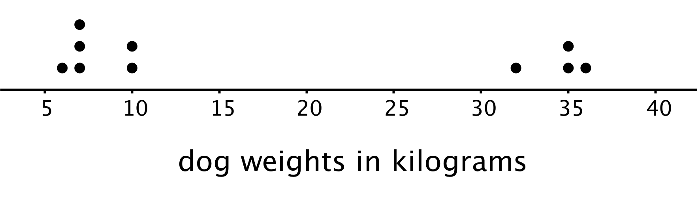
We can collect and study both kinds of data by doing surveys or taking measurements. When we do, it is important to think about what feature we are studying (for example, breeds of dogs or weights of dogs) and what units of measurement are used.
© CC BY Open Up Resources. Adaptations CC BY IM.

