Lesson 18: Surface Area of a Cube

18.1: Exponent Review
Select the greater expression of each pair without calculating the value of each expression. Be prepared to explain your choices.
- $10⋅3$ or ${10}^{3}$
- ${13}^{2}$ or $12⋅12$
- $97+97+97+97+97+97$ or $5⋅97$

18.2: The Net of a Cube
- A cube has edge length 5 inches.
  - Draw a net for this cube, and label its sides with measurements.
  - What is the shape of each face?
  - What is the area of each face?
  - What is the surface area of this cube?
  - What is the volume of this cube?
- A second cube has edge length 17 units.
  - Draw a net for this cube, and label its sides with measurements.
  - Explain why the area of each face of this cube is ${17}^{2}$ square units.
  - Write an expression for the surface area, in square units.
  - Write an expression for the volume, in cubic units.

18.3: Every Cube in the Whole World
A cube has edge length $s$.
- Draw a net for the cube.
- Write an expression for the area of each face. Label each face with its area.
- Write an expression for the surface area.
- Write an expression for the volume.

Lesson 18 Summary
The volume of a cube with edge length $s$ is $s^{3}$.
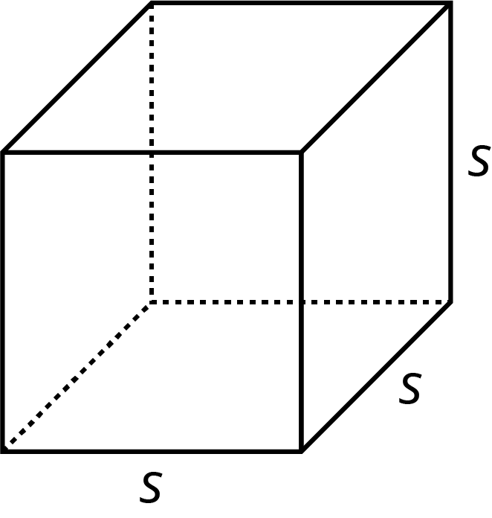
A cube has 6 faces that are all identical squares. The surface area of a cube with edge length $s$ is $6⋅s^{2}$.
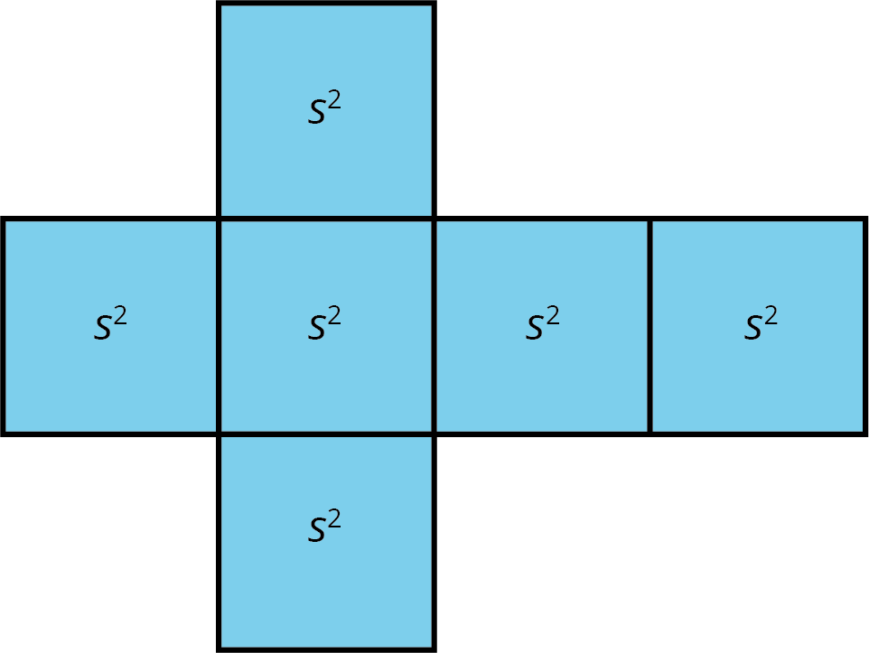
© CC BY Open Up Resources. Adaptations CC BY IM.

