Lesson 7: The Correlation Coefficient
- Let’s see how good a linear model is for some data.

7.1: Which One Doesn’t Belong: Linear Models
Which one doesn’t belong?

A

B

C

D

7.2: Card Sort: Scatter Plot Fit
Your teacher will give you a set of cards that show scatter plots of data. Sort the cards into 2 categories of your choosing. Be prepared to explain the meaning of your categories. Then, sort the cards into 2 categories in a different way. Be prepared to explain the meaning of your new categories.

7.3: Matching Correlation Coefficients
- Take turns with your partner to match a scatter plot with a correlation coefficient.
- For each match you find, explain to your partner how you know it’s a match.
- For each match your partner finds, listen carefully to their explanation. If you disagree, discuss your thinking and work to reach an agreement.

A
- $r=\text{-}1$
- $r=\text{-}0.95$
- $r=\text{-}0.74$
- $r=\text{-}0.06$
- $r=0.48$
- $r=0.65$
- $r=0.9$
- $r=1$

B

C

D

E

F

G

H

Are you ready for more?
Jada wants to know if the speed that people walk is correlated with their texting speed. To investigate this, she measured the distance, in feet, that 5 of her friends walked in 30 seconds and the number of characters they texted during that time. Each of the 5 friends took 4 walks for a total of 20 walks. Here are the results of the first 20 walks.
distance (feet)
number of characters texted
distance (feet)
number of characters texted
105
142
95
138
125
110
125
110
115
120
160
80
140
98
175
64
145
102
130
106
160
89
140
95
170
72
150
95
140
100
155
90
130
107
160
74
105
113
135
108
Over the next few days, the same 5 friends practiced walking and texting to see if they could walk faster and text more characters. They did not record any more data while practicing. After practicing, each of the 5 friends took another 4 walks. Here are the results of the final 20 walks.
distance (feet)
number of characters texted
distance (feet)
number of characters texted
140
140
165
151
150
155
170
136
160
151
190
143
155
170
205
132
180
125
205
128
205
130
210
140
225
95
215
109
175
161
220
105
195
108
230
126
155
142
225
138
- What do you notice about the 2 scatter plots?
- Jada noticed that her friends walked further and texted faster during the last 20 walks than they did during the first 20 walks. Since both were faster, she predicts that the correlation coefficient of the line of best fit for the last 20 walks will be closer to -1 then the correlation coefficient of the line of best fit for the first 20 walks. Do you agree with Jada? Explain your reasoning.
- Use technology to find an equation of the line of best fit and the correlation coefficient for each data set. Was your answer to the previous question correct?
- Why do you think the correlation coefficients for the 2 data sets are so different? Explain your reasoning.

Lesson 7 Summary
While residuals can help pick the best line to fit the data among all lines, we still need a way to determine the strength of a linear relationship. Scatter plots of data that are close to the best fit line are better modeled by the line than scatter plots of data that are farther from the line.
The correlation coefficient is a convenient number that can be used to describe the strength and direction of a linear relationship. Usually represented by the letter $r$, the correlation coefficient can take values from -1 to 1. The sign of the correlation coefficient is the same as the sign of the slope for the best fit line. The closer the correlation coefficient is to 0, the weaker the linear relationship. When the correlation coefficient is closer to 1 or -1, the linear model fits the data better.
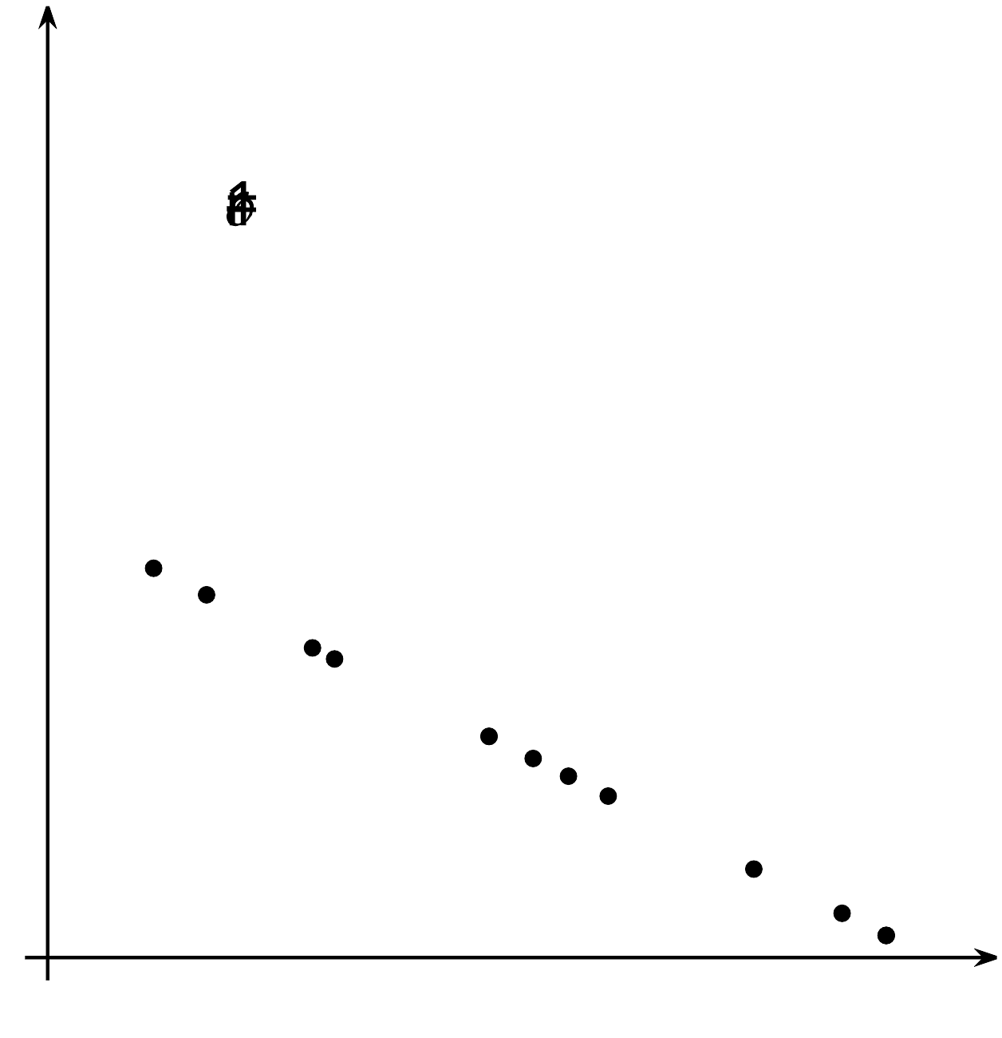
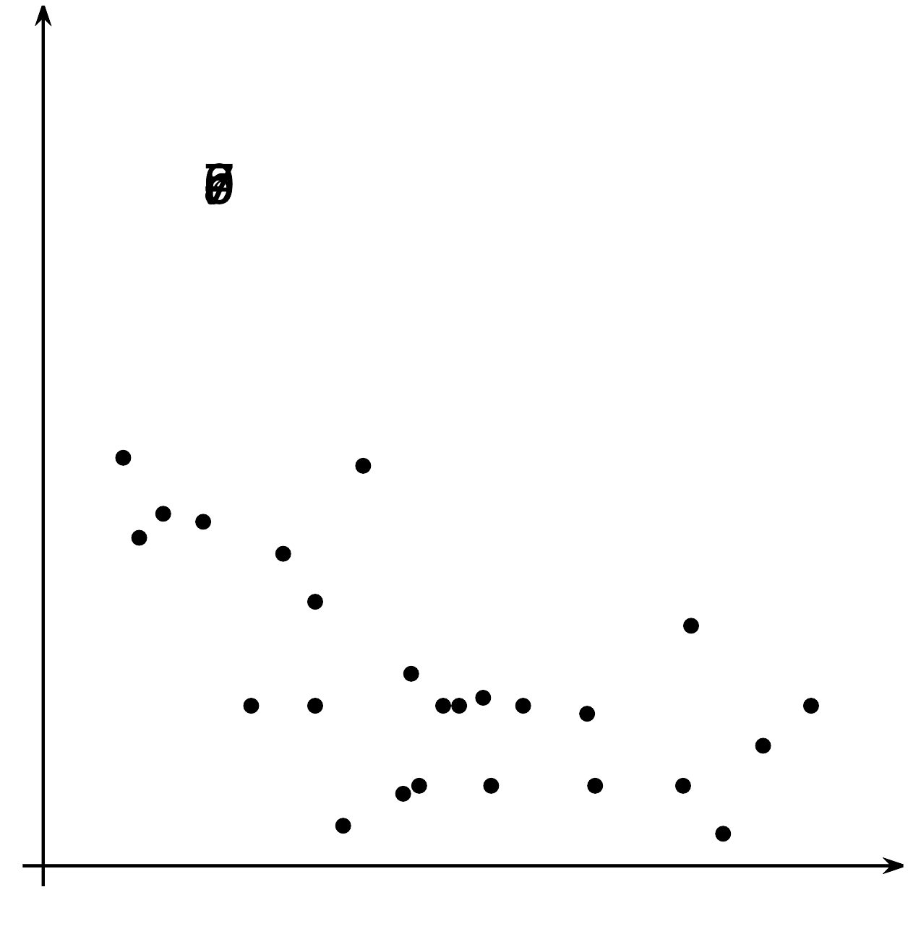
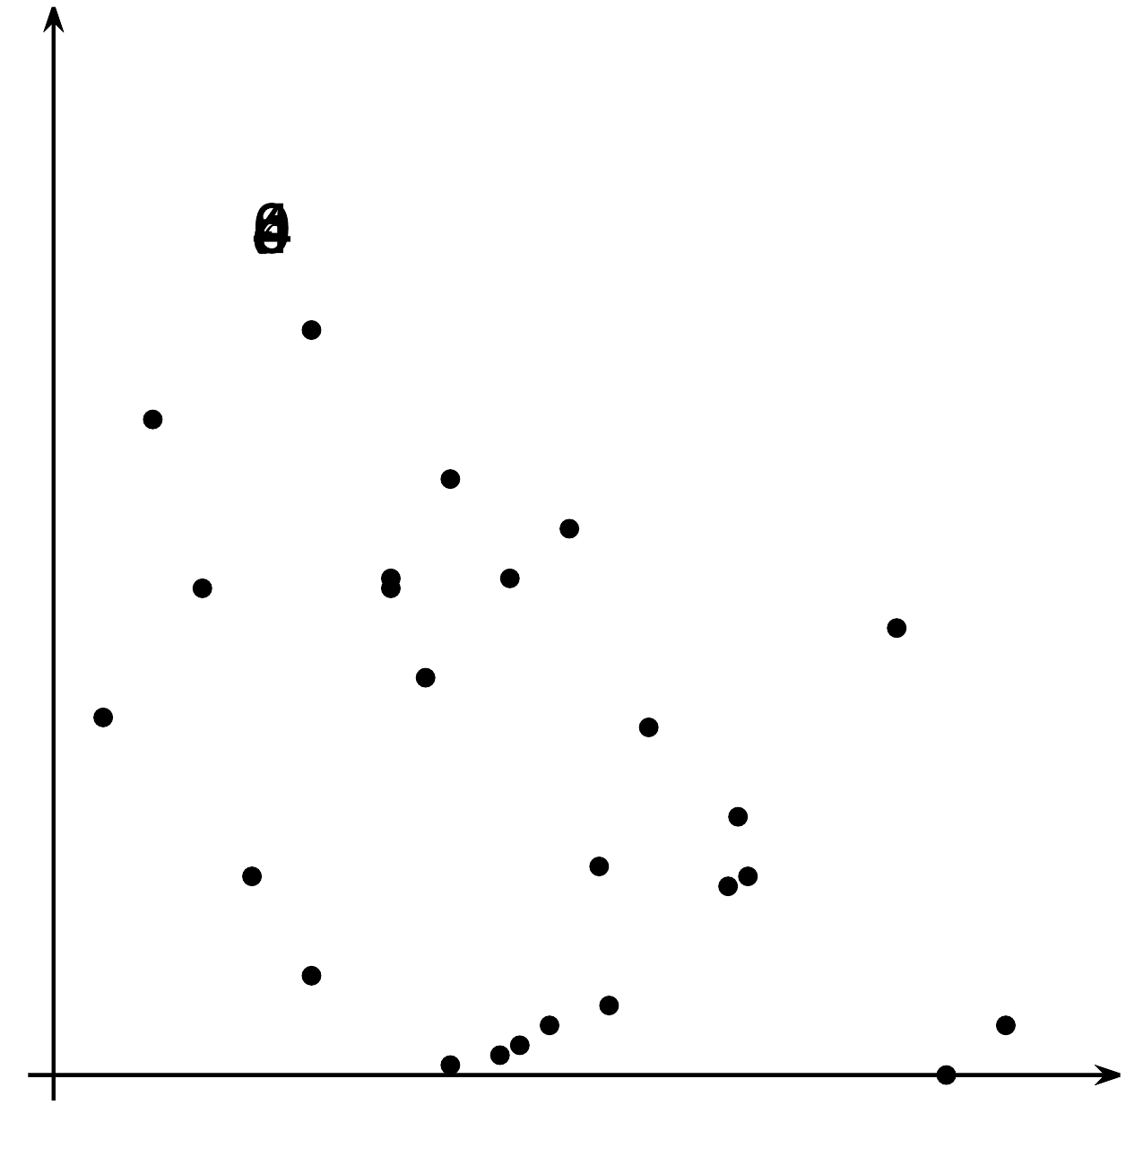
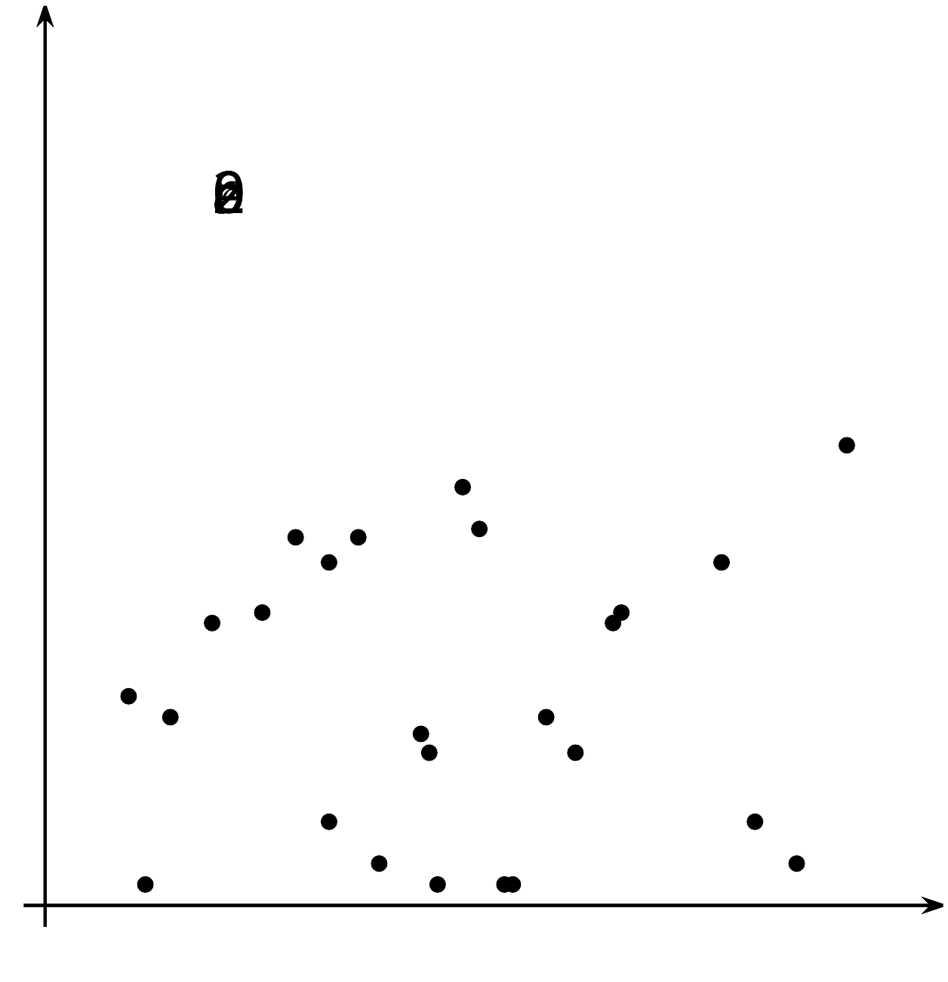
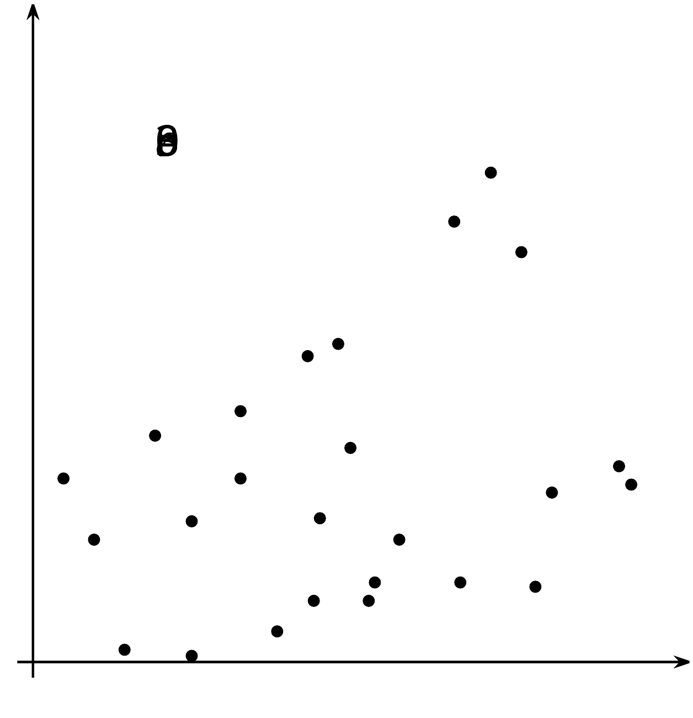
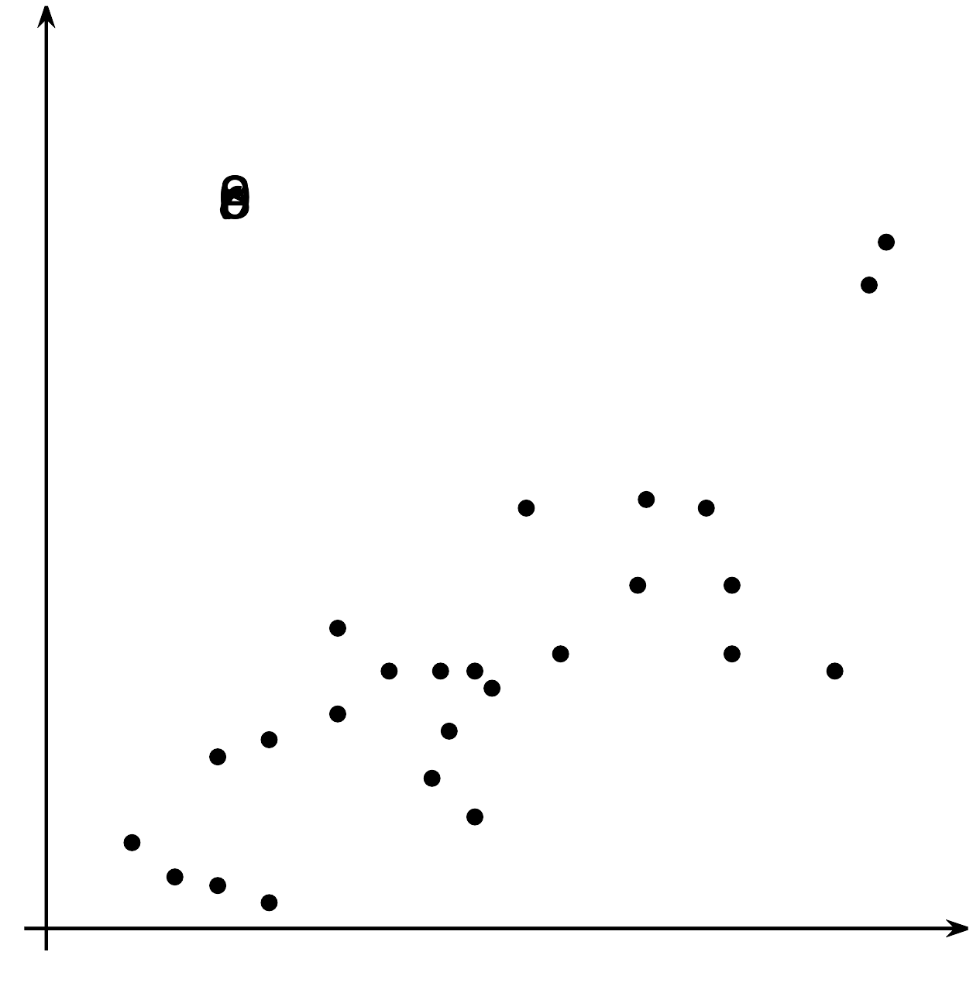
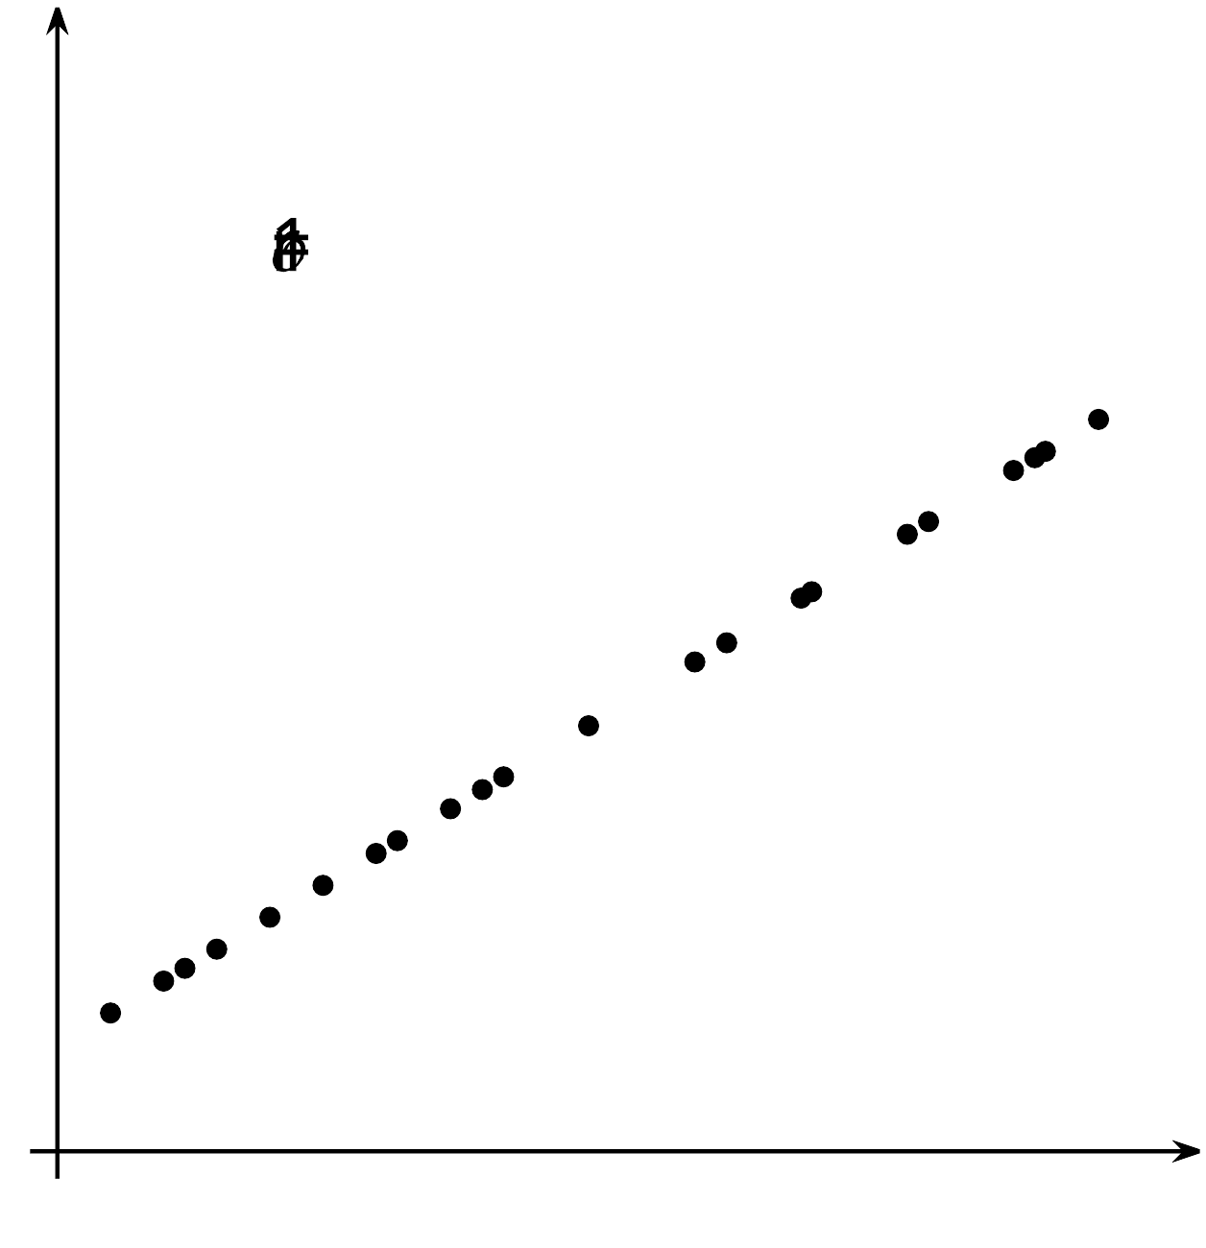
While it is possible to try to fit a linear model to any data, you should always look at the scatter plot to see if there is a possible linear trend. The correlation coefficient and residuals can also help determine whether the linear model makes sense to use to estimate the situation. In some cases, another type of function might be a better fit for the data, or the two variables you are examining may be uncorrelated, and you should look for other connections using other variables.
© CC BY 2019 by Illustrative Mathematics®

