Unit 2 Lesson 16: Write Numbers to Represent Quantities

WU How Many Do You See: One More with a 5-frame (Warm up)

Student Task Statement
How many do you see?
How do you see them?
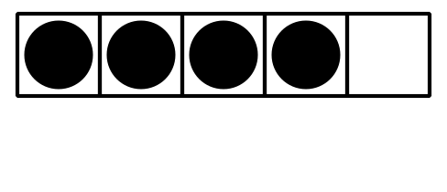
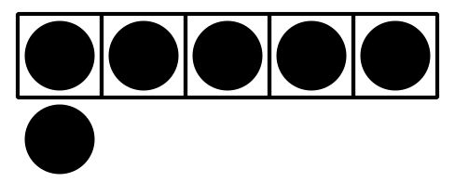
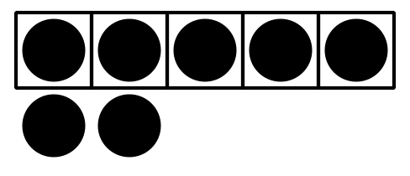

1 Revisit Math Stories, How Many?

Student Task Statement

2 Label Mystery Bags

Student Task Statement

3 Centers: Choice Time

Student Task Statement
Choose a center.
Math Stories
Math Libs
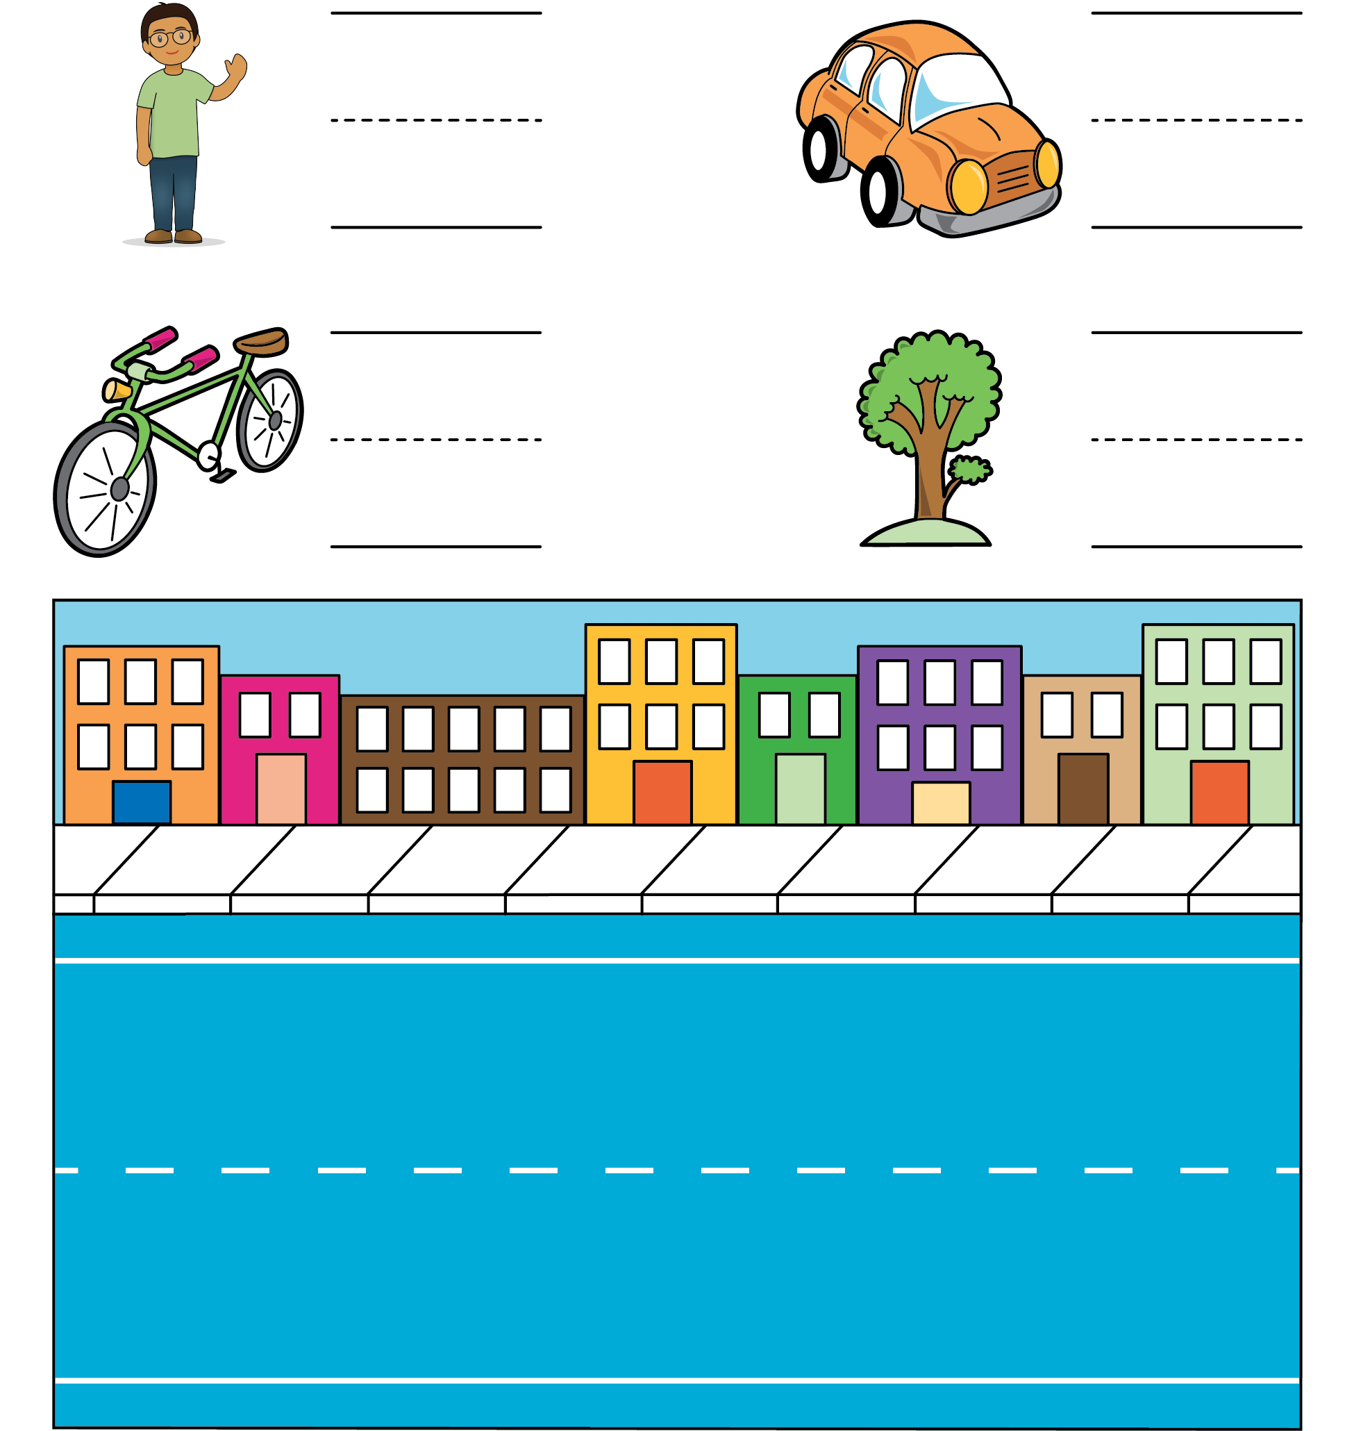
Bingo
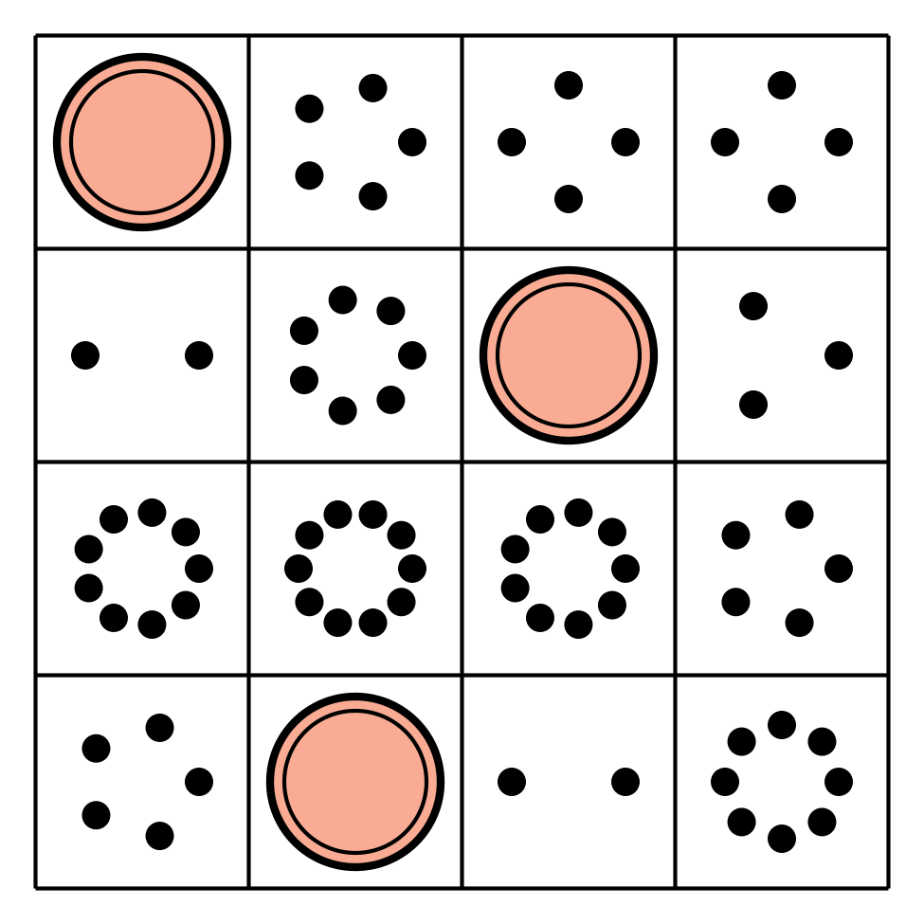
Number Race
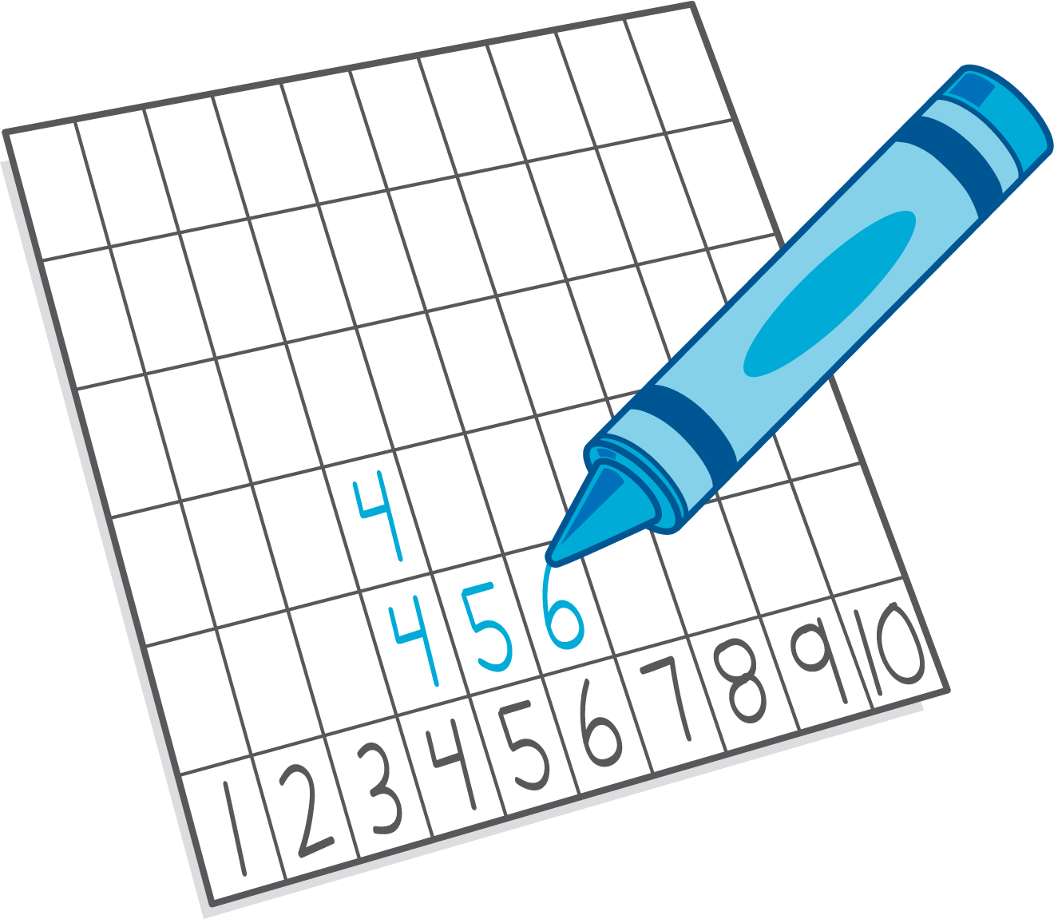
Geoblocks
Math Fingers
© CC BY 2021 Illustrative Mathematics®

