Unit 4 Lesson 10 Cumulative Practice Problems
  - Match the lines $m$ and $n$ to the statements they represent:
  - 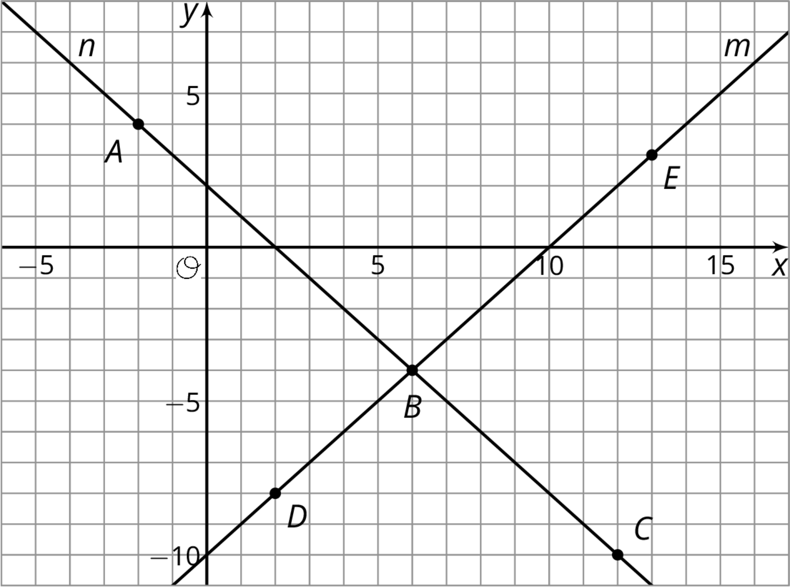
    - A set of points where the coordinates of each point have a sum of 2
    - A set of points where the $y$-coordinate of each point is 10 less than its $x$-coordinate
  - Match the labeled points on the graph to statements about their coordinates:
    - Two numbers with a sum of 2
    - Two numbers where the $y$-coordinate is 10 less than the $x$-coordinate
    - Two numbers with a sum of 2 and where the $y$-coordinate is 10 less than the $x$-coordinate
- Here is an equation: $4x−4=4x+\text{__}$. What could you write in the blank so the equation would be true for:
  - No values of $x$
  - All values of $x$
  - One value of $x$
- (From Unit 4, Lesson 7.)
- Mai earns $7 per hour mowing her neighbors' lawns. She also earned $14 for hauling away bags of recyclables for some neighbors.
- Priya babysits her neighbor’s children. The table shows the amount of money $m$ she earns in $h$ hours. Priya and Mai have agreed to go to the movies the weekend after they have earned the same amount of money for the same number of work hours.
- $h$ | - $m$
- 1 | - $8.40
- 2 | - $16.80
- 4 | - $33.60
  - How many hours do they each have to work before they go to the movies?
  - How much will each of them have earned?
  - Explain where the solution can be seen in tables of values, graphs, and equations that represent Priya's and Mai's hourly earnings.
- For each equation, explain what you could do first to each side of the equation so that there would be no fractions. You do not have to solve the equations (unless you want more practice).
  - $\frac{3x−4}{8}=\frac{x+2}{3}$
  - $\frac{3(2−r)}{4}=\frac{3+r}{6}$
  - $\frac{4p+3}{8}=\frac{p+2}{4}$
  - $\frac{2(a−7)}{15}=\frac{a+4}{6}$
- (From Unit 4, Lesson 6.)
- The owner of a new restaurant is ordering tables and chairs. He wants to have only tables for 2 and tables for 4. The total number of people that can be seated in the restaurant is 120.
  - Describe some possible combinations of 2-seat tables and 4-seat tables that will seat 120 customers. Explain how you found them.
  - Write an equation to represent the situation. What do the variables represent?
  - Create a graph to represent the situation.
  - 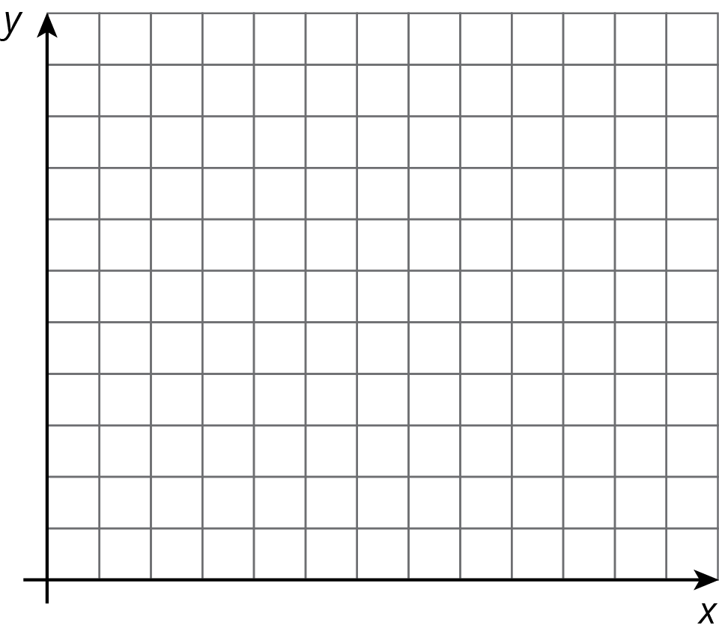

  - What does the slope tell us about the situation?
  - Interpret the $x$ and $y$ intercepts in the situation.
- (From Unit 3, Lesson 14.)
© CC BY Open Up Resources. Adaptations CC BY IM.

