Lesson 15 Practice Problems
- Jada drew a net for a polyhedron and calculated its surface area.
- 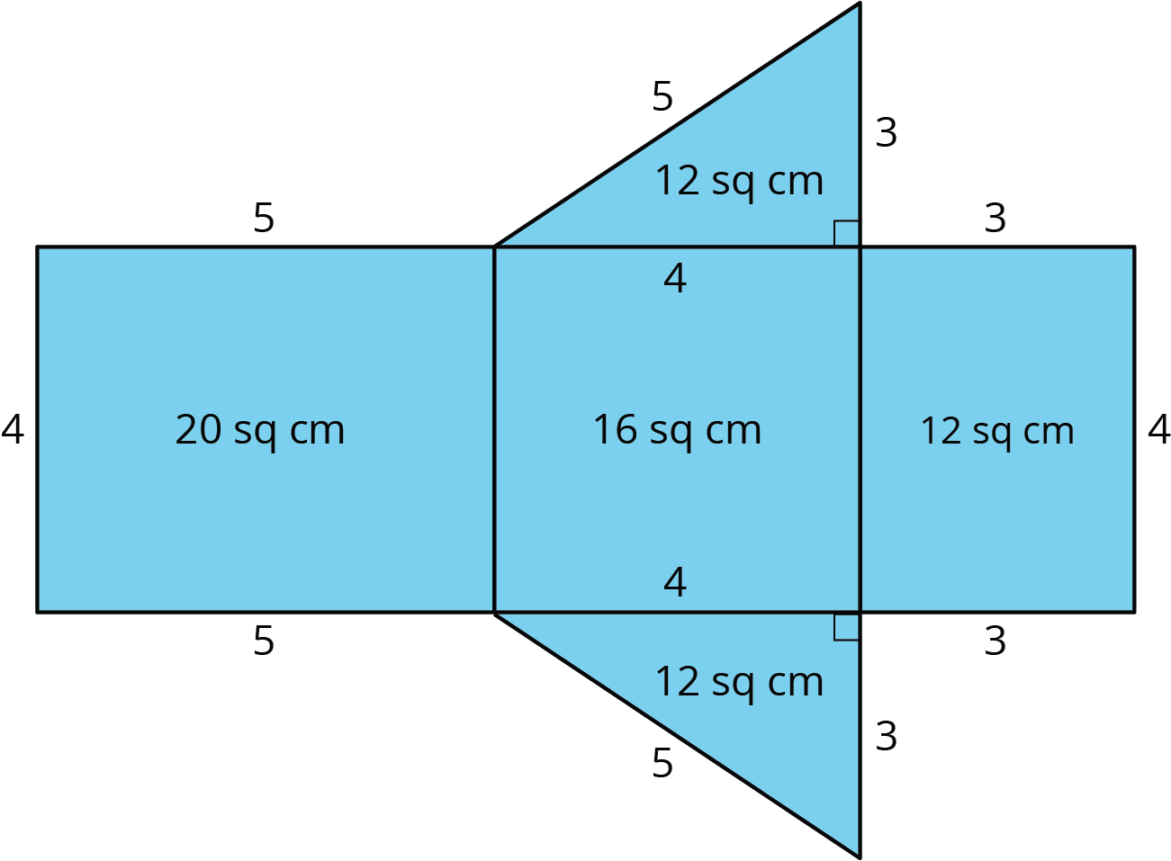
  - What polyhedron can be assembled from this net?
  - Jada made some mistakes in her area calculation. What were the mistakes?
  - Find the surface area of the polyhedron. Show your reasoning.
- A cereal box is 8 inches by 2 inches by 12 inches. What is its surface area? Show your reasoning. If you get stuck, consider drawing a sketch of the box or its net and labeling the edges with their measurements.
- Twelve cubes are stacked to make this figure.
- 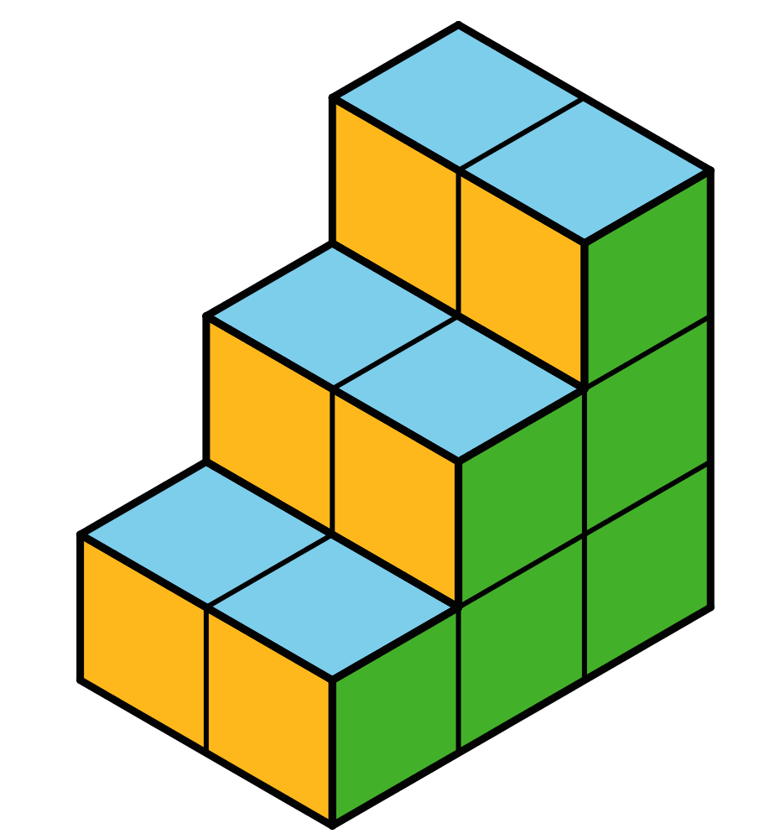
  - What is its surface area?
  - How would the surface area change if the top two cubes are removed?
- (From Unit 1, Lesson 12.)
- Here are two polyhedra and their nets. Label all edges in the net with the correct lengths.
- 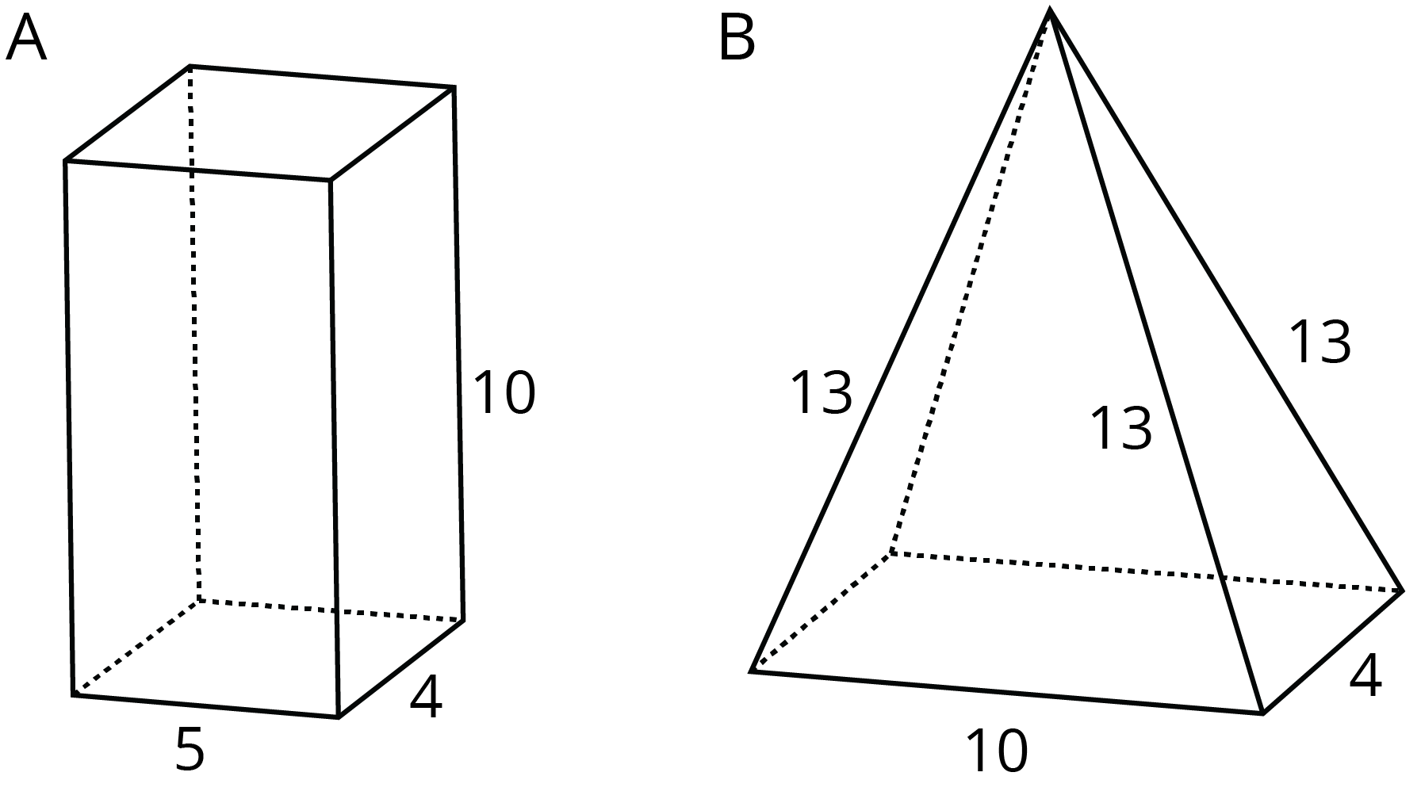
- 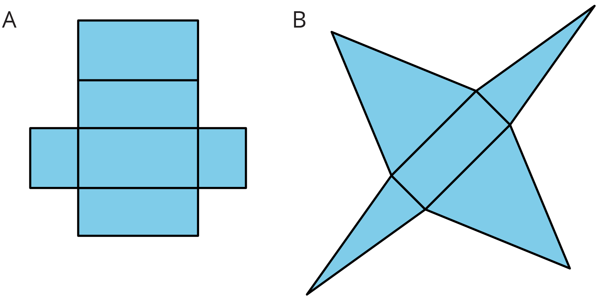

  - What three-dimensional figure can be assembled from the net?
  - 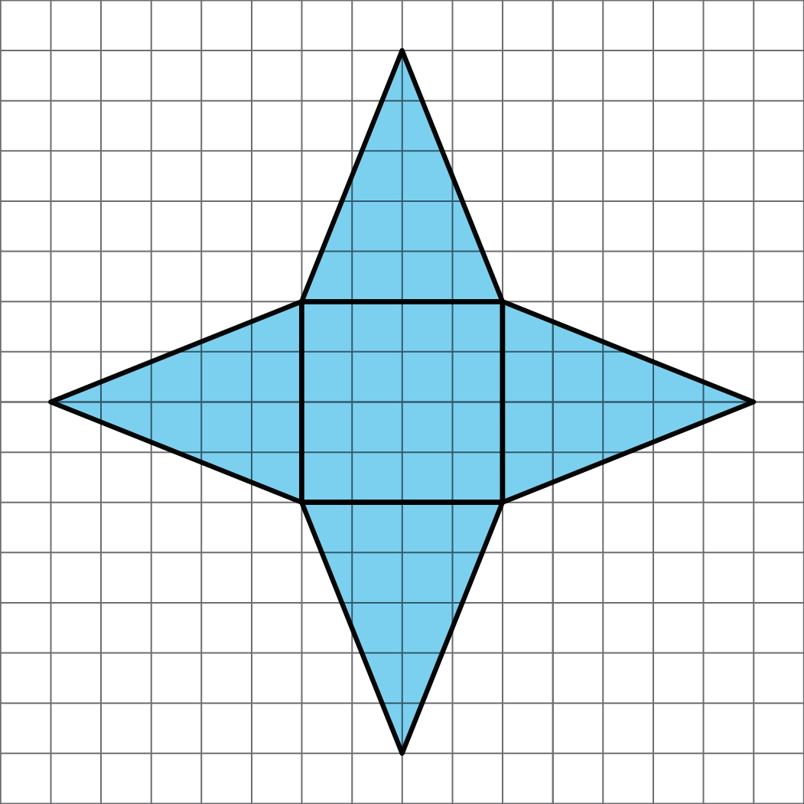
  - What is the surface area of the figure? (One grid square is 1 square unit.)
- (From Unit 1, Lesson 14.)
© CC BY Open Up Resources. Adaptations CC BY IM.

