Lesson 1: Explore the Coordinate Grid

Standards Alignments
Addressing | 5.G.A.1
Building Towards | 5.G.A.1

Teacher-facing Learning Goals
- Recognize the structure of a coordinate grid and use it to describe the location of two-dimensional shapes.

Student-facing Learning Goals
- Let’s explore the coordinate grid.

Lesson Purpose
The purpose of this lesson is for students to build familiarity with the structure of the coordinate grid.
In this lesson students use the coordinates on a coordinate grid to describe the location of rectangles. Students have used the grid, without coordinates, in other courses where they drew shapes and described their properties. In this lesson, students discover the usefulness of the numbers on a coordinate grid by trying to communicate to their partner the size and location of a rectangle. It gives students a reason to attend to the features of the grid and to use language precisely (MP6). Then they further exploit the coordinates using them to pick one rectangle out of a set of closely related rectangles all lying in different locations on the coordinate grid. Students are formally introduced to the terms coordinate grid, axes, horizontal axis, and vertical axis.

Access for:

Students with Disabilities
- Engagement (Activity 1)

Instructional Routines
MLR2 Collect and Display (Activity 1), Notice and Wonder (Warm-up)

Materials to Copy
- Can You Draw It Stage 6 Recording Sheet (groups of 1): Activity 1
- Explore the Coordinate Grid Cards (groups of 1): Activity 1

Lesson Timeline
Warm-up | 10 min
Activity 1 | 25 min
Activity 2 | 10 min
Lesson Synthesis | 10 min
Cool-down | 5 min

Teacher Reflection Question
In what ways did students use informal language to explain the structure of the coordinate grid? How did you connect their informal language to more formal math vocabulary?

Cool-down
(to be completed at the end of the lesson) 5min
The Last Two Shapes

Standards Alignments
Addressing | 5.G.A.1

Student-facing Task Statement
Elena and Lin were playing a round of Guess Which One. These are the last two shapes. What question can Elena ask to determine which shape is the one that Lin picked?
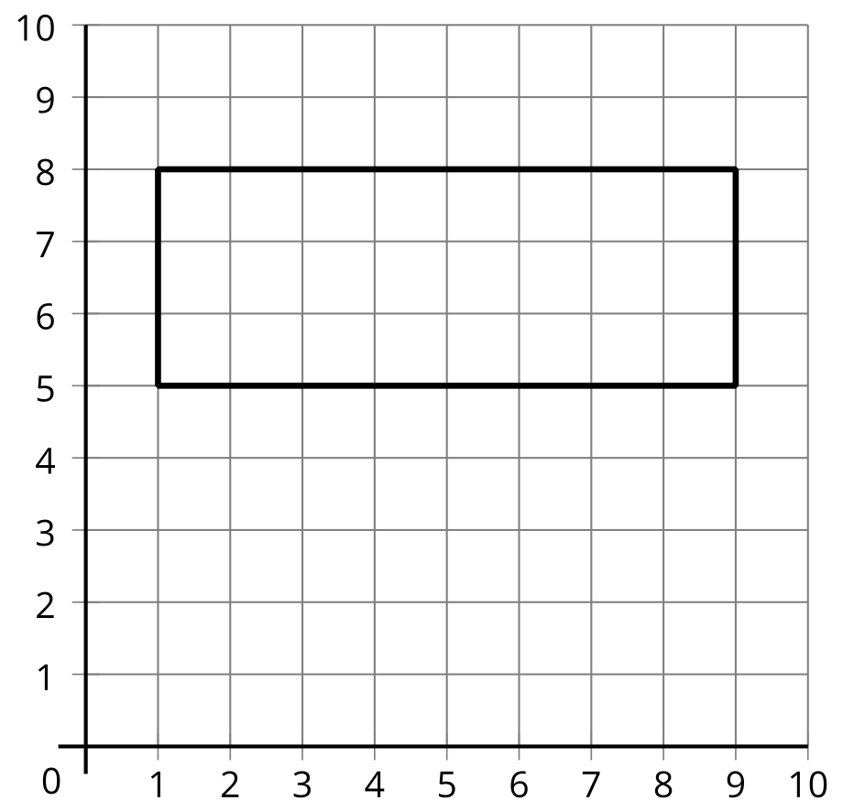
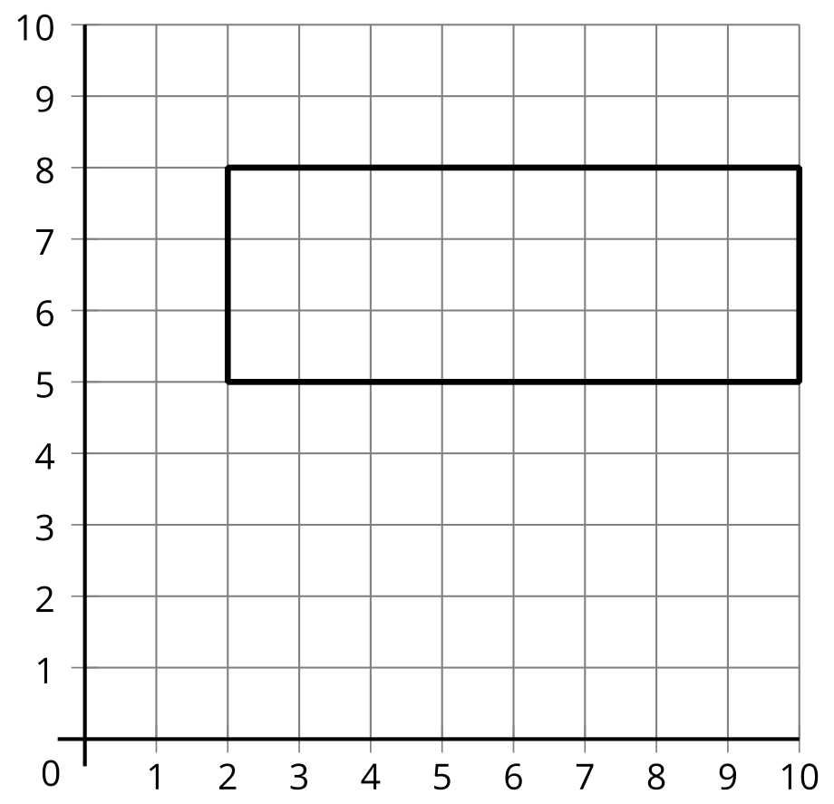

Student Responses
Answers vary. Sample responses:
- Is one of the sides of the rectangle on the grid line labeled with a 1?
- Is one of the sides on the grid line labeled with a 10?

