Lesson 1: Count and Add
- Let’s count objects.

Warm-up: What Do You Know About Math?
What do you know about math?
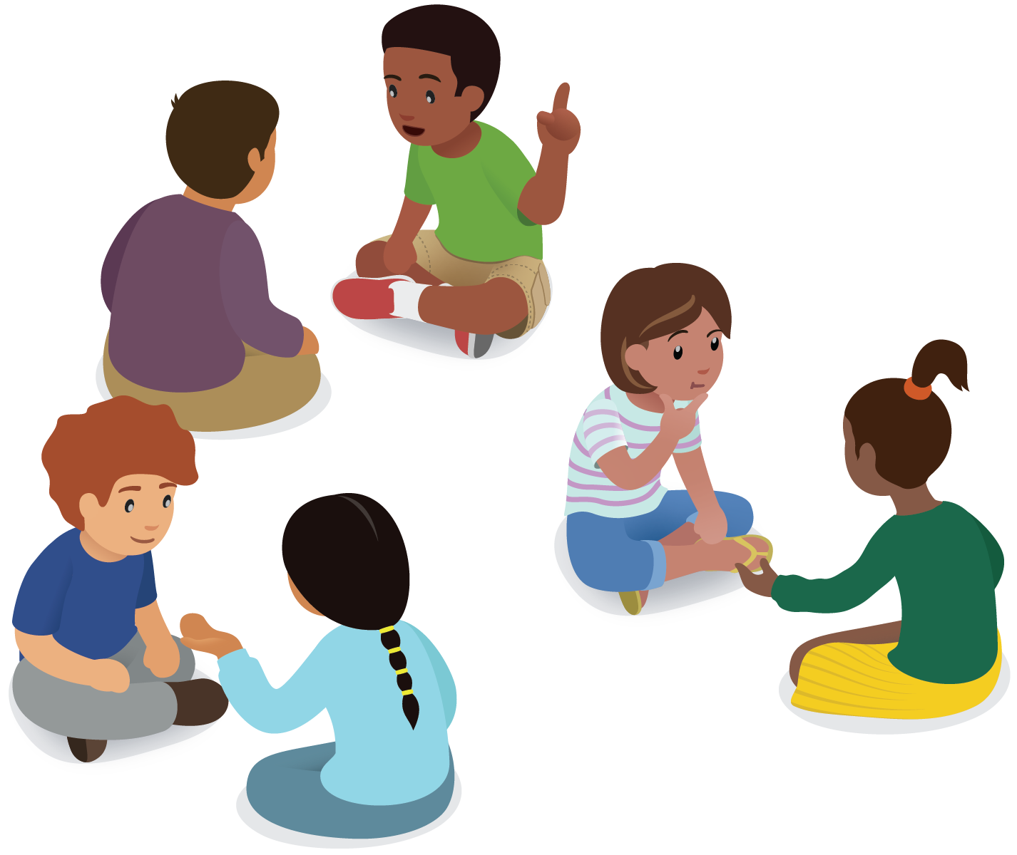
© CC BY 2021 Illustrative Mathematics®

