Lesson 12: Subtract Strategically
- Let’s consider when to use algorithms and when to use other strategies to subtract.

Warm-up: Number Talk: Threes
Find the value of each expression mentally.
- $2×6$
- $3×6$
- $2×7$
- $3×7$

12.1: How Would You Subtract?
Use a strategy or algorithm of your choice to find the value of each difference. Show your reasoning. Organize it so it can be followed by others.
- $451−329$
- $382−190$
- $924−285$
- $600−478$
- $505−417$

12.2: Greatest Difference, Smallest Difference
- Decide with your partner whether you will try to make the greatest difference or smallest difference.
- Take turns spinning and recording a digit in the hundreds, tens, or ones place. Continue until your numbers are complete.
- Find the difference.
- Compare your values.
- Write a comparison using >, <, or =.
- Play again.
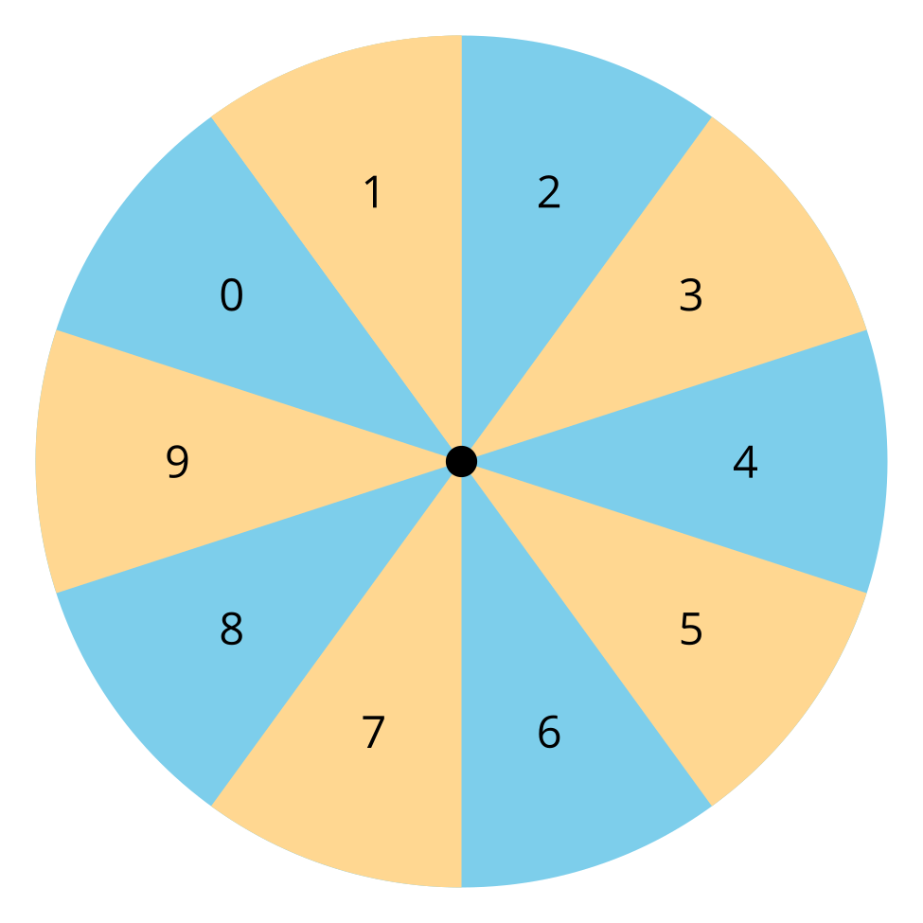
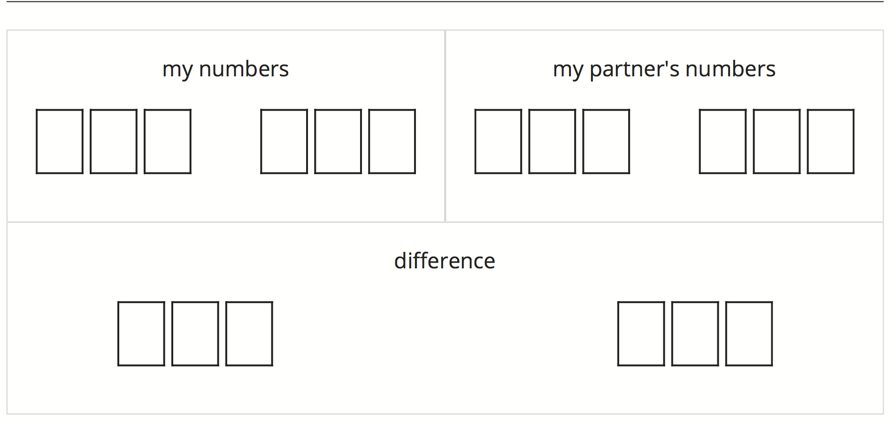

Section Summary
Section Summary
In this section, we learned algorithms to subtract numbers within 1,000. We also learned that we can choose whether to use an algorithm or another strategy for subtracting based on the numbers.
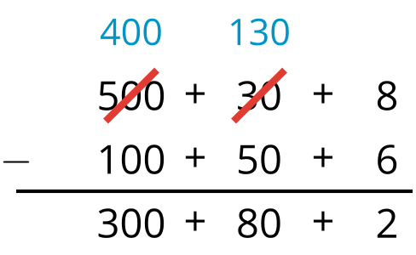
step 1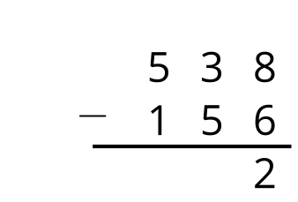
step 2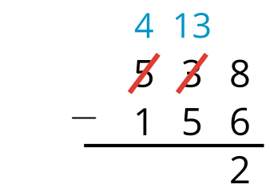
step 3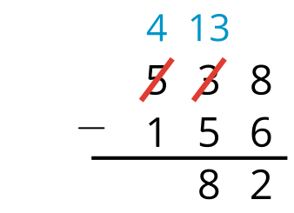
step 4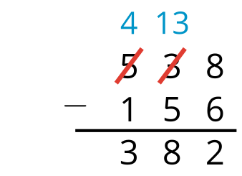
© CC BY 2021 Illustrative Mathematics®

