Lesson 11: All About Tape Diagrams
- Let’s match diagrams, story problems, and equations.

Warm-up: Number Talk: Addition and Subtraction
Find the value of each expression mentally.
- $7+13$
- $27+13$
- $40−13$
- $40−27$

11.1: Represent Story Problems
Match the stories, diagrams, and equations.

11.2: Write Stories
Choose one of the diagrams. Write and solve a story problem that the diagram could represent.

- 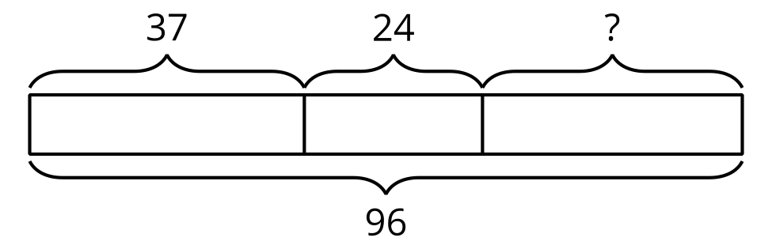

- 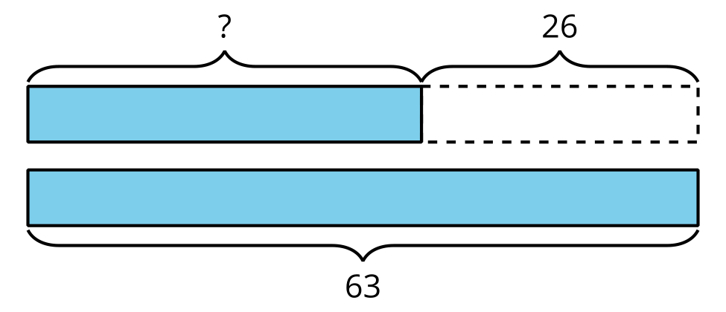

- 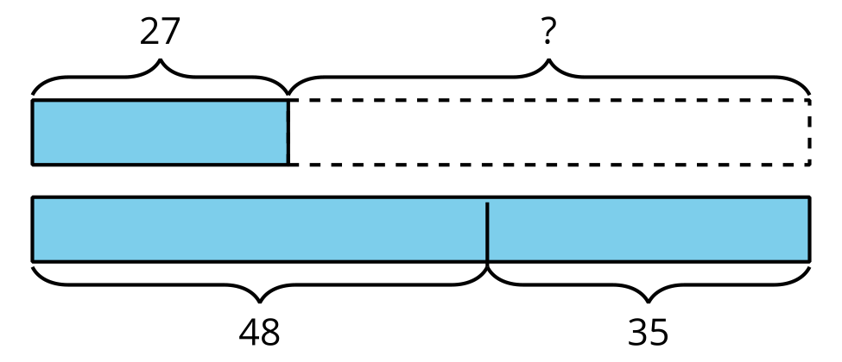
Problem ______
© CC BY 2021 Illustrative Mathematics®

