Unit 2 Lesson 1: What is Area?

WU How Many Do You See: Arrays (Warm up)

Student Task Statement
How many do you see? How do you see them?
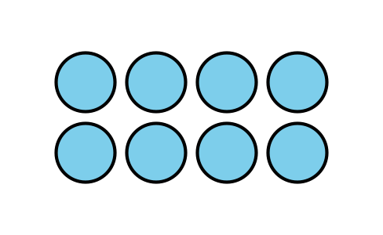
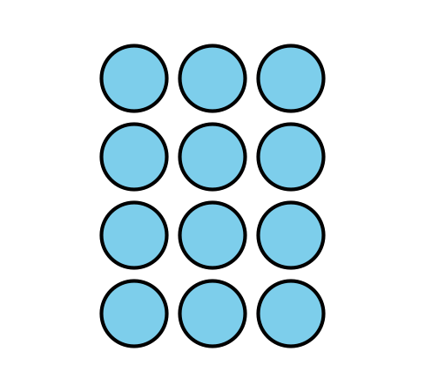
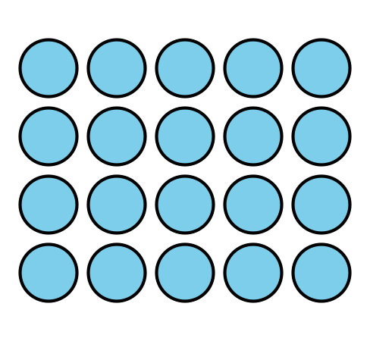

1 Compare Shapes

Student Task Statement
- Here are two triangles. Which triangle is larger?
- 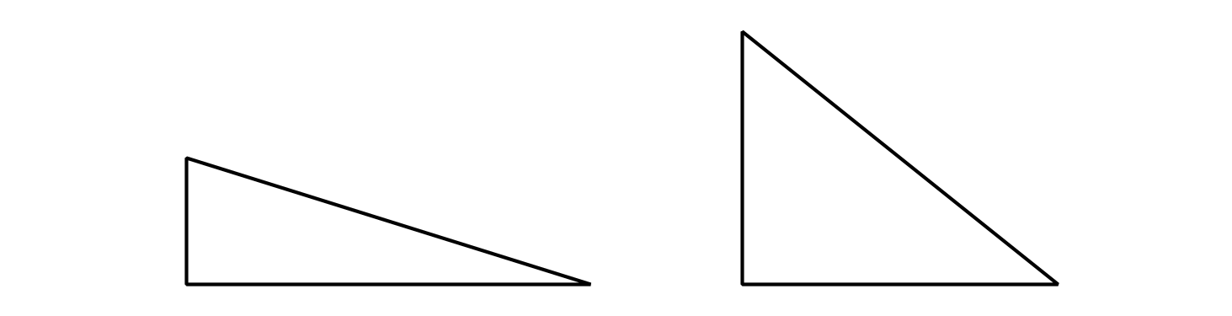
- In each pair of shapes, which shape is larger? Be prepared to explain your reasoning.

  - 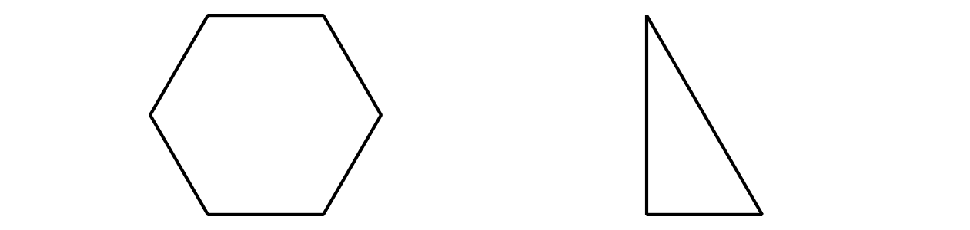

2 Pattern Blocks to Compare Shapes

Student Task Statement
Your teacher will give you handouts with some shapes on them.
Use pattern blocks to decide which shape covers the most space. Be ready to explain your reasoning.
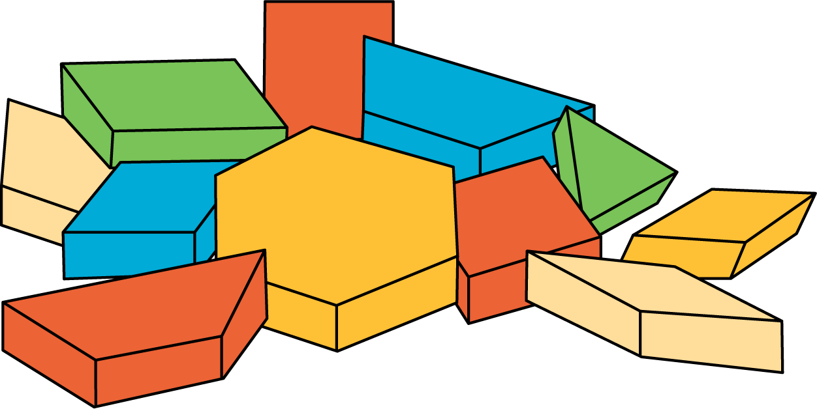
© CC BY 2021 Illustrative Mathematics®

