Unit 6 Lesson 16: Features of Trigonometric Graphs (Part 2)

1 Which One Doesn't Belong: Graph Periods (Warm up)

Student Task Statement
Which one doesn't belong?

A. $y=\text{sin}(πθ)$

B. $y=\text{sin}(θ)$

C. $y=\text{sin}(\frac{1}{2}θ)$

D. $y=\text{sin}(θ+\frac{π}{2})$

2 Any Period

Student Task Statement
- For each graph of a trigonometric function, identify the period.

- A

- B

- C

- D
- Here are some trigonometric functions. Find the period of each function.
- function | - period
- $y=\text{cos}(θ)$
- $y=\text{cos}(3θ)$
- $y=\text{sin}(6θ)$
- $y=\text{sin}(10θ)$
- $y=\text{cos}\left(\frac{1}{3}θ\right)$
- What is the period of the function $y=\text{cos}(πθ)$? Explain your reasoning.
- Identify a possible equation for a trigonometric function with this graph.

3 Around the World’s Largest Ferris Wheel

Student Task Statement
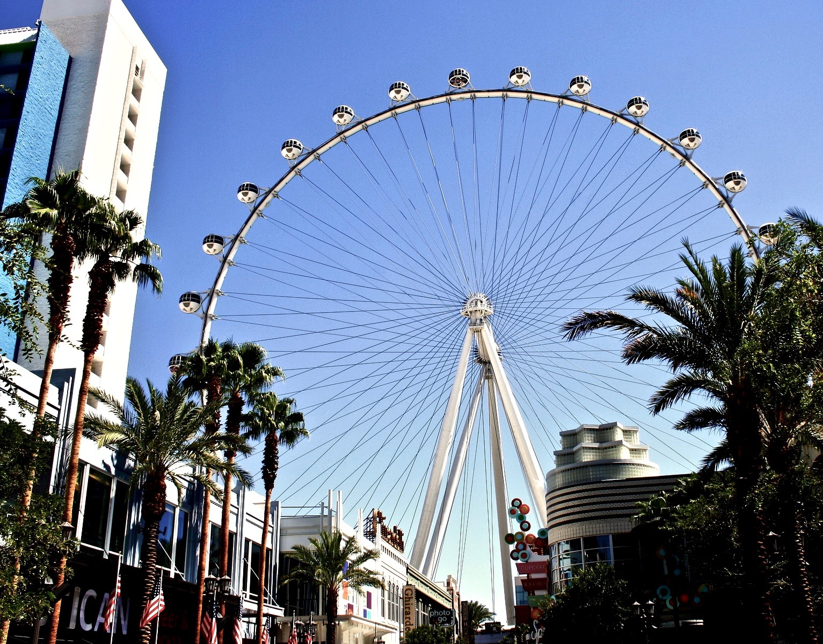
The world’s tallest Ferris wheel is in Las Vegas. The height $h$ in feet of one of the passenger seats on the Ferris wheel can be modeled by the function $f(t)=275+260\text{sin}\left(\frac{2πt}{30}\right)$ where time $t$ is measured in minutes after 8:00 a.m.
- What is the diameter of the Ferris wheel? Explain how you know.
- How long does it take the Ferris wheel to make a complete revolution? Explain how you know.
- Give at least three different times when the passenger seat modeled by $f$ is at its lowest point. Explain how you know.
- Sketch a graph of the height of the seat on the Ferris wheel for at least two full revolutions.
© CC BY 2019 by Illustrative Mathematics®

