Unit 6 Lesson 7: Reasoning about Solving Equations (Part 1)

1 Hanger Diagrams (Warm up)

Images for Launch
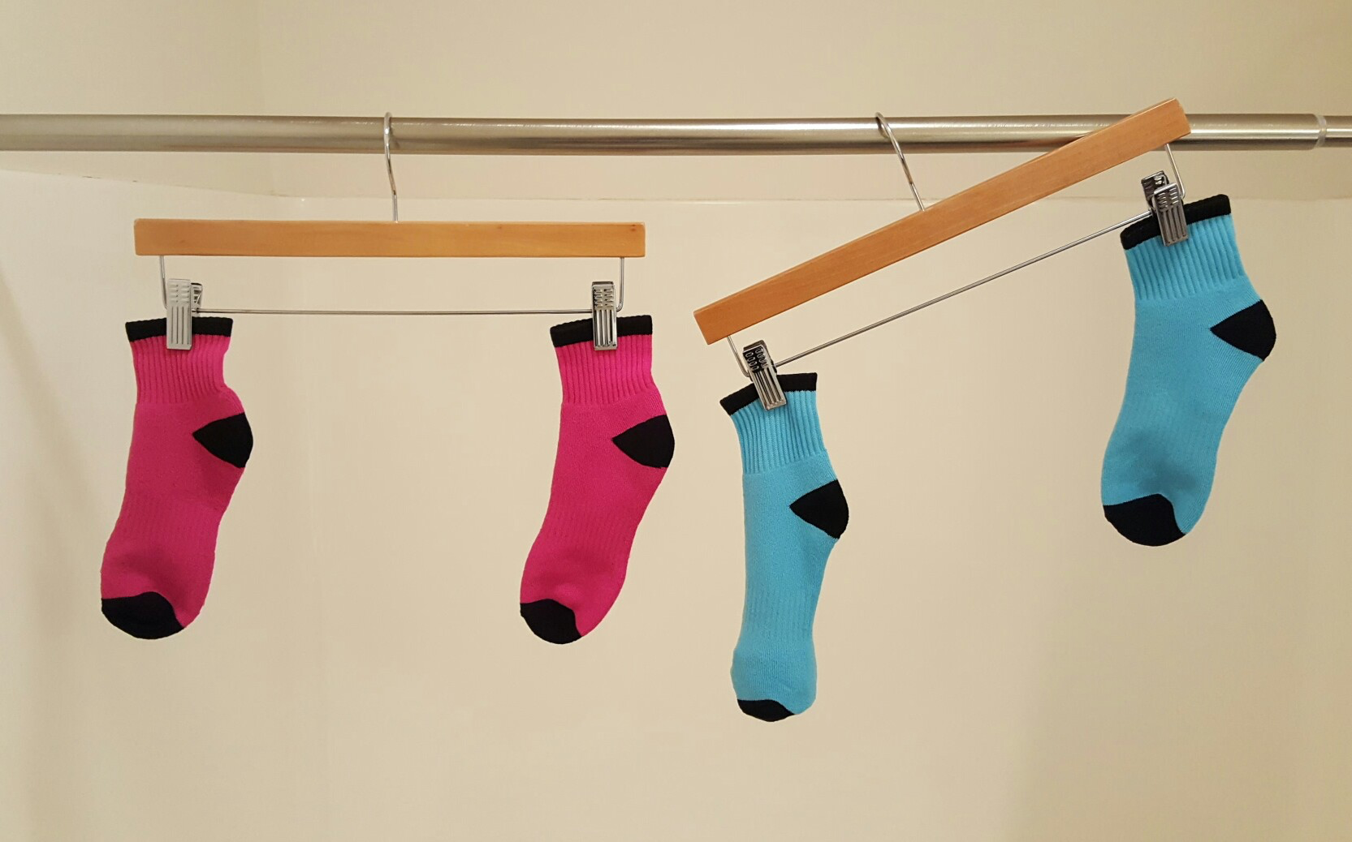

Student Task Statement
In the two diagrams, all the triangles weigh the same and all the squares weigh the same.
For each diagram, come up with . . .
- One thing that must be true
- One thing that could be true
- One thing that cannot possibly be true

2 Hanger and Equation Matching

Student Task Statement
On each balanced hanger, figures with the same letter have the same weight.
- Match each hanger to an equation. Complete the equation by writing $x$, $y$, $z$, or $w$ in the empty box.
  - 23+3=5
  - 33+2=3
  - 6=23+3
  - 7=33+1
- Find the solution to each equation. Use the hanger to explain what the solution means.
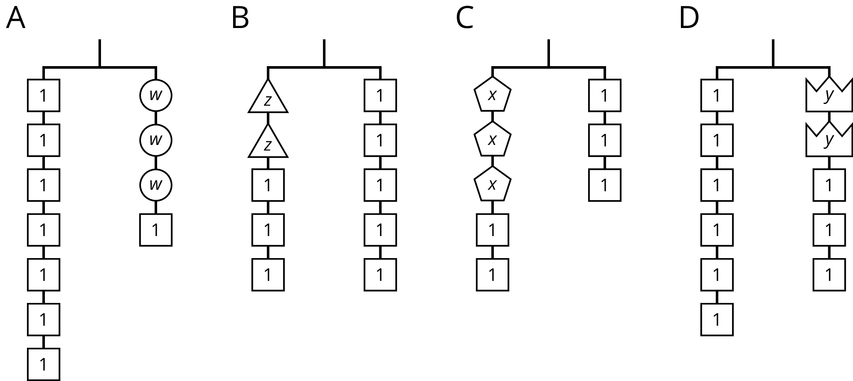

3 Use Hangers to Understand Equation Solving

Student Task Statement
Here are some balanced hangers where each piece is labeled with its weight. For each diagram:
- Write an equation.
- Explain how to figure out the weight of a piece labeled with a letter by reasoning about the diagram.
- Explain how to figure out the weight of a piece labeled with a letter by reasoning about the equation.
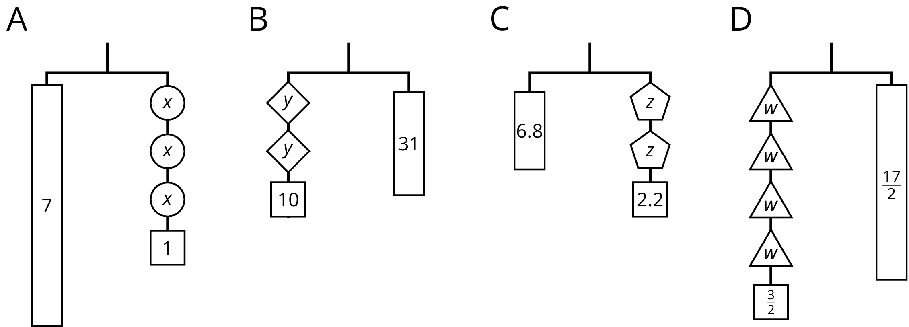

© CC BY Open Up Resources. Adaptations CC BY IM.

