Unit 2 Lesson 2: Mixtures

1 Flower Pattern (Warm up)

Student Task Statement
This flower is made up of yellow hexagons, red trapezoids, and green triangles.
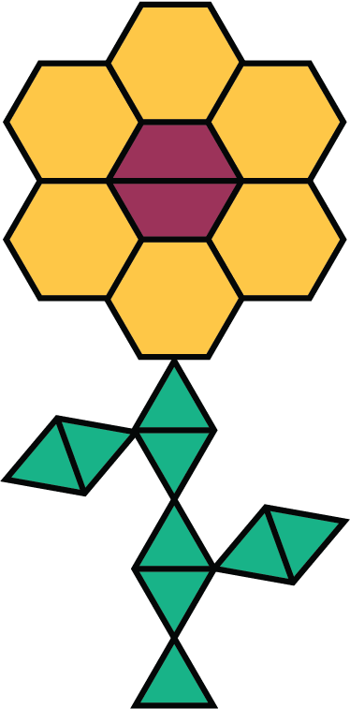
- Write sentences to describe the ratios of the shapes that make up this pattern.
- How many of each shape would be in two copies of this flower pattern?

2 Powdered Drink Mix

Images for Launch
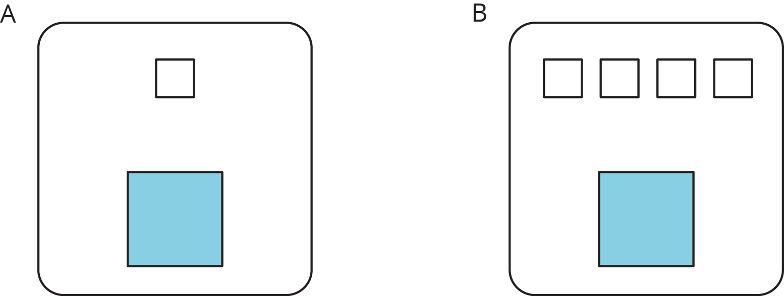
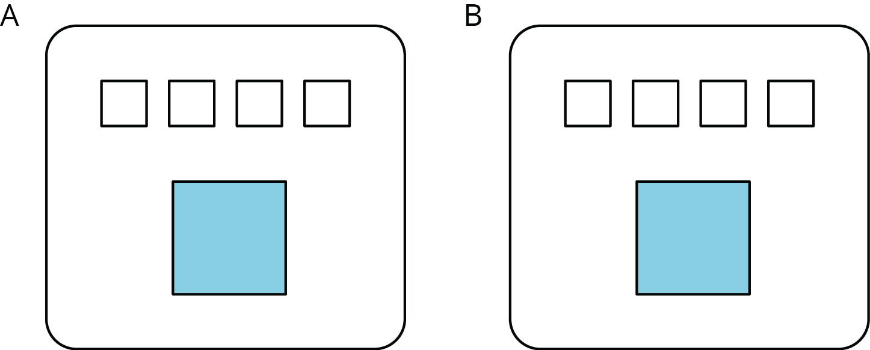

Student Task Statement
Here are diagrams representing three mixtures of powdered drink mix and water:
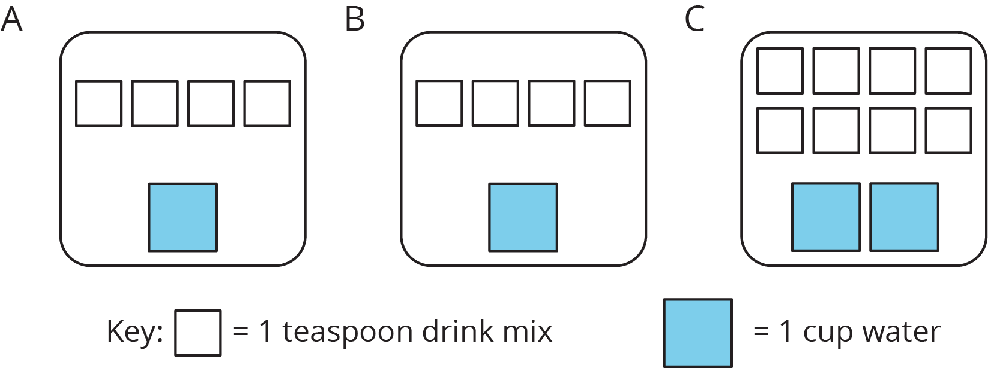
- How would the taste of Mixture A compare to the taste of Mixture B?
- Use the diagrams to complete each statement:
  - Mixture B uses ______ cups of water and ______ teaspoons of drink mix. The ratio of cups of water to teaspoons of drink mix in Mixture B is ________.
  - Mixture C uses ______ cups of water and ______ teaspoons of drink mix. The ratio of cups of water to teaspoons of drink mix in Mixture C is ________.
- How would the taste of Mixture B compare to the taste of Mixture C?

3 Batches of Cookies

Student Task Statement
A recipe for one batch of cookies calls for 5 cups of flour and 2 teaspoons of vanilla.
- Draw a diagram that shows the amount of flour and vanilla needed for two batches of cookies.
- How many batches can you make with 15 cups of flour and 6 teaspoons of vanilla? Show the additional batches by adding more ingredients to your diagram.
- How much flour and vanilla would you need for 5 batches of cookies?
- Whether the ratio of cups of flour to teaspoons of vanilla is $5:2$, $10:4$, or $15:6$, the recipes would make cookies that taste the same. We call these equivalent ratios.
  - Find another ratio of cups of flour to teaspoons of vanilla that is equivalent to these ratios.
  - How many batches can you make using this new ratio of ingredients?
© CC BY Open Up Resources. Adaptations CC BY IM.

