Unit 7 Lesson 8: Money and Debts

1 Concert Tickets (Warm up)

Student Task Statement
Priya wants to buy three tickets for a concert. She has earned $135 and each ticket costs $50. She borrows the rest of the money she needs from a bank and buys the tickets.
- How can you represent the amount of money that Priya has after buying the tickets?
- How much more money will Priya need to earn to pay back the money she borrowed from the bank?
- How much money will she have after she pays back the money she borrowed from the bank?

2 Cafeteria Food Debt

Student Task Statement
At the beginning of the month Kiran had $24 in his school cafeteria account. Use a variable to represent the unknown quantity in each transaction below and write an equation to represent it. Then, represent each transaction on a number line. What is the unknown quantity in each case?
- In the first week he spent $16 on lunches. How much was in his account then?
- Then he deposited some more money and his account balance was $28. How much did he deposit?
- Then he spent $34 on lunches the next week. How much was in his account then?
- Then he deposited enough money to pay off his debt to the cafeteria. How much did he deposit?
- Explain why it makes sense to use a negative number to represent Kiran's account balance when he owes money.

3 Bank Statement

Student Task Statement
Here is a bank statement.
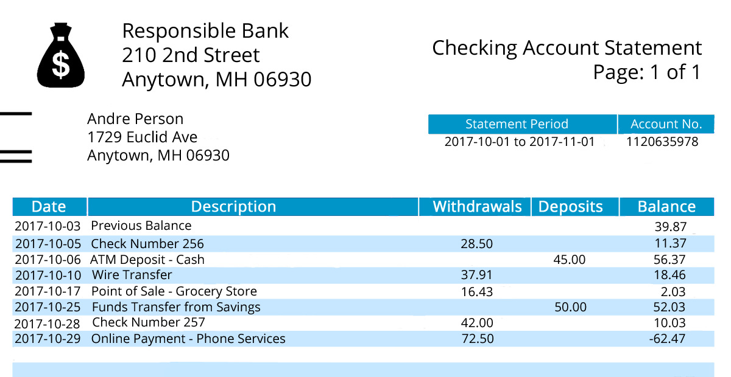
- If we put withdrawals and deposits in the same column, how can they be represented?
- Andre withdraws $40 to buy a music player. What is his new balance?
- If Andre deposits $100 in this account, will he still be in debt? How do you know?
© CC BY Open Up Resources. Adaptations CC BY IM.

