Unit 2 Lesson 17: Order Towers and Numbers

WU Act It Out: Family Dinner (Warm up)

Student Task Statement
Han is helping his grandfather set the table for dinner.
Han puts 8 plates on the table.

1 Cube Towers

Student Task Statement

2 Order Towers and Numbers

Student Task Statement

3 Centers: Choice Time

Student Task Statement
Choose a center.
Math Stories
Math Libs
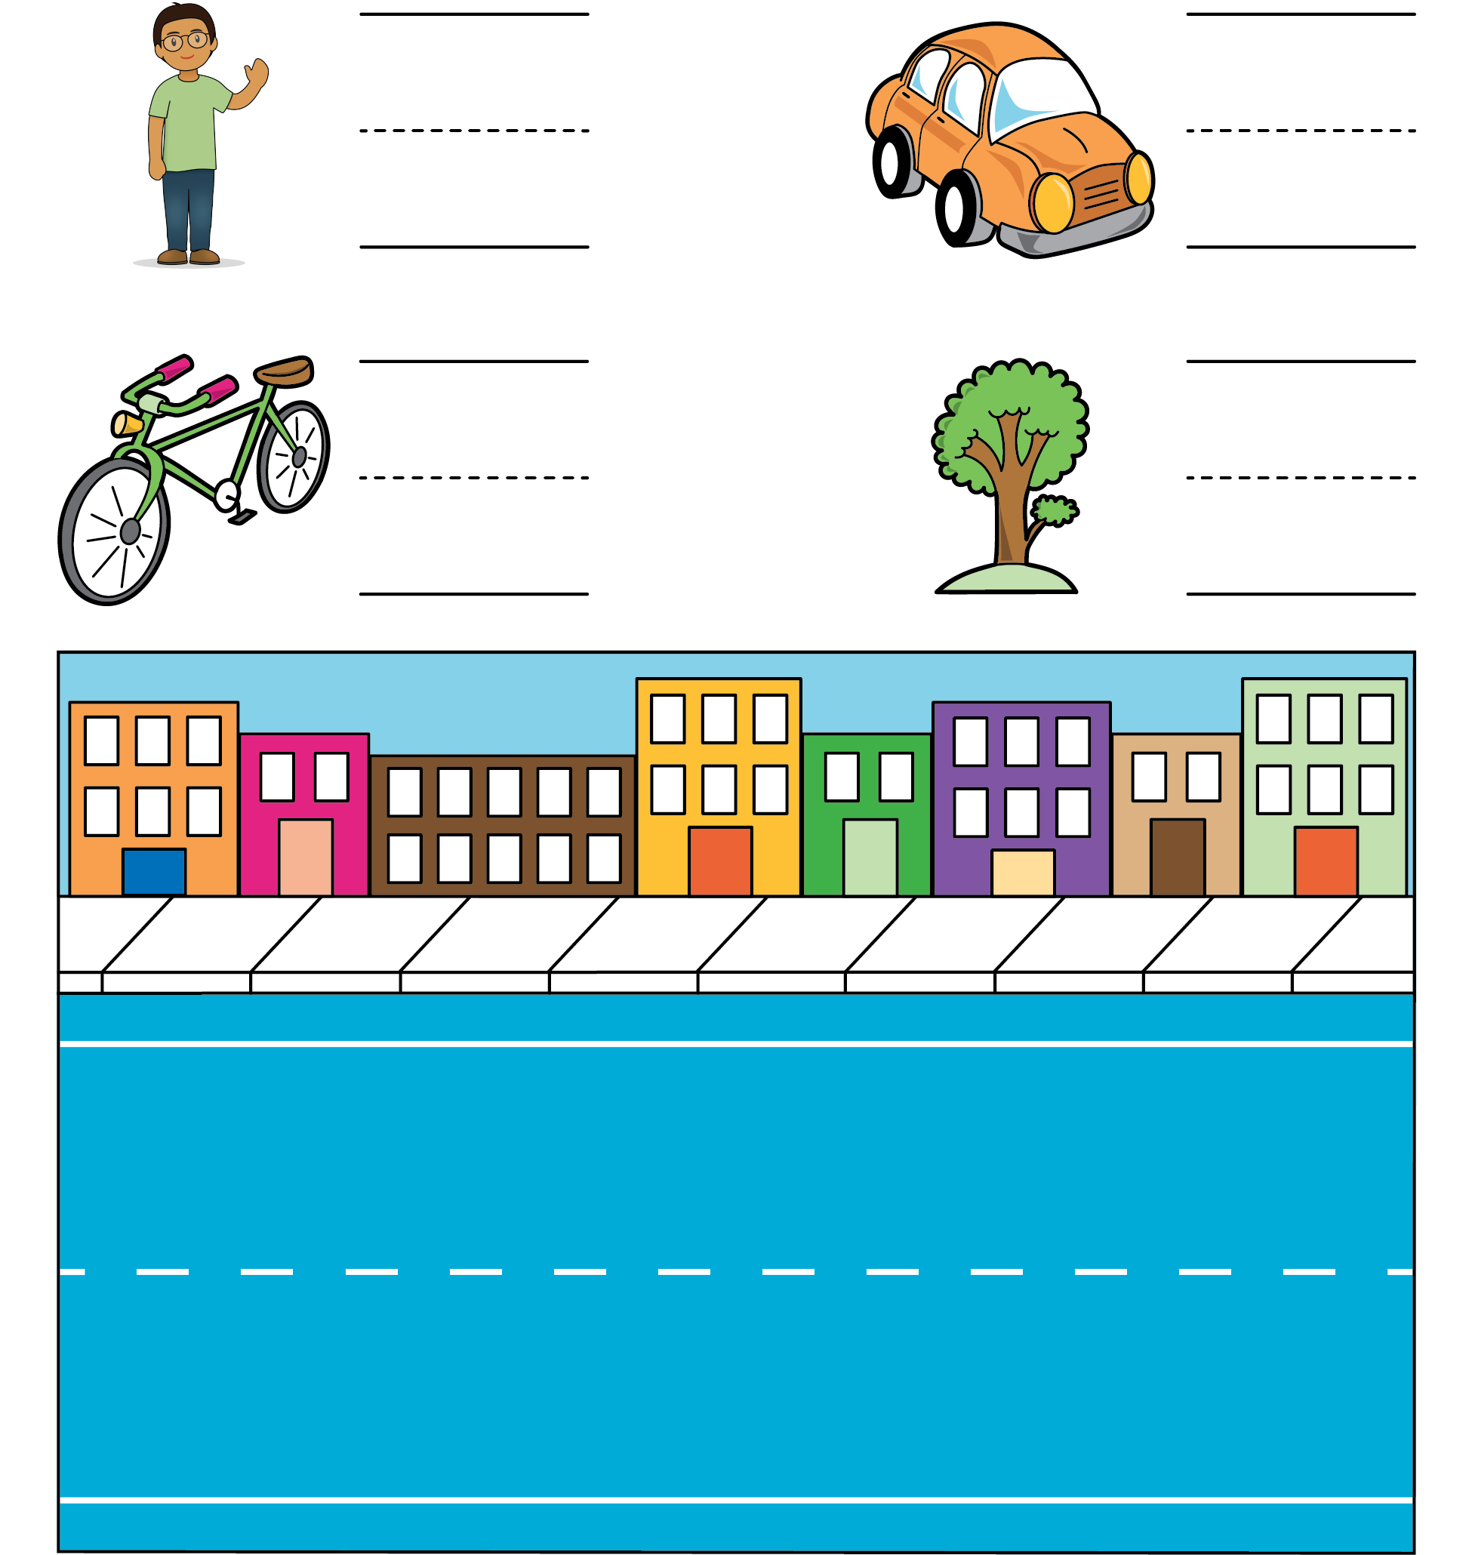
Number Race
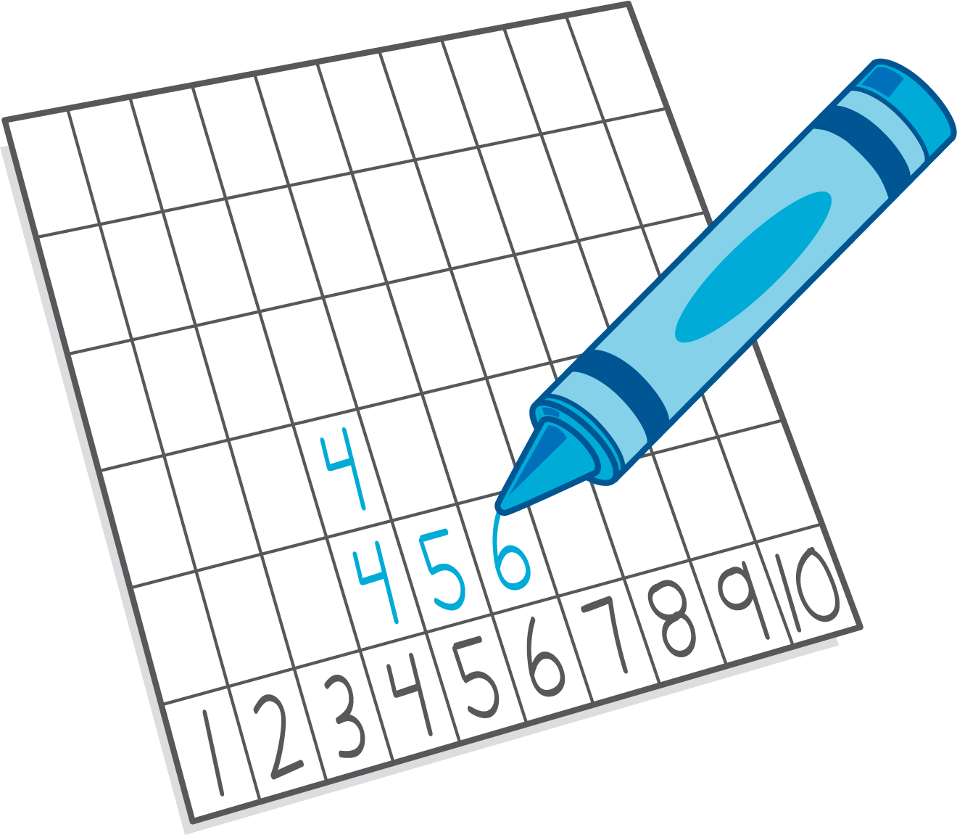
© CC BY 2021 Illustrative Mathematics®

