Lesson 10: Interpreting Inputs and Outputs
- Let’s look at inputs and outputs of a function.

10.1: A Function Riddle
The table shows inputs and outputs for a function. What function could it be?
input | output
1 | 3
2 | 3
3 | 5
4 | 4
5 | 4
10 | 3
11 | 6

10.2: What’s the Input?
- For each pair of variables, which one makes the most sense as the input? When possible, include a reasonable unit.
  - The number of popcorn kernels left unpopped as a function of time cooked.
  - The cost of crab legs as a function of the weight of the crab legs.
  - 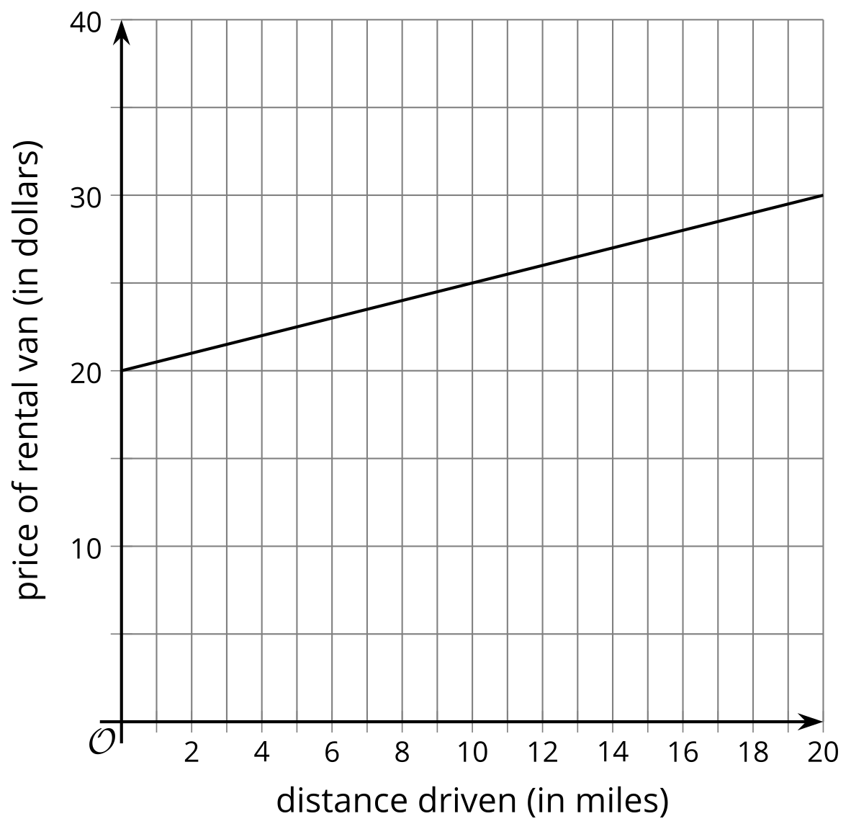
  - 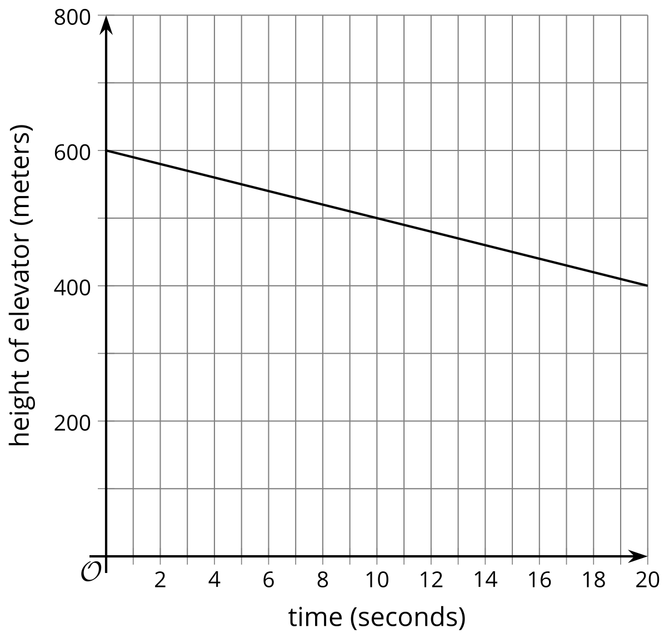
  - $f\left(t\right)=5t+8$ where $t$ represents the time that a bike is rented, in hours, and $f\left(t\right)$ gives the cost of renting the bike.
  - $g\left(n\right)=7n+4$ where $n$ represents the number of pencils in a box and $g\left(n\right)$ represents the weight of the box of pencils in grams.
- Write the equation or draw the graph of a function relating the 2 variables.
  - Input: side length of a square, output: perimeter of the square
  - Input: time spent walking (minutes), output: distance walked (meters)
  - Input: time spent working out (minutes), output: heart rate (beats per minute)

10.3: Matching Possible Inputs
For each function in column A, find which inputs in column B could be used in the function. Be prepared to explain your reasoning for whether you include each input or not.
- Take turns with your partner to match a function with its possible inputs.
  - For each function, explain to your partner whether each input is possible to use in the function or not.
  - For each input, listen carefully to their explanation. If you disagree, discuss your thinking and work to reach an agreement.
- $f\left(\text{person}\right)=\text{the person’s birthday}$
- $g\left(x\right)=2x+1$
- $h\left(\text{item}\right)=\text{the number of chromosomes in the item}$
- $P\left(\text{equilateral triangle side length}\right)=3⋅\left(\text{side length}\right)$
- $C\left(\text{number of students}\right)=9.99\left(\text{number of students}\right)+15$
- Martha Washington (the first First Lady of the United States)
- an apple
- 6
- 9.2
- 0
- -1
For each function, write 2 additional inputs that make sense to use. Write 1 additional input that does not make sense to use. Be prepared to share your reasoning.
© CC BY 2019 by Illustrative Mathematics®

