Unit 3 Lesson 12: Practice With Proportional Relationships

1 Vegetable Garden (Warm up)

Student Task Statement
These are the plans for a vegetable garden that a school is designing.
Scale: 1 unit = 2.8 ft
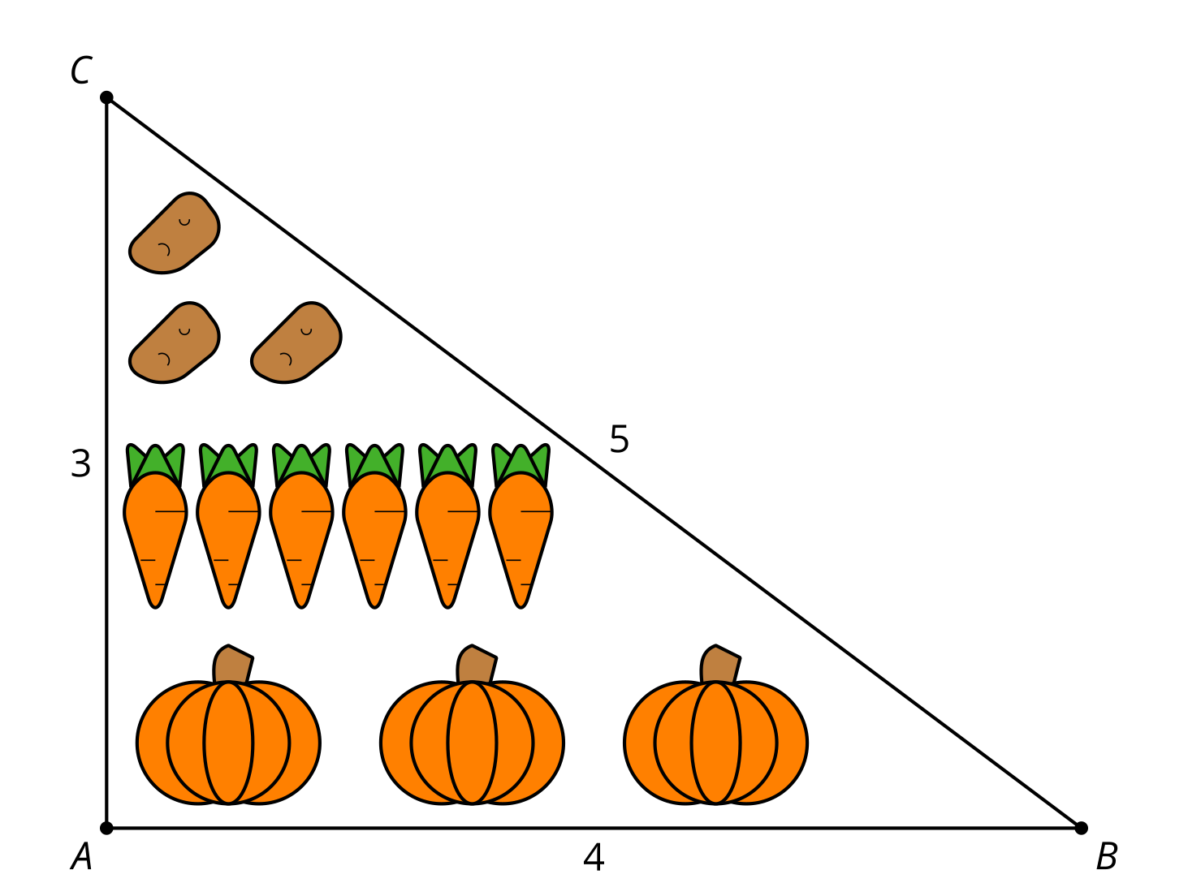
Write at least 3 equivalent ratios or equations using lengths from both the diagram and the full-size garden.

2 Card Sort: Corresponding Parts (Optional)

Student Task Statement
Your teacher will give you a set of cards. Group them into pairs of similar figures. For each pair, determine:
- a similarity statement
- the scale factor between the similar figures
- the missing lengths

3 Quilting Questions (Optional)

Student Task Statement
- Here is a quilt design made of right isosceles triangles. The smallest squares in the center have an area of 1 square unit. Find the dimensions of the triangles.
- 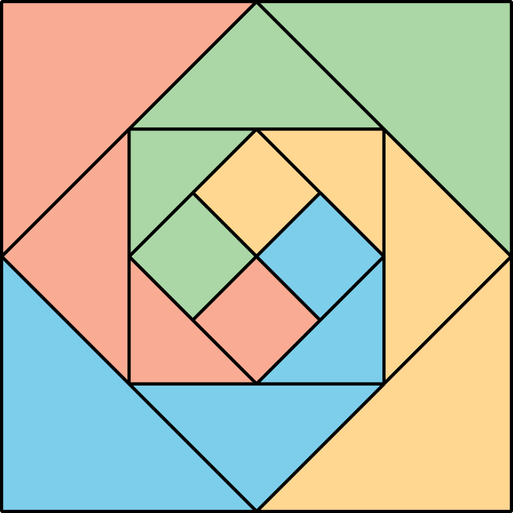
- Are the triangles similar? If so, what are the scale factors?
- This quilt is meant for a baby (1 unit = 6 inches). To make a quilt for a queen-size bed, it needs to be 90 inches wide. What dimensions should the center squares of the big quilt have to reach that width?

Images for Activity Synthesis

$∠Y≅∠W,\overset{¯}{JD}⊥\overset{¯}{DY},\overset{¯}{BL}⊥\overset{¯}{BW}$
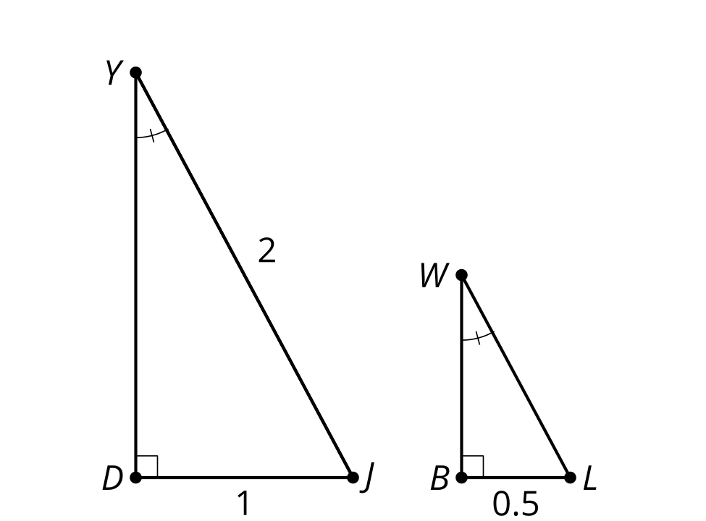
© CC BY 2019 by Illustrative Mathematics®

