Lesson 13: Multiples of 100
- Let’s explore multiples of 100 and how other numbers relate to them.

Warm-up: Estimation Exploration: Marching Band
How many people are in the marching band?
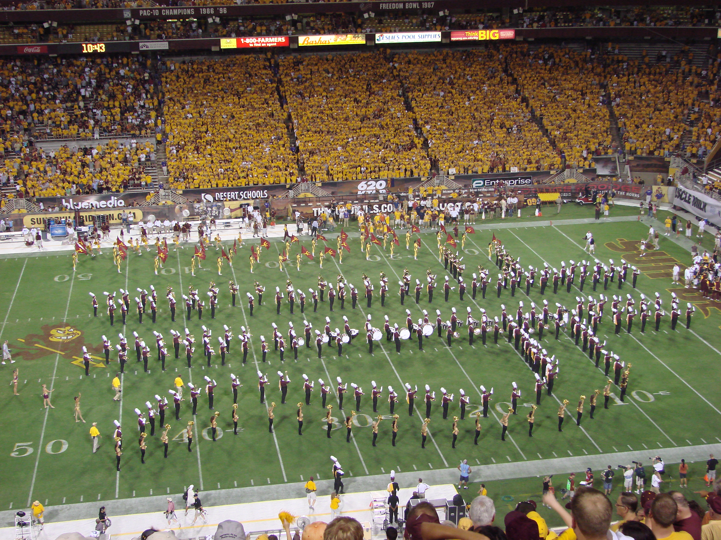
Record an estimate that is:
too low | about right | too high

13.1: About 100? Close to 100?
- Here are the numbers of people in different parts of a school at noon during a school day.
  - playground: 94
  - cafeteria: 163
  - art room: 36
  - library: 13
  - classrooms: 216
  - gymnasium: 109
  - music room: 52
- Where in the school would you say that there are about 100 people?
- Record the numbers in the table. Be prepared to explain your reasoning.
- about 100 | - not about 100
- Now decide if the number of people in each part of the school is close to 0, close to 100, or close to 200.
- If you don’t think a number belongs in any column, set it aside. Be prepared to explain your reasoning.
- close to 0 | - close to 100 | - close to 200

13.2: Close to Multiples of 100
Your teacher will assign a set of numbers to you.
A | 94 | 36 | 109 | 163 | 229
B | 24 | 52 | 216 | 11 | 481
C | 187 | 135 | 67 | 83 | 241
D | 332 | 154 | 408 | 296 | 45
E | 279 | 205 | 377 | 449 | 73
- Work with your group to decide on which number line each number should go. Then, locate and label each number on the number line.
- Locate and label 364 on the correct number line.
  - Name two multiples of 100 that are closest to 364.
  - Of the two multiples of 100 you named, which one is 364 closer to?
- Write the numbers assigned to you earlier. For each number, name the nearest multiple of 100.
- number
- nearest multiple of 100
© CC BY 2021 Illustrative Mathematics®

