Unit 2 Lesson 2: How Do We Measure Area?

WU Which One Doesn’t Belong: Shapes with Squares (Warm up)

Student Task Statement
Which one doesn’t belong?
A
B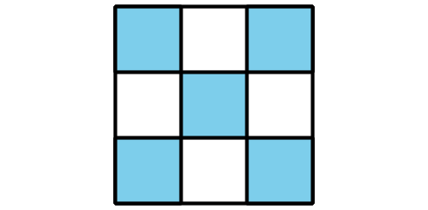
C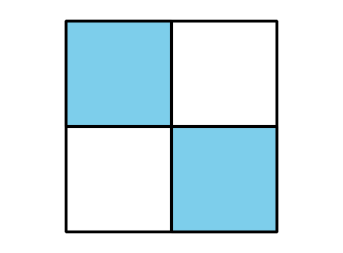
D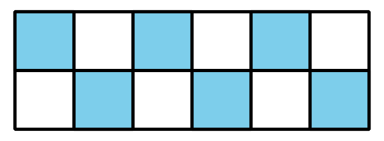

1 Create and Compare

Student Task Statement
- Take a handful of square tiles.
- Create a shape from the tiles.
- As a group, order the shapes from smallest to largest.
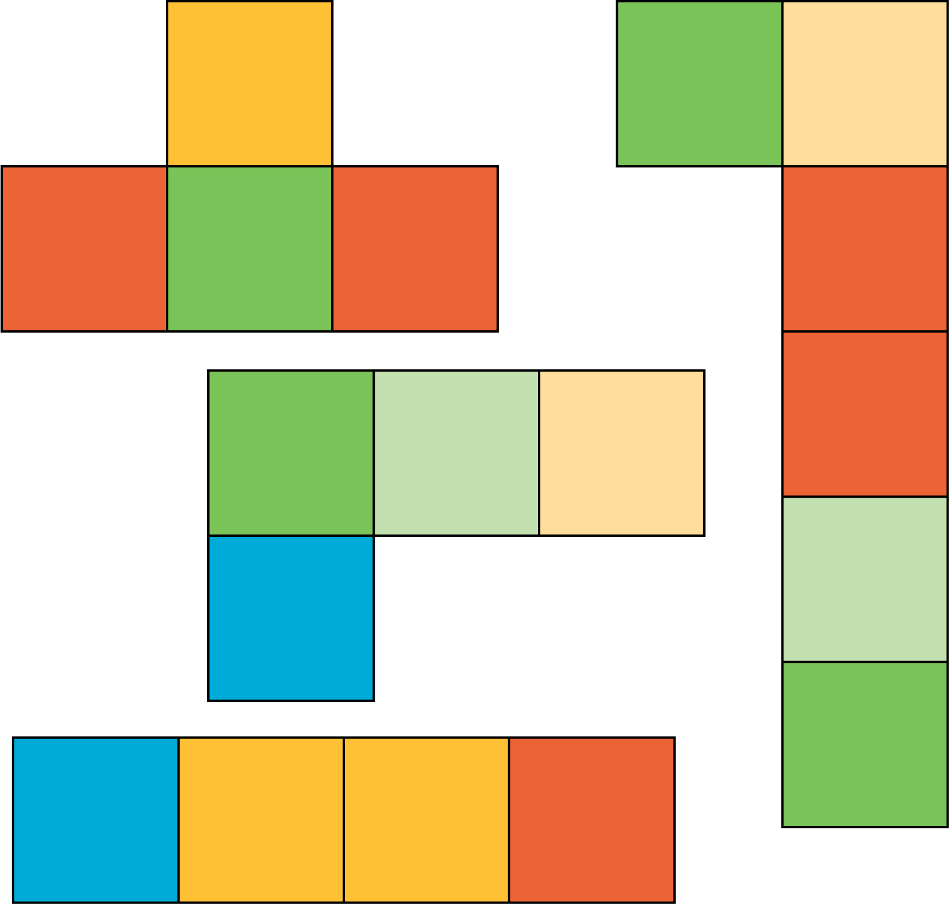

2 Use Square Tiles to Measure Area

Student Task Statement
Your teacher will give you handouts with some figures on them.
Use square tiles to find the area of each figure. Record your answers here. Be prepared to explain your reasoning.
- Area: _____ square units
- Area: _____ square units
- Area: _____ square units
- Area: _____ square units
- Area: _____ square units
- Area: _____ square units
© CC BY 2021 Illustrative Mathematics®

