Unit 7 Lesson 9: Representing Subtraction

1 Equivalent Equations (Warm up)

Student Task Statement
Consider the equation $2+3=5$. Here are some more equations, using the same numbers, that express the same relationship in a different way:
$3+2=5$
$5−3=2$
$5−2=3$
For each equation, write two more equations, using the same numbers, that express the same relationship in a different way.
- $9+\left(\text{-}1\right)=8$
- $\text{-}11+x=7$

2 Subtraction with Number Lines

Student Task Statement
- Here is an unfinished number line diagram that represents a sum of 8.
- 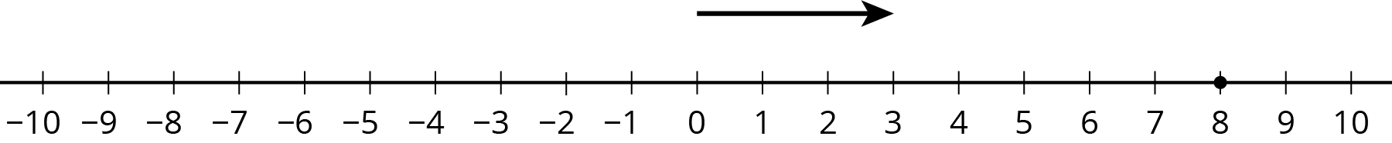
  - How long should the other arrow be?
  - For an equation that goes with this diagram, Mai writes $3+?=8$.
Tyler writes $8−3=?$. Do you agree with either of them?
  - What is the unknown number? How do you know?
- Here are two more unfinished diagrams that represent sums.
- 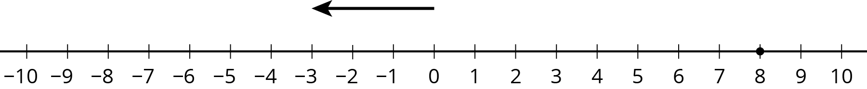

- 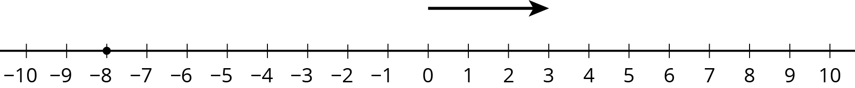

- For each diagram:
  - What equation would Mai write if she used the same reasoning as before?
  - What equation would Tyler write if he used the same reasoning as before?
  - How long should the other arrow be?
  - What number would complete each equation? Be prepared to explain your reasoning.
- Draw a number line diagram for $\left(\text{-}8\right)−\left(\text{-}3\right)=?$ What is the unknown number? How do you know?

3 We Can Add Instead

Student Task Statement
- Match each diagram to one of these expressions:
- $3+7$
- $3−7$
- $3+\left(\text{-}7\right)$
- $3−\left(\text{-}7\right)$

  - 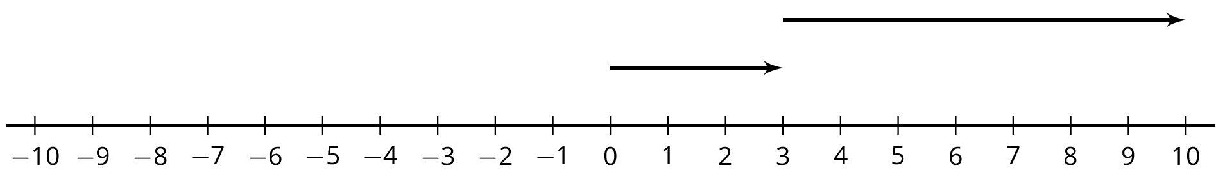
  - 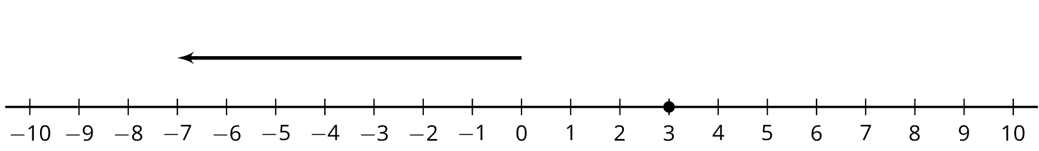
  - 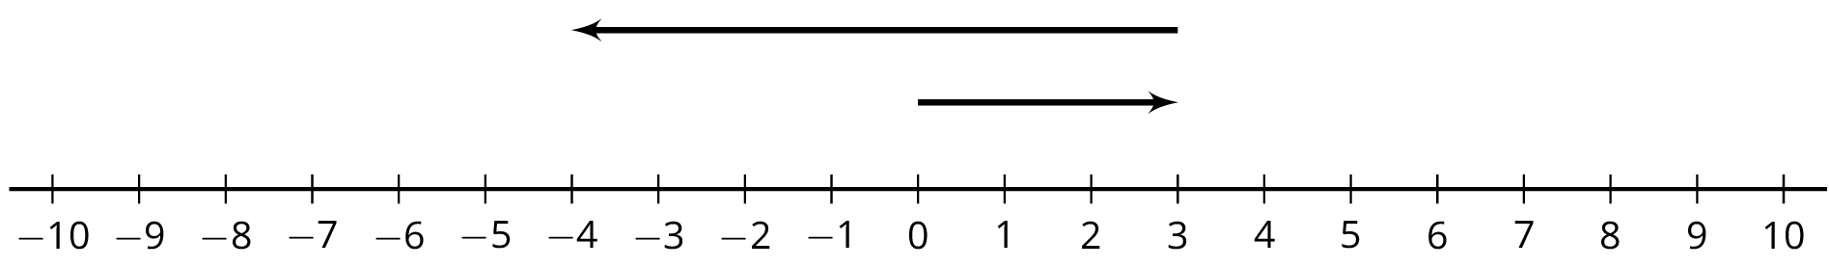
  - 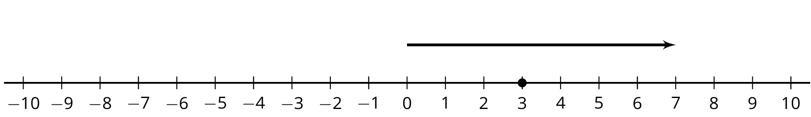
- Which expressions in the first question have the same value? What do you notice?
- Complete each of these tables. What do you notice?
- expression | - value
- $8+\left(\text{-}8\right)$
- $8−8$
- $8+\left(\text{-}5\right)$
- $8−5$
- $8+\left(\text{-}12\right)$
- $8−12$

- expression | - value
- $\text{-}5+5$
- $\text{-}5−\left(\text{-}5\right)$
- $\text{-}5+9$
- $\text{-}5−\left(\text{-}9\right)$
- $\text{-}5+2$
- $\text{-}5−\left(\text{-}2\right)$
© CC BY Open Up Resources. Adaptations CC BY IM.

