Unit 2 Lesson 18: 1 More or 1 Less with Towers and Numbers

WU Act It Out: Forks for Dinner (Warm up)

Student Task Statement
Mai is helping hand out the forks for dinner.
There are 9 people sitting at the table.
Mai has 7 forks.
Are there enough forks for each person to get one?

1 What’s Missing?

Student Task Statement

2 One Less, One More

Student Task Statement
my tower
my partner’s tower
my tower
my partner’s tower
my tower
my partner’s tower
my tower
my partner’s tower

3 Centers: Choice Time

Student Task Statement
Choose a center.
Math Stories
Math Libs
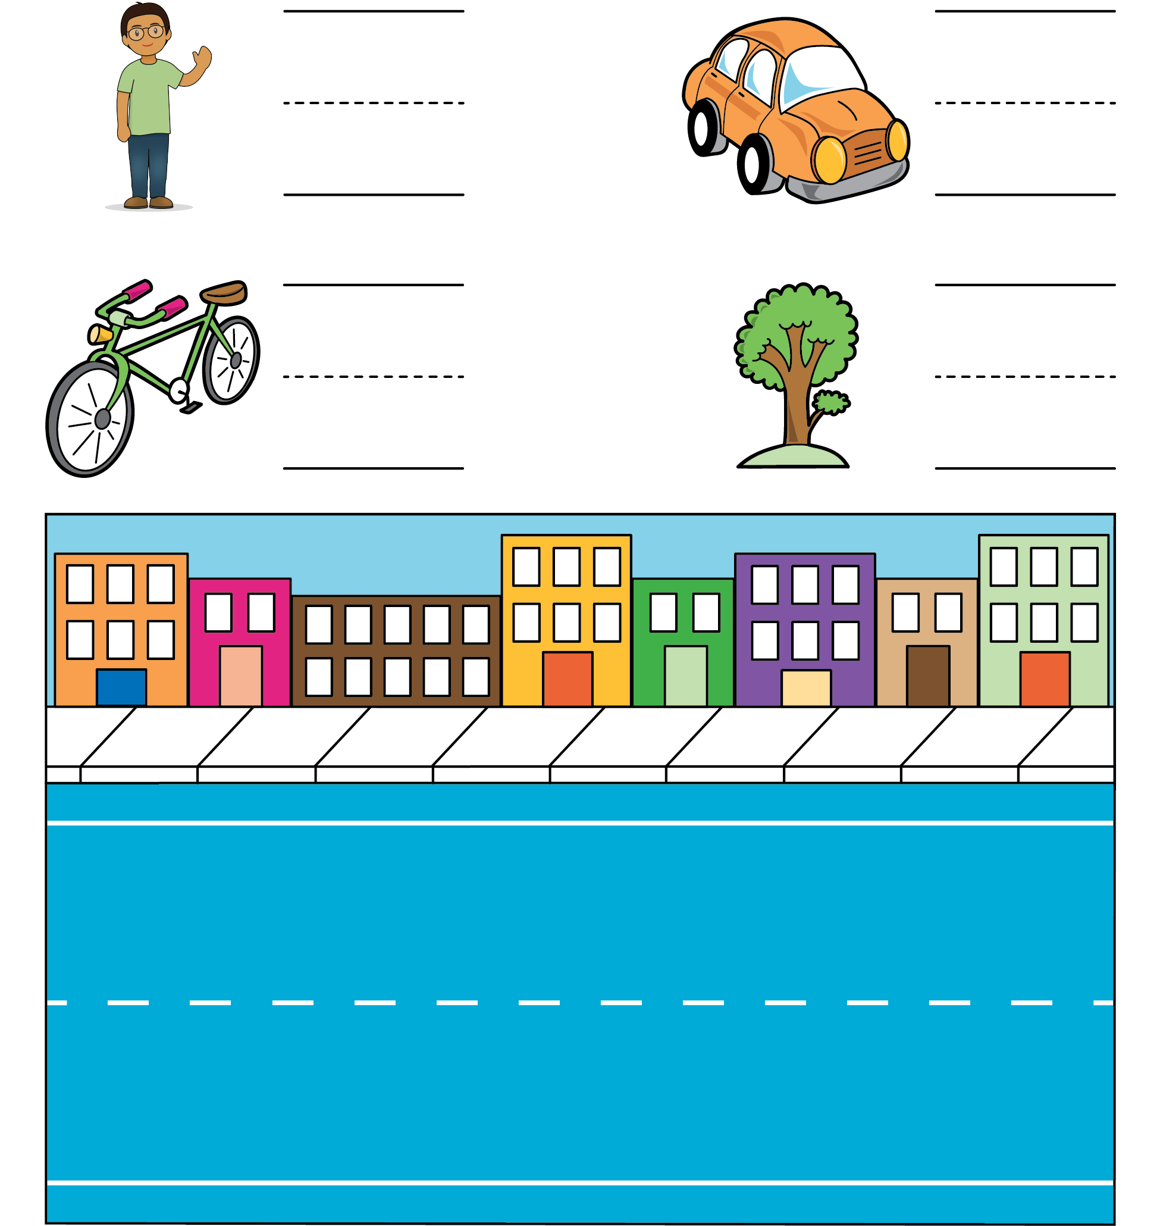
Number Race
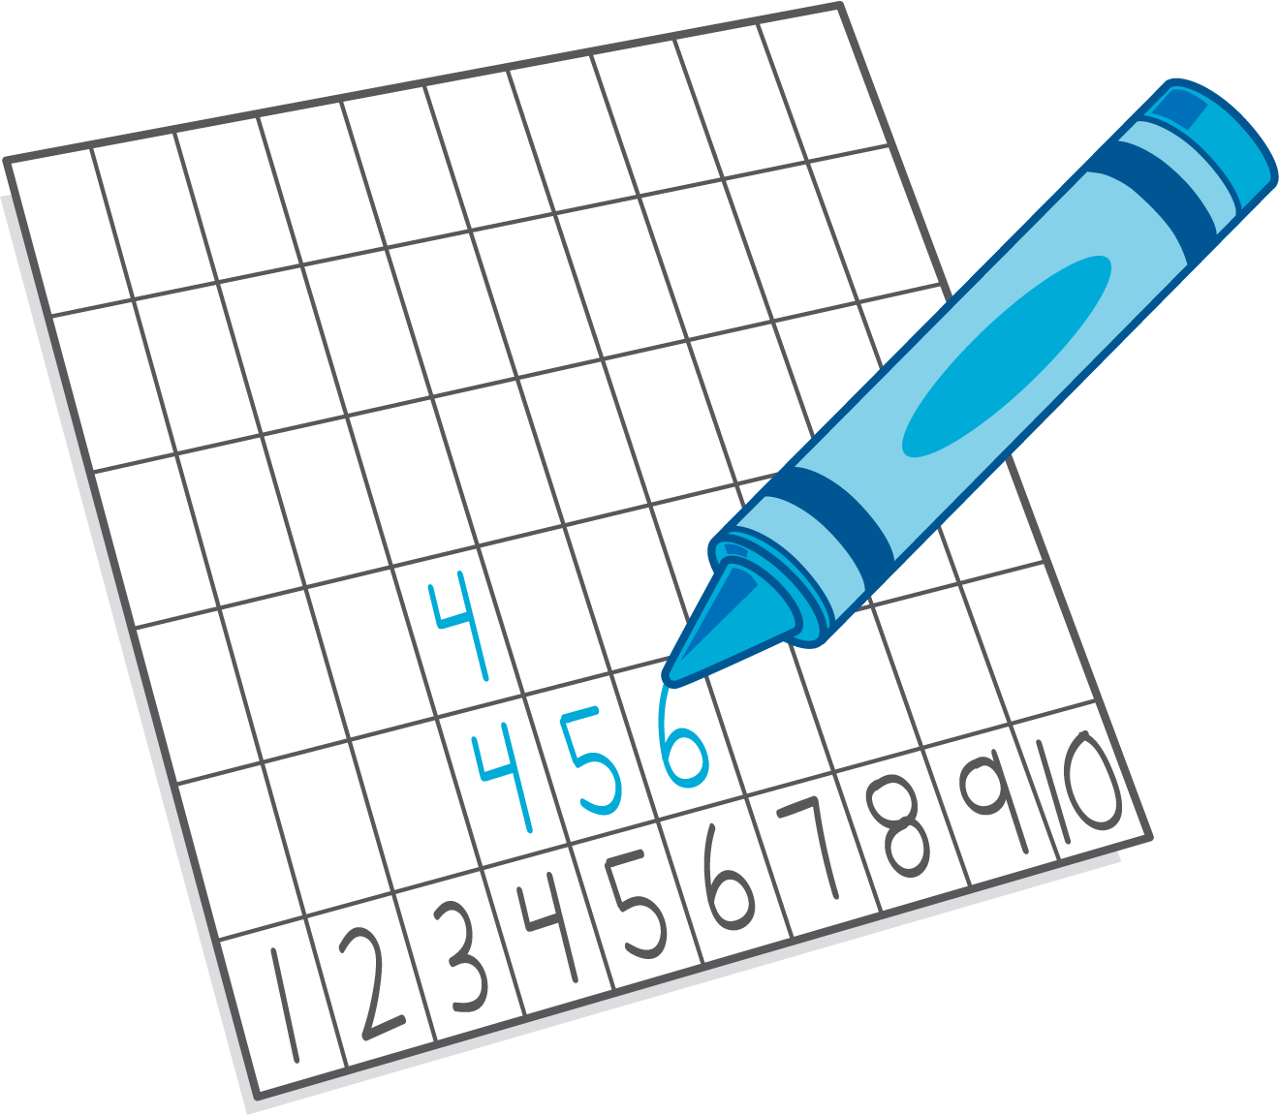
© CC BY 2021 Illustrative Mathematics®

