Lesson 2 Practice Problems
- The thermostat in an empty apartment is set to ${65}^{∘}\text{F}$ from 4:00 a.m. to 5:00 p.m. and to ${50}^{∘}\text{F}$ from 5:00 p.m. until 4:00 a.m. Here is a graph of the function $H$ that gives the temperature $H\left(x\right)$ in degrees Fahrenheit in the apartment $x$ hours after midnight.
- 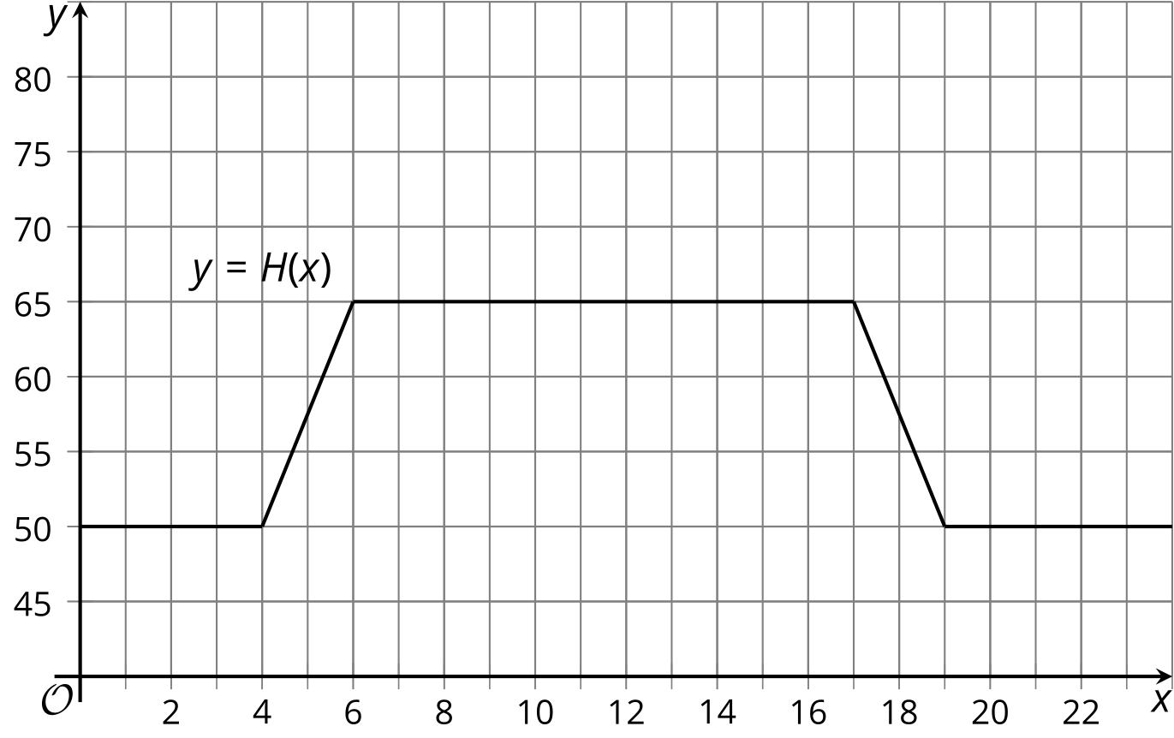
  - The owner of the apartment decides to change to a new schedule and they set the thermostat to change 3 hours later in the morning and the evening. On the same axes, sketch a graph of the new function, $G$, giving the temperature as a function of time.
  - Explain what $H\left(6.5\right)=65$ means in this context. Why is this a reasonable value for the function?
  - If $H\left(6.5\right)=65$, then what is the corresponding point on the graph of $G$? Use function notation to describe the point on the graph of $G$.
  - Write an expression for $G$ in terms of $H$.
- A pumpkin pie recipe says to bake the pie at ${425}^{∘}\text{F}$ for 15 minutes, and then to adjust the temperature down to ${350}^{∘}\text{F}$ for 45 additional minutes. The function $P$ gives the oven temperature setting $P\left(t\right)$, in degrees Fahrenheit, $t$ minutes after the pie is placed in the oven.
  - Explain what $P\left(30\right)=350$ means in this context.
  - Diego discovers that the temperature inside the oven is always 25 degrees warmer than the oven’s temperature setting. The function $B$ gives the actual temperature of Diego’s oven. If $P\left(30\right)=350$, then what is the corresponding point on the function $B$?
  - Write an expression for $B$ in terms of $P$.
- Here is the graph of $y=f\left(x\right)$ for a function $f$.
  - On the same axes, sketch a graph of $g\left(x\right)=f\left(x\right)+2$.
  - On the same axes, sketch a graph of $h\left(x\right)=f\left(x+2\right)$.
  - How do the graphs of $g$ and $h$ compare to $f$?
- 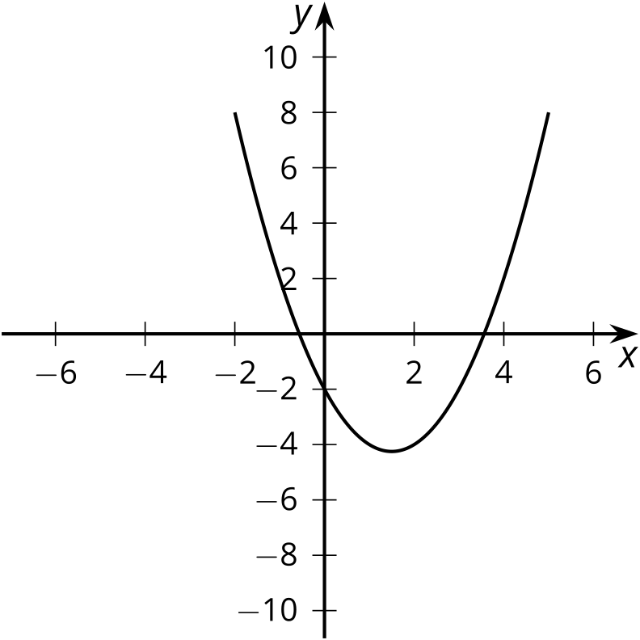
- The graph shows the height of a tennis ball $t$ seconds after it has been hit.
- 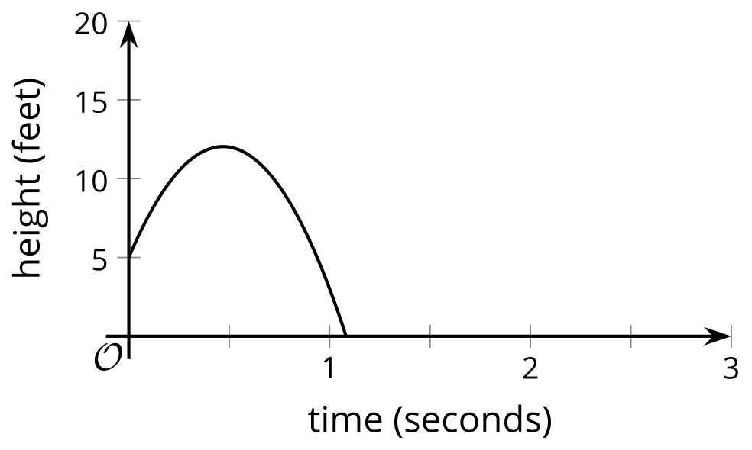
- The function $f$ given by $f\left(t\right)=5+30t−32t^{2}$ models the height of the ball in feet.
  - How high was the ball when it was hit? Where do you see this in the equation?
  - Suppose a second ball follows the same trajectory but is hit from 7 feet off the ground. Sketch the graph of the height of the second ball on the same axes.
  - Write an equation for a function $g$ that defines the height $g\left(t\right)$, in feet, of the second ball hit from 7 feet off the ground in terms of $f\left(t\right)$.

  - Describe a horizontal translation of the line to a line that contains the two labeled points.
  - Describe a vertical translation of the line to a line that contains the two labeled points.
- 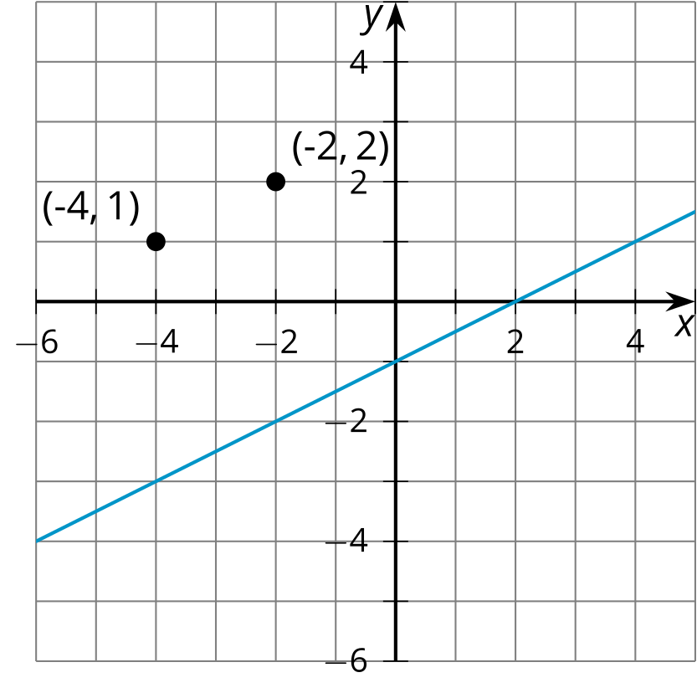
- (From Unit 5, Lesson 1.)
- Does the function $f$ or the function $g$ fit the data better? Explain your reasoning.
- 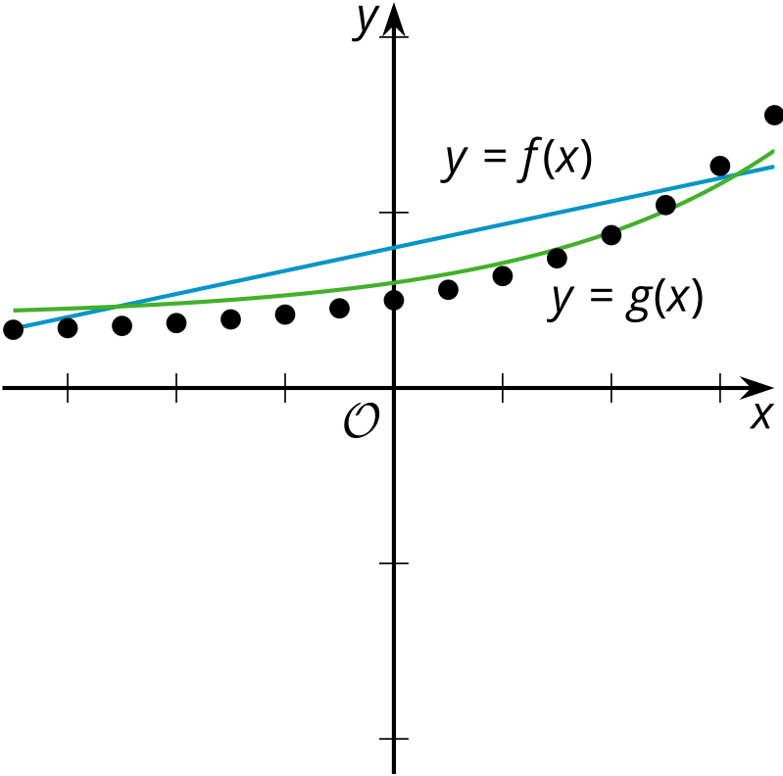
- (From Unit 5, Lesson 1.)
© CC BY 2019 by Illustrative Mathematics®

