Unit 4 Lesson 12 Cumulative Practice Problems
- Here is the graph for one equation in a system of equations:
- 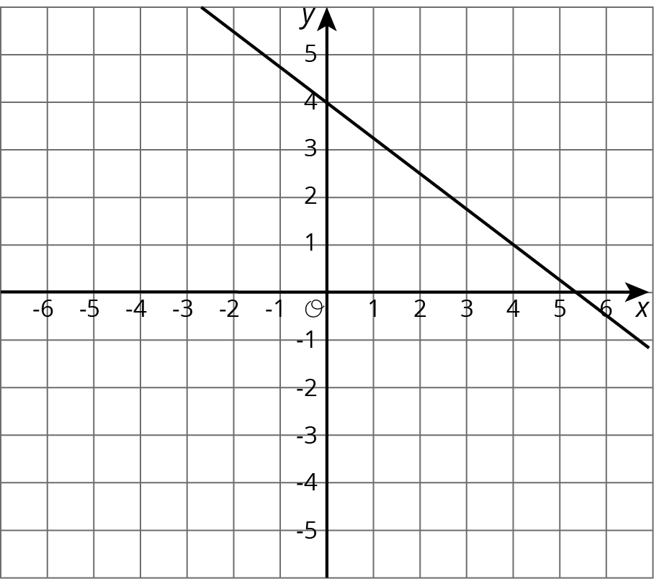
  - Write a second equation for the system so it has infinitely many solutions.
  - Write a second equation whose graph goes through $(0,1)$ so the system has no solutions.
  - Write a second equation whose graph goes through $(0,2)$ so the system has one solution at $(4,1)$.
- Create a second equation so the system has no solutions.
- $\left\{\begin{matrix}y=\frac{3}{4}x−4 \\ \end{matrix}\right.$
- Andre is in charge of cooking broccoli and zucchini for a large group. He has to spend all $17 he has and can carry 10 pounds of veggies. Zucchini costs $1.50 per pound and broccoli costs $2 per pound. One graph shows combinations of zucchini and broccoli that weigh 10 pounds and the other shows combinations of zucchini and broccoli that cost $17.
- 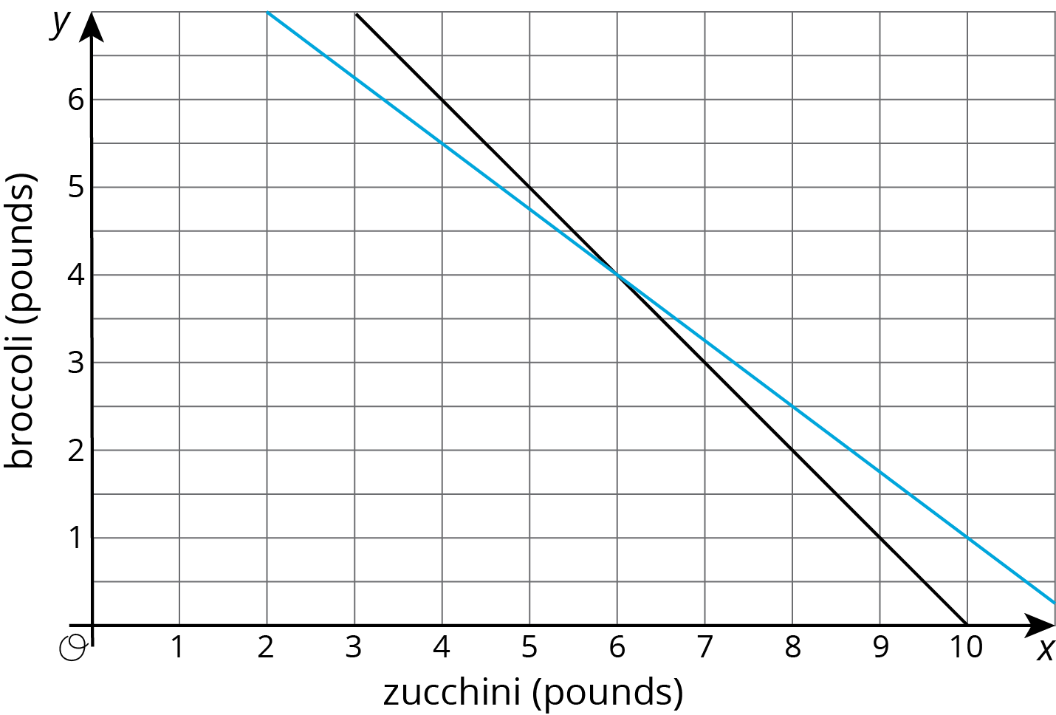
  - Name one combination of veggies that weighs 10 pounds but does not cost $17.
  - Name one combination of veggies that costs $17 but does not weigh 10 pounds.
  - How many pounds each of zucchini and broccoli can Andre get so that he spends all $17 and gets 10 pounds of veggies?
- (From Unit 4, Lesson 10.)
- The temperature in degrees Fahrenheit, $F$, is related to the temperature in degrees Celsius, $C$, by the equation $F=\frac{9}{5}C+32$
  - In the Sahara desert, temperatures often reach 50 degrees Celsius. How many degrees Fahrenheit is this?
  - In parts of Alaska, the temperatures can reach -60 degrees Fahrenheit. How many degrees Celsius is this?
  - There is one temperature where the degrees Fahrenheit and degrees Celsius are the same, so that $C=F$. Use the expression from the equation, where $F$ is expressed in terms of $C$, to solve for this temperature.
- (From Unit 4, Lesson 9.)
© CC BY Open Up Resources. Adaptations CC BY IM.

