Lesson 3: Add 1 or 2
- Let’s add 1 or 2.

Warm-up: How Many Do You See: Dot Cubes
How many do you see?
How do you see them?
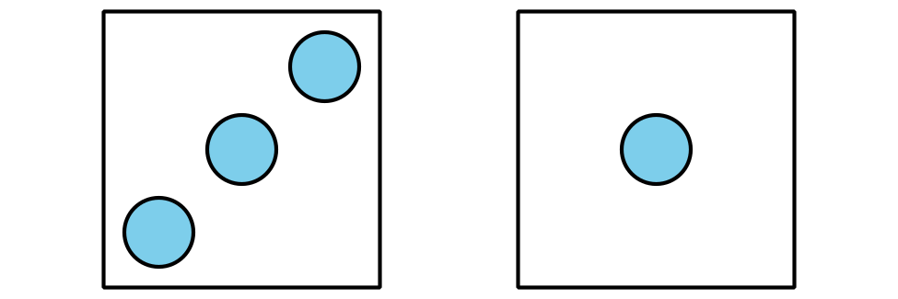
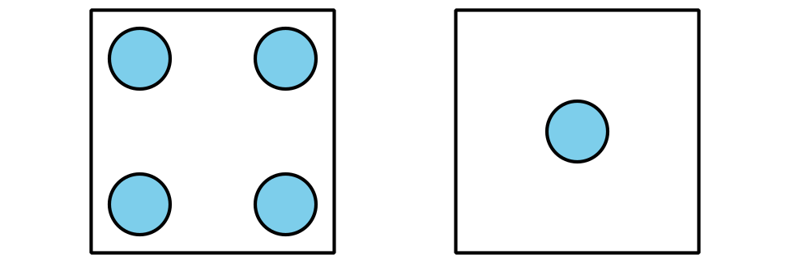
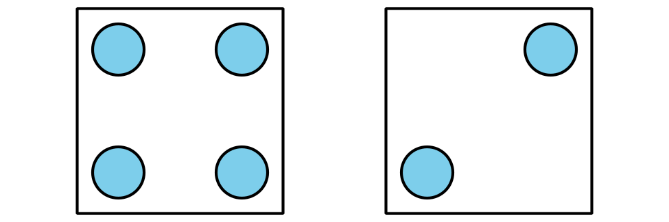
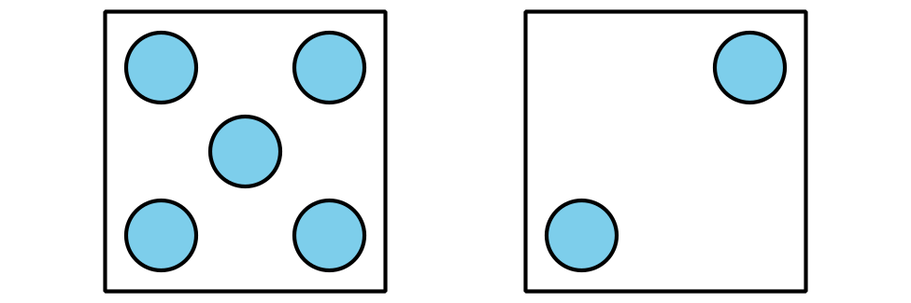

3.2: Centers: Choice Time
Choose a center.
Counting Collections
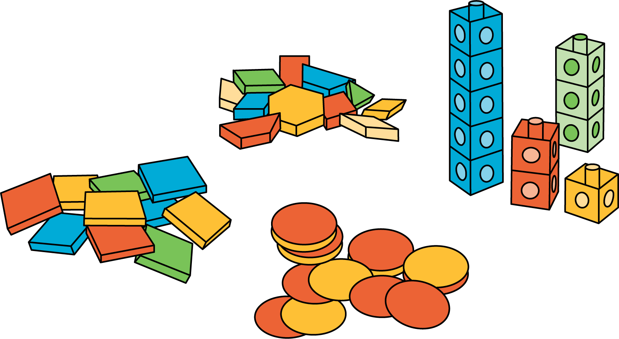
Number Race
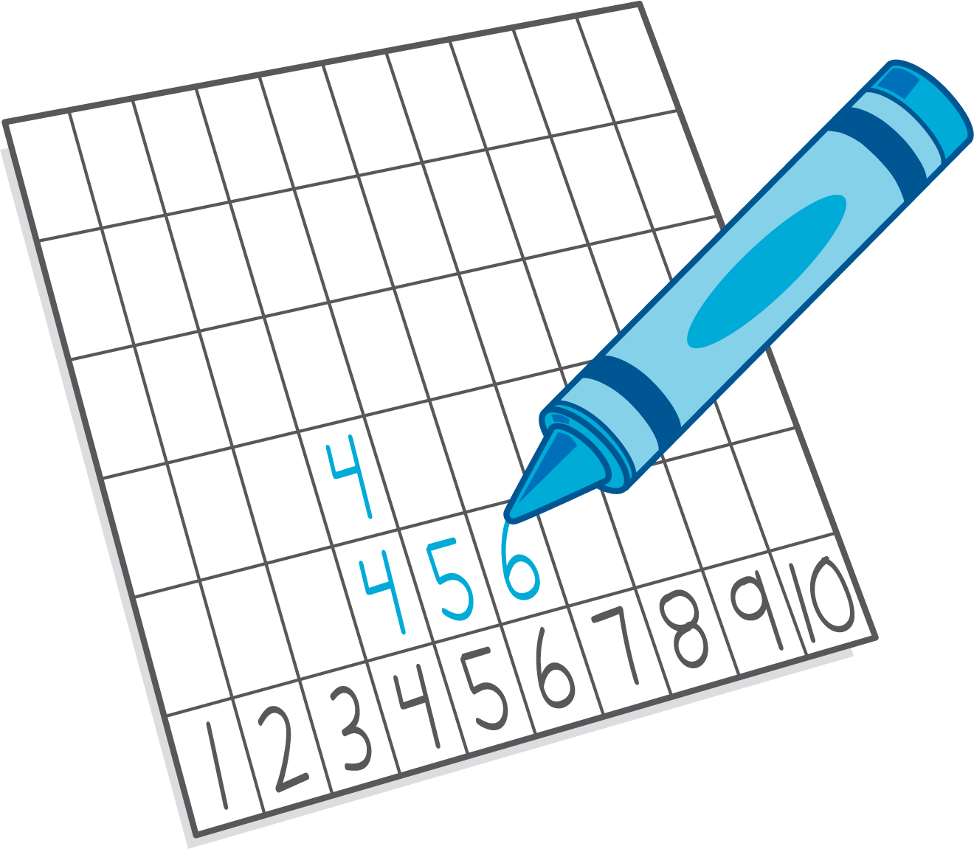
Check it Off
Five in a Row: Addition and Subtraction
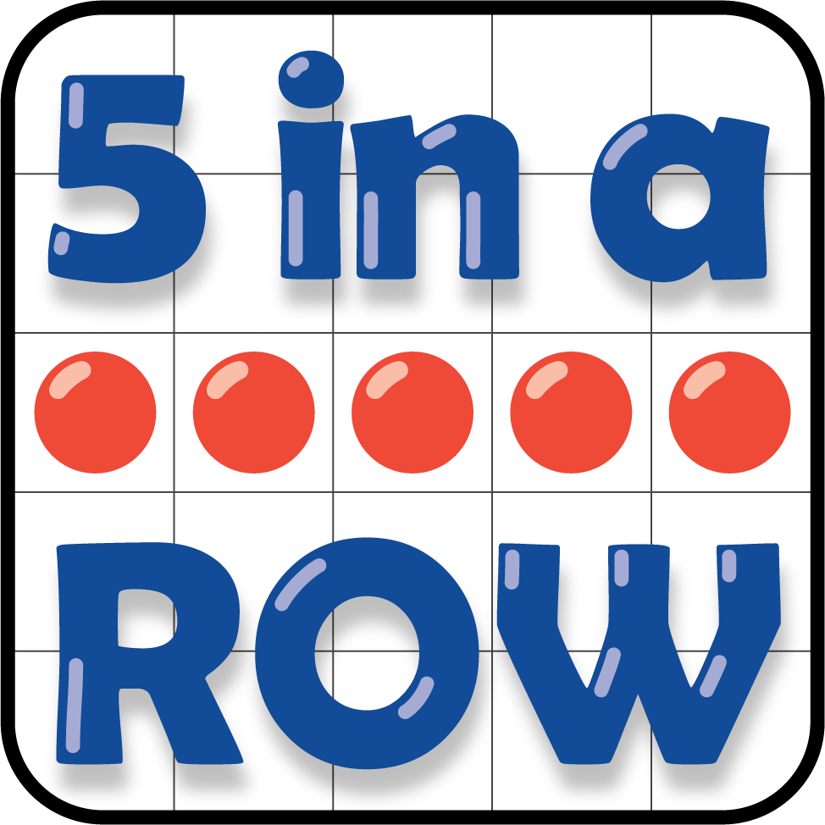
© CC BY 2021 Illustrative Mathematics®

