Lesson 2: Match Representations of Tens

Standards Alignments
Addressing | 1.NBT.A.1, 1.NBT.B.2, 1.NBT.B.2.c

Teacher-facing Learning Goals
- Interpet different base-ten representations of multiples of 10.

Student-facing Learning Goals
- Let’s match different representations of numbers.

Lesson Purpose
The purpose of this lesson is for students to interpret different base-ten representations of multiples of 10.
Students make connections between different representations of multiples of 10. In the first activity, students work together to find the three representations (a number, ___ tens, and drawings of towers of 10) that show the same value and prove how they know the values are equivalent. In the second activity, students use what they have learned to match numbers to towers of 10. Throughout the lesson, when students explain how they know different representations match based on the their understanding of tens, the count sequence, or connections they make to the digits in the numerical representations, they look for and make use of structure and express regularity in repeated reasoning (MP7, MP8).

Access for:

Students with Disabilities
- Engagement (Activity 1)

English Learners
- MLR8 (Activity 2)

Instructional Routines
Estimation Exploration (Warm-up)

Materials to Gather
- Connecting cubes: Activity 2

Materials to Copy
- Representations of Tens (groups of 27): Activity 1
- It's a Match (10-90) words, numbers, pictures (groups of 1): Activity 2

Lesson Timeline
Warm-up | 10 min
Activity 1 | 20 min
Activity 2 | 15 min
Lesson Synthesis | 10 min
Cool-down | 5 min

Teacher Reflection Question
Reflect on how readily students work with the unit ten, rather than ten ones. Are students counting the connecting cubes in each tower to confirm there are ten? How can you provide opportunities for students to develop an understanding of the unit ten at their own pace?

Cool-down
(to be completed at the end of the lesson) 5min
How Many Are There?

Standards Alignments
Addressing | 1.NBT.A.1, 1.NBT.B.2.c

Student-facing Task Statement
How many cubes are there?
Show your thinking using drawings, numbers, or words.
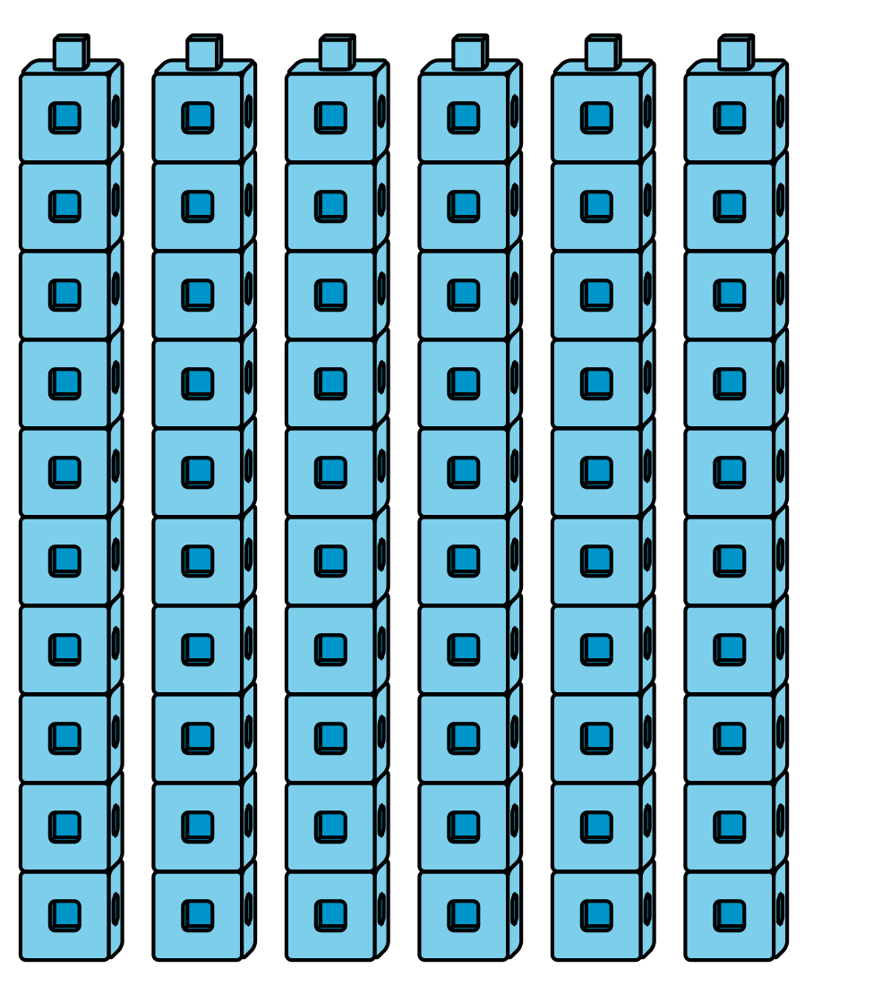
I know there are ____________ cubes because

Student Responses
Sample responses:
- I know there are 60 cubes because I counted 6 tens.
- I know there are 60 cubes because I counted 10, 20, 30, 40, 50, 60.

