Unit 2 Lesson 3: Tile Rectangles

WU Which One Doesn’t Belong: Tiles (Warm up)

Student Task Statement
Which one doesn't belong?
A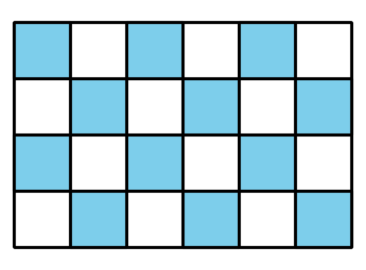
B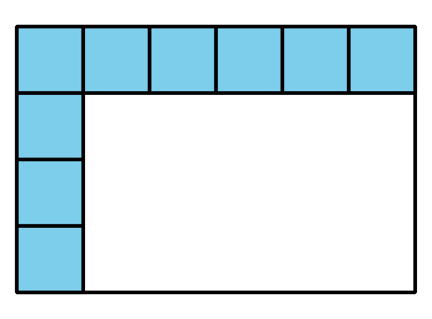
C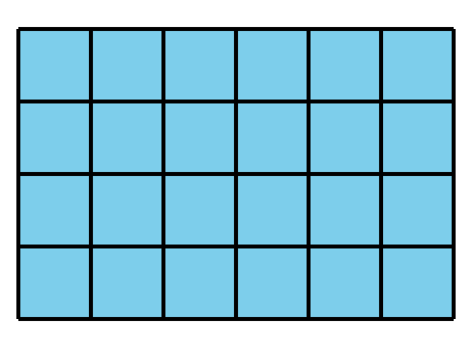
D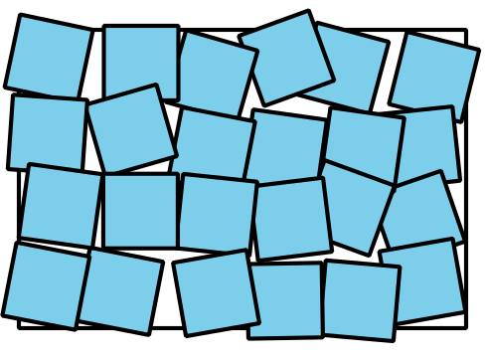

1 Time to Tile

Student Task Statement
Your teacher will give you square tiles and a handout showing rectangles and squares.
- Describe or show how to use the square tiles to measure the area of each rectangle. You can place square tiles on the handout where squares are already shown. You can also move the tiles, if needed.

  - 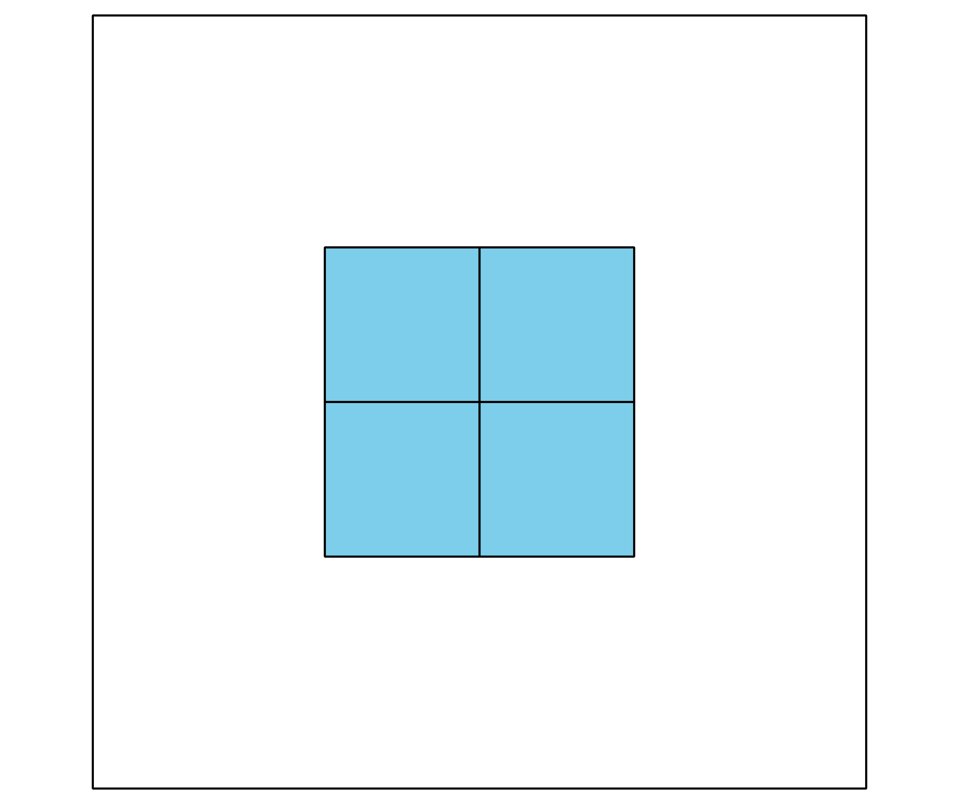

  - 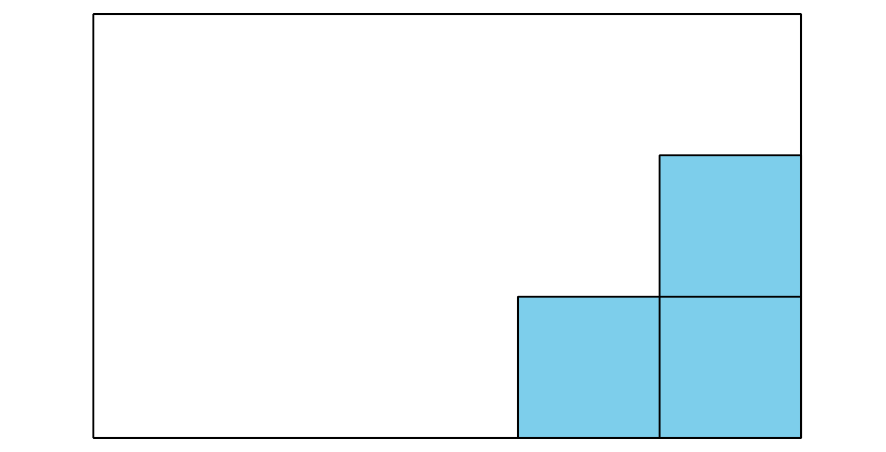

  - 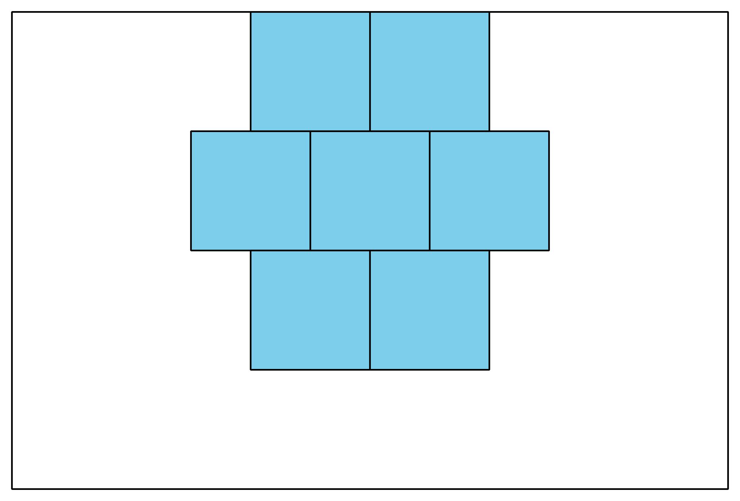

  - 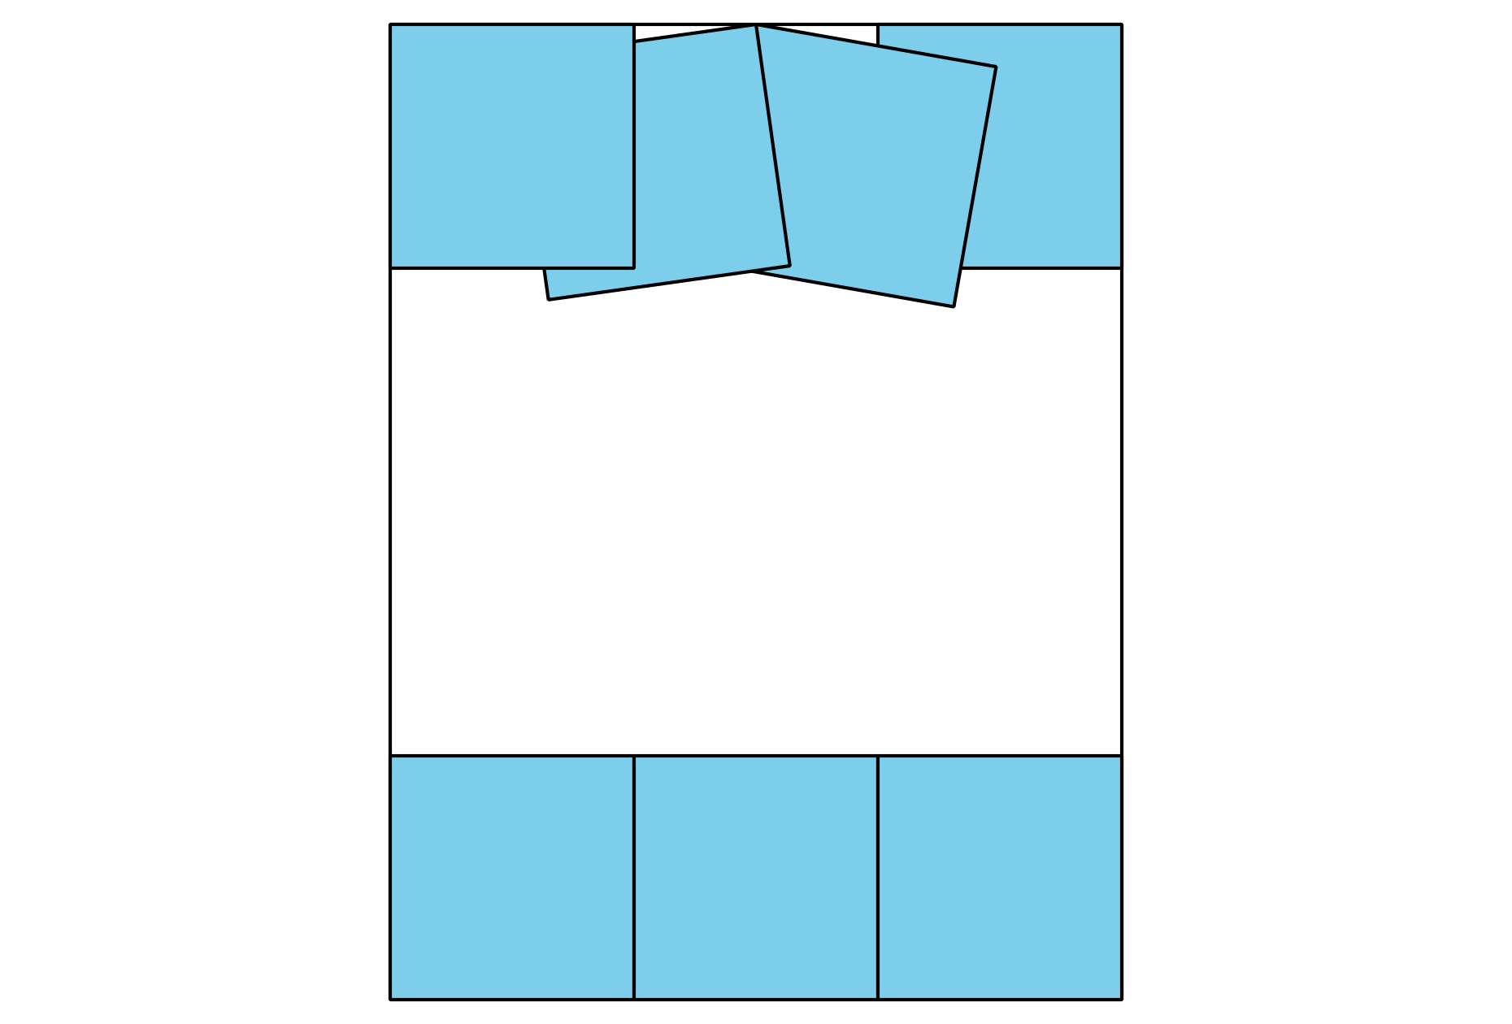
- Describe how to use square tiles to find the area of any rectangle.

2 Card Sort: Rectangles

Student Task Statement
What do you notice? What do you wonder?
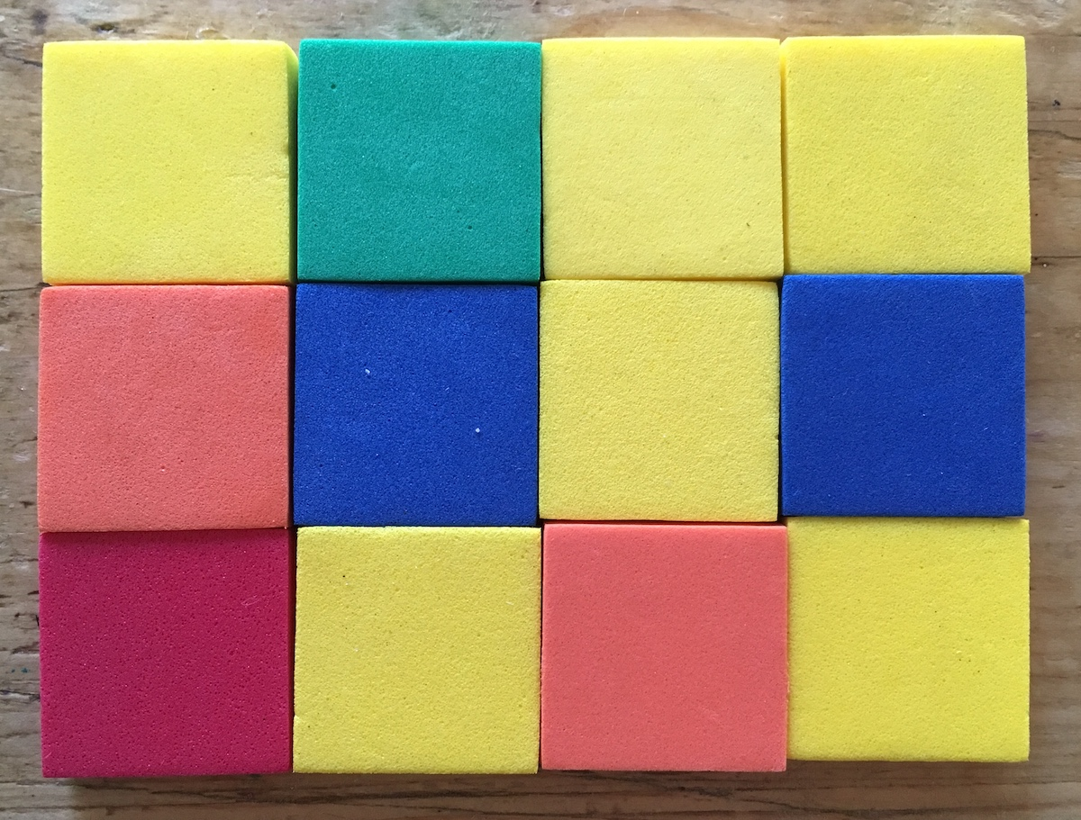
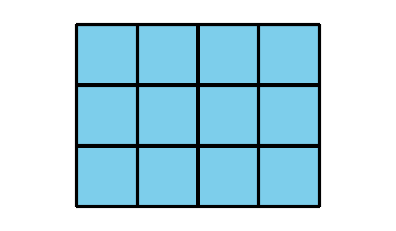
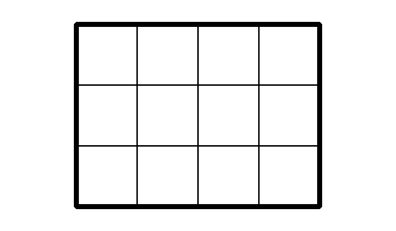
Draw a rectangle with an area of 8 square units on the grid.
Your teacher will give you a set of cards that show rectangles. Sort the cards into categories of your choosing. Be prepared to explain your categories.
- A
- D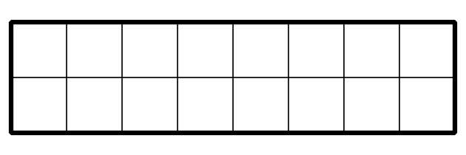
- B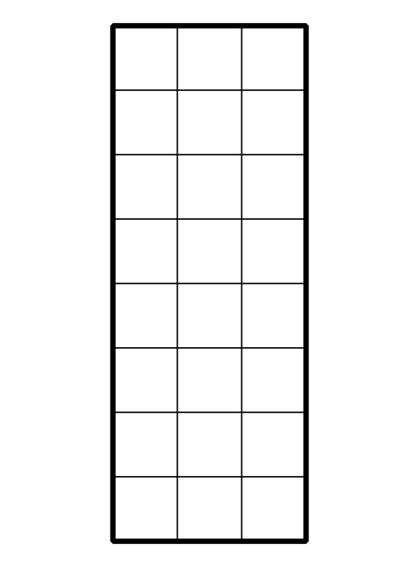
- E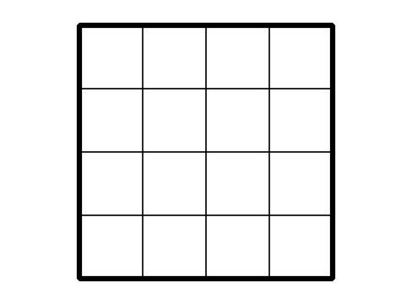
- C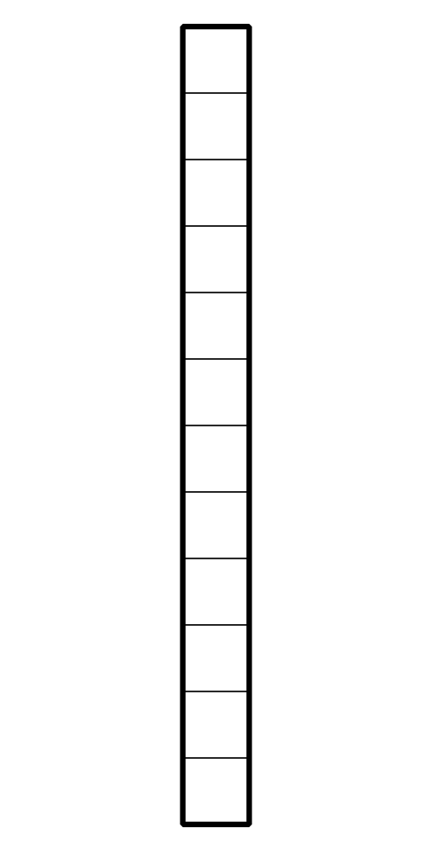
- F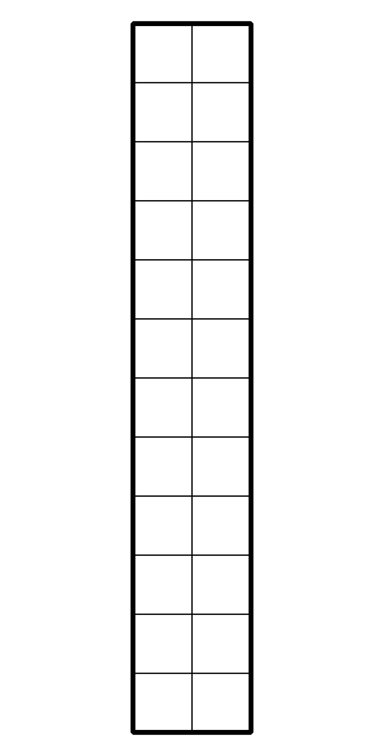
- Create a rectangle that would fit in each group.
© CC BY 2021 Illustrative Mathematics®

