Lesson 4: Standard Algorithm: One-digit and Multi-digit Numbers with Composing
- Let’s use the standard algorithm to multiply one-digit numbers and multi-digit numbers.

Warm-up: Number Talk: Partial Product
Find the value of each product mentally.
- $3×3$
- $3×20$
- $3×600$
- $3×623$

4.1: Compose with the Standard Algorithm
Here is how Han calculated $318×3$ using partial products.
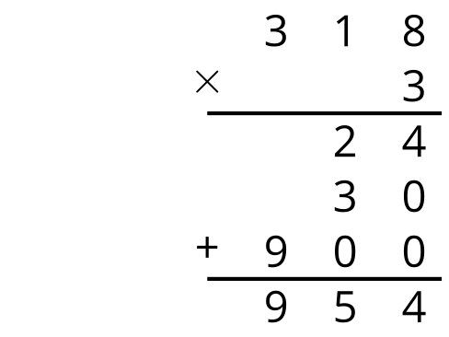
Here is how Elena calculated $318×3$ using the standard algorithm.
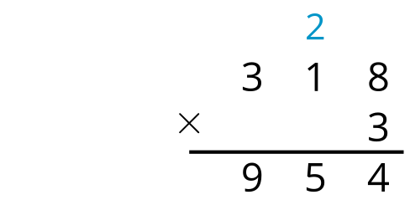
- What does the 2 in Elena’s calculation represent? Explain or show your reasoning.
- What does the 5 in Elena’s solution represent? Explain or show your reasoning.

4.2: Use the Standard Algorithm
Calculate each product using Elena’s strategy.
- $3,​615×4$
- $16,​023×3$
- $27,​326×3$
- $10,​215×6$
© CC BY 2021 Illustrative Mathematics®

